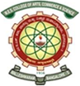MES COLLEGE OF ARTS, COMMERCE & SCIENCE
‘Vidyasagara’ Prof MPL Sastry Rd, 15th Cross,Malleshwaram, Bangalore -03
NAAC Accredited with Grade “A”
MES ASTRONOMY CLUB
Report on The Events of the Club
EVENT 1 : Stargazing event on 30 August 2023
On the evening of August 30th, 2023, the MES Astronomy Club hosted a captivating Stargazing Night at the College. Guided by Prof. Rajeshwari S (Physics Department), Prof. Madhumathi, and Prof. Vamshi (Electronics Department), participants embarked on an exploration of the cosmos.
Sahana, from the MES Astronomy Club, enlightened the attendees at 7:15 PM about the Super Blue Moon, telescopes, and Messier Objects. After a delightful dinner break, Rudresh shared his Astronomy and Astrophotography journey. Despite initial clouds, the night unfolded with educational activities until 2:41 AM when the Super Blue Moon graced the sky until 3:15 AM. Jupiter and its moons followed, observed through a 20 mm telescope (33x magnification) until 4:30 AM. The event concluded with rest until 6 AM, leaving participants with a newfound cosmic appreciation. The program aimed to provide students with insights into astronomy, telescope usage, and the observation of celestial phenomena such as the Super Blue Moon and Jupiter.
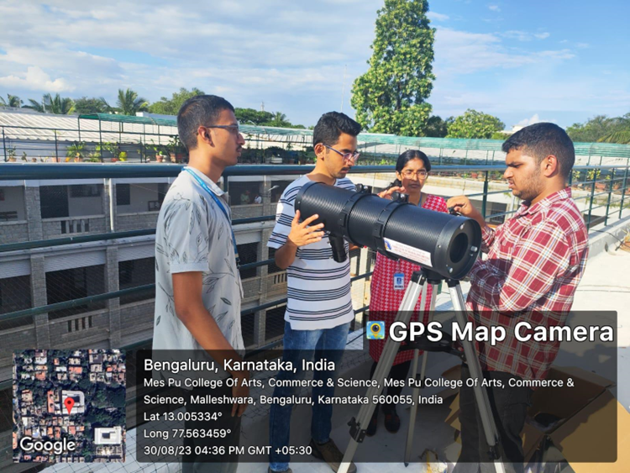
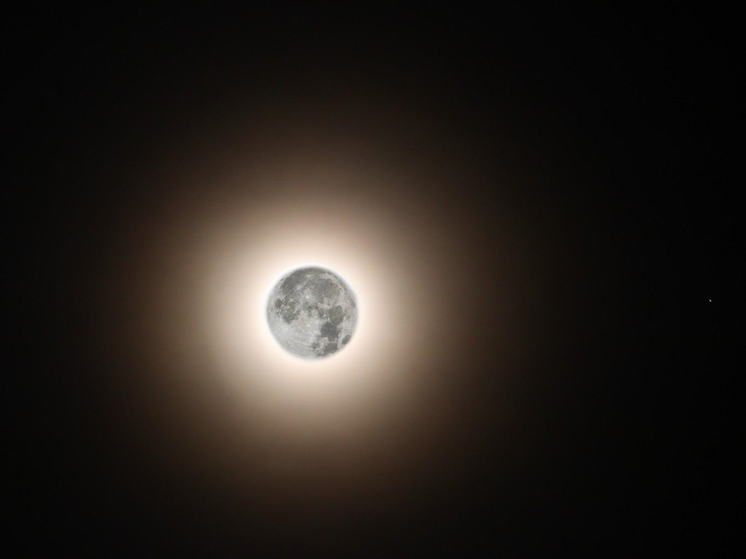
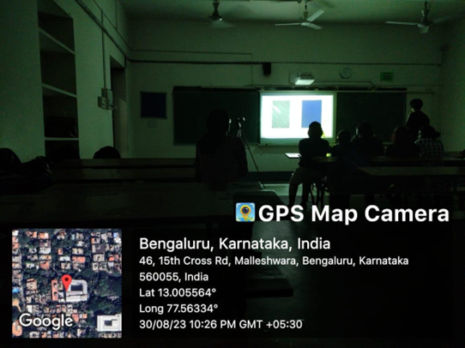
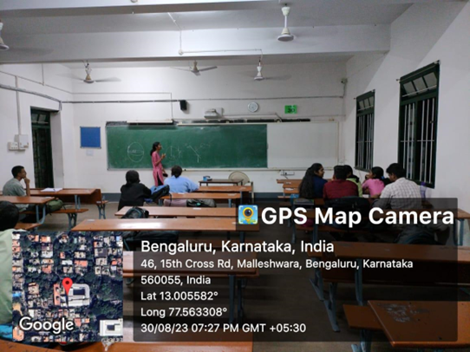
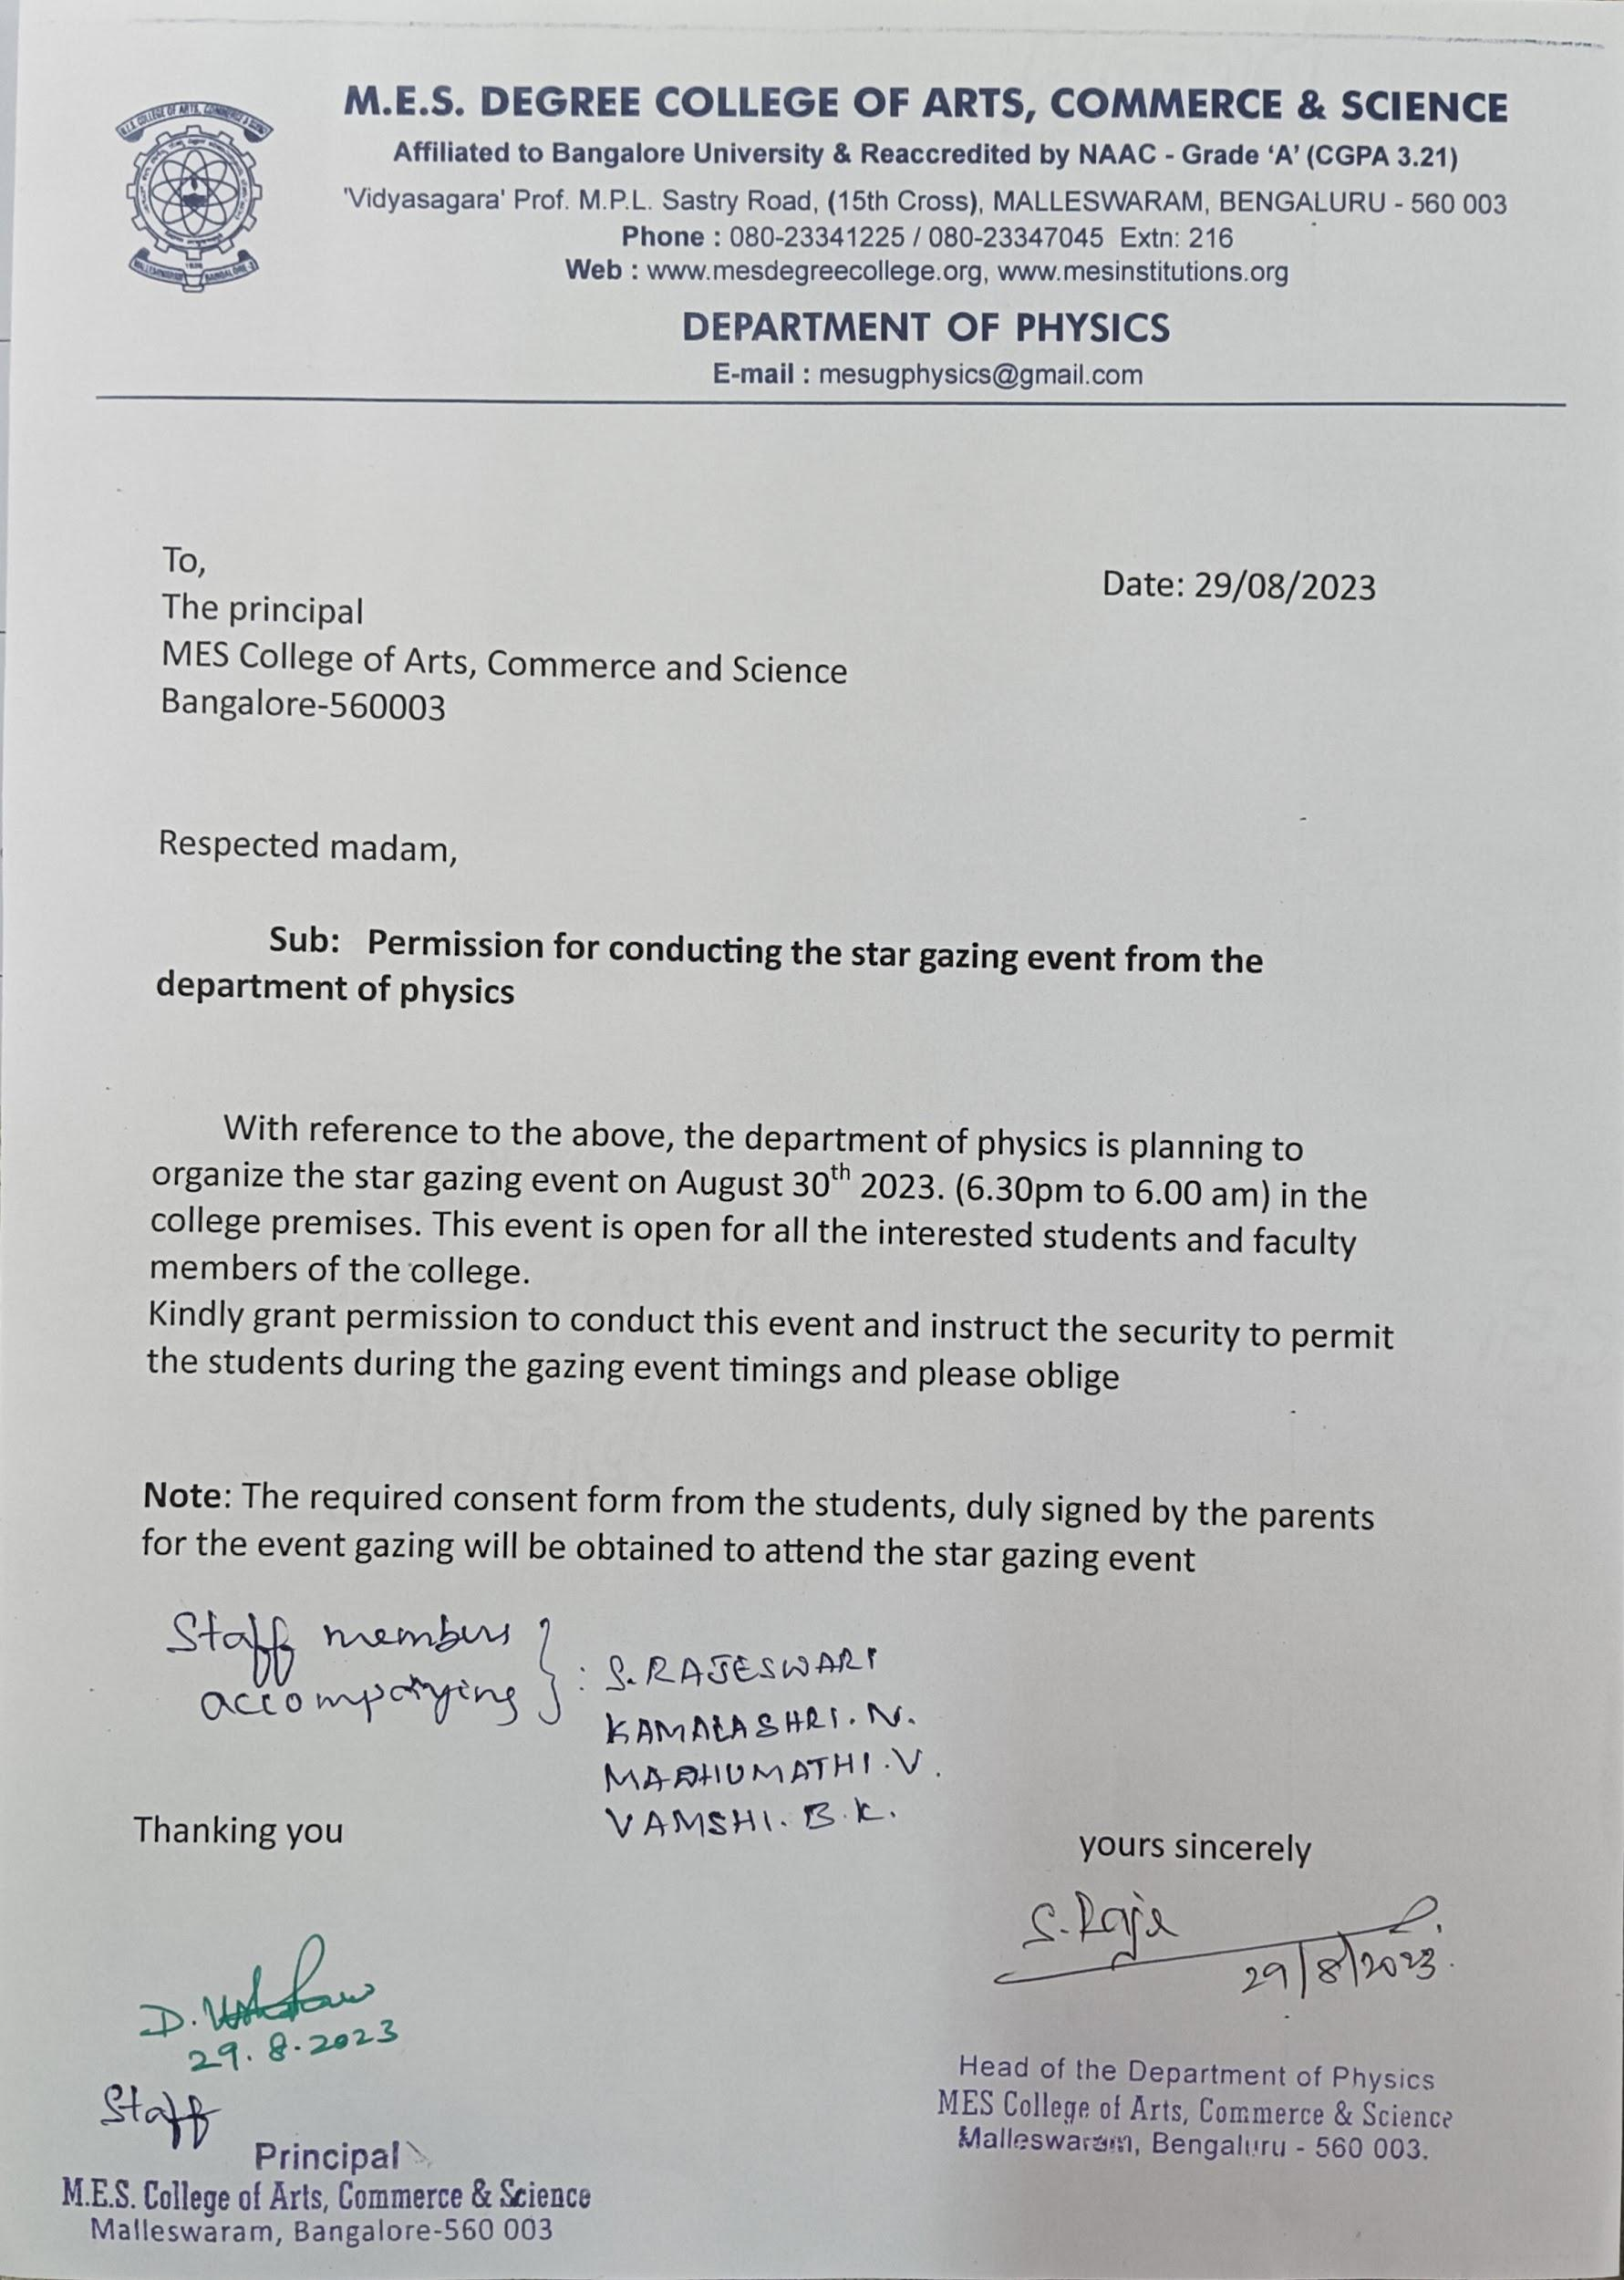
EVENT 2: Planetarium visit on 8th November 2023
The MES Astronomy Club, in collaboration with the Department of Physics, organised a ”Visit to the Planetarium”on November 8th, 2023. The event featured a talk session by Prof. Madhusudan, an Educator from the Jawaharlal Nehru Planetarium, followed by an insightful show on Gravity. A total of 35 attendees, including faculty members, participated.
The program was designed to delve into the "Multi-Messenger Theory" by means of a talk session led by Prof. Madhusudan. The session aimed to shed light on the diverse types of measurements and messengers that convey information about the universe. Additionally, the event sought to explore the historical progression of humanity's comprehension of gravity. The Gravity show afterwards aimed to give a visual understanding of the development of the theories surrounding gravity. It helped the students gain key insights about physics and famous physicists who contributed to it.
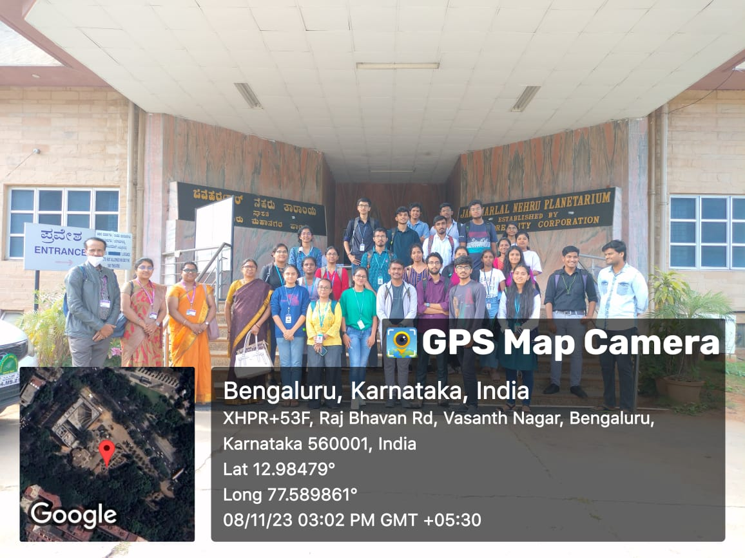
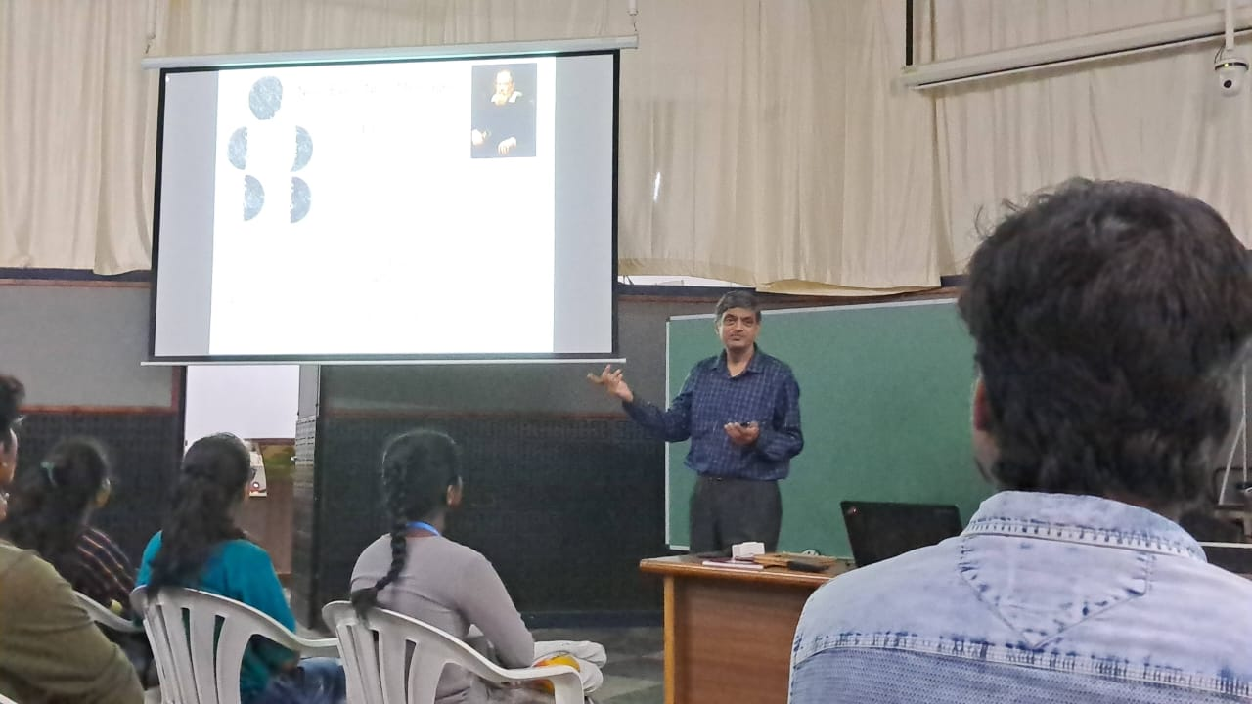
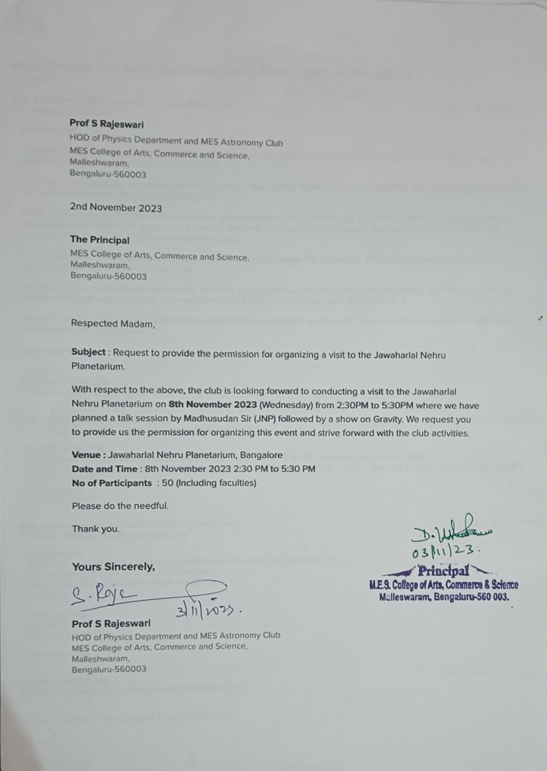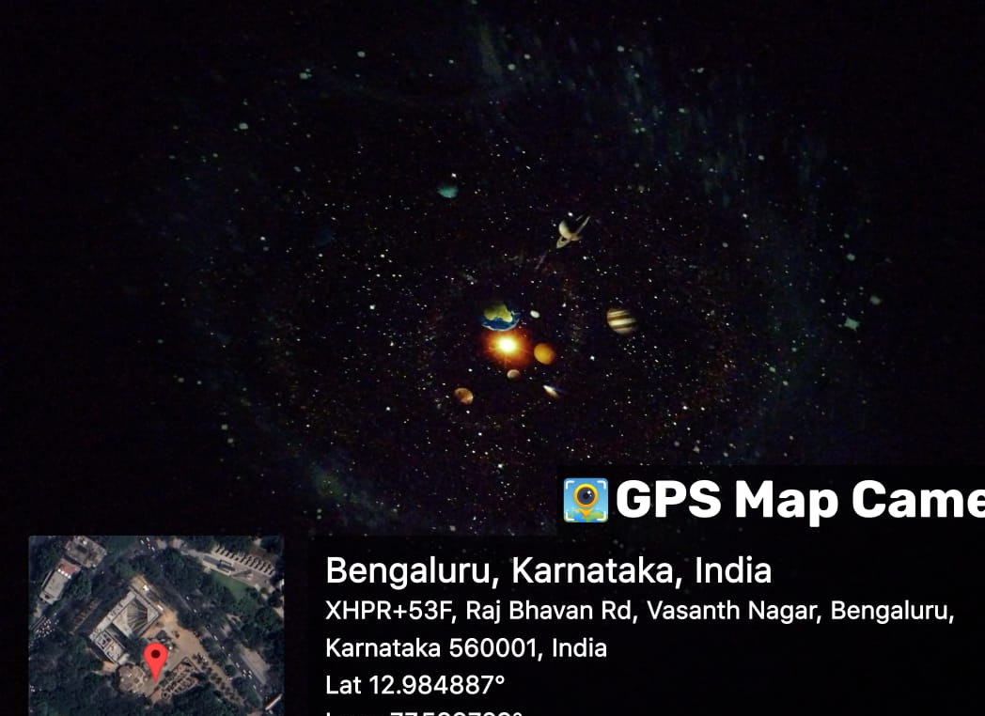

EVENT 3: Sunspot trial Observation on 9th December 2023
The Members of MES Astronomy club gathered on 9th Dec 2023 in the afternoon at 2: 47 PM. We observed the Sun Spots through our solar filter using 35x magnification.

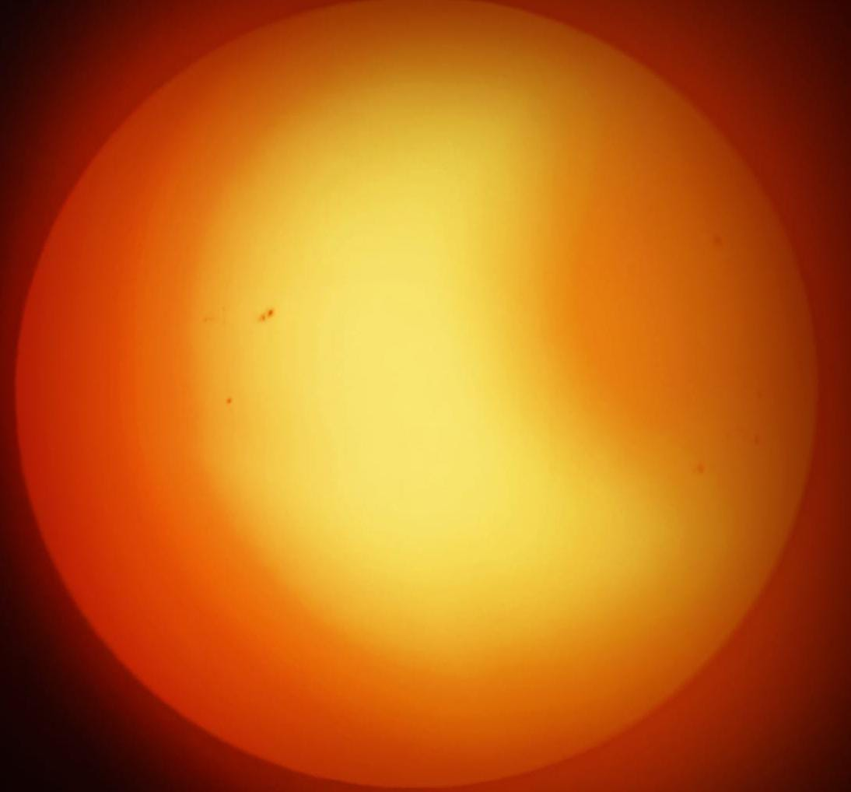

EVENT 4: Stargazing on 6th January 2024
The MES Astronomy club conducted a Stargazing Night on 6th January 2024. The event started with the introduction of the team members and inauguration of our very first E-Newsletter i.e., COSMOS Edition-1 featuring about Orion [M42], latest updates of astronomy, club activities and few briefing and motivational talk by the founders of MES Astronomy Club. Subsequently, Vishnu and Sahana from the MES Astronomy Club explained about the types of telescopes and their uses. Later, we witnessed Jupiter and its moons (33x and 100x magnification), Pleiades (Naked eye and 33x magnification), Orion Nebula (33x Magnification).
Feedback
Feedback was collected anonymously and this was the feedback we received.
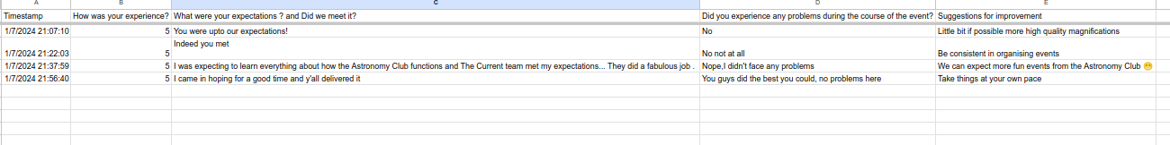
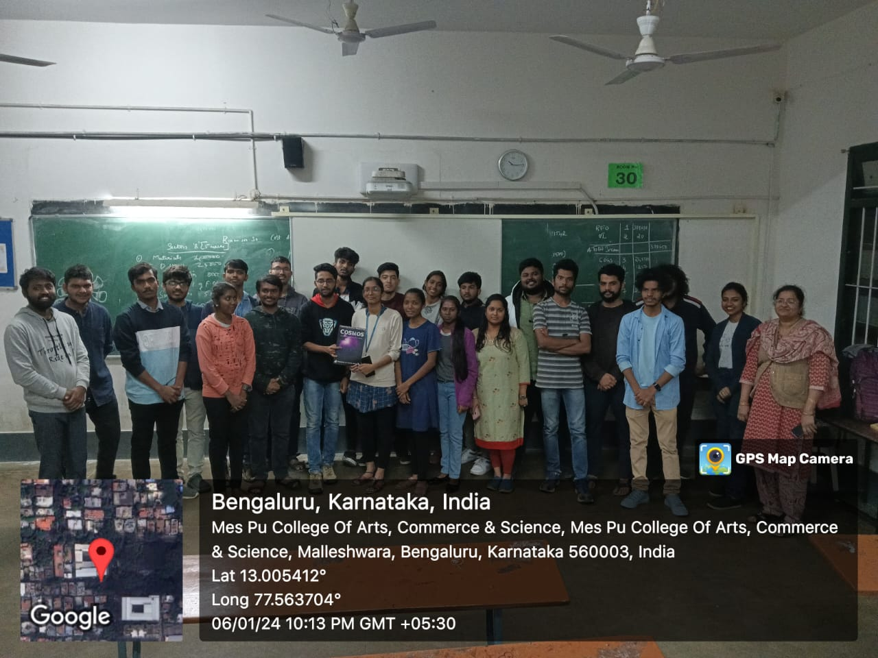
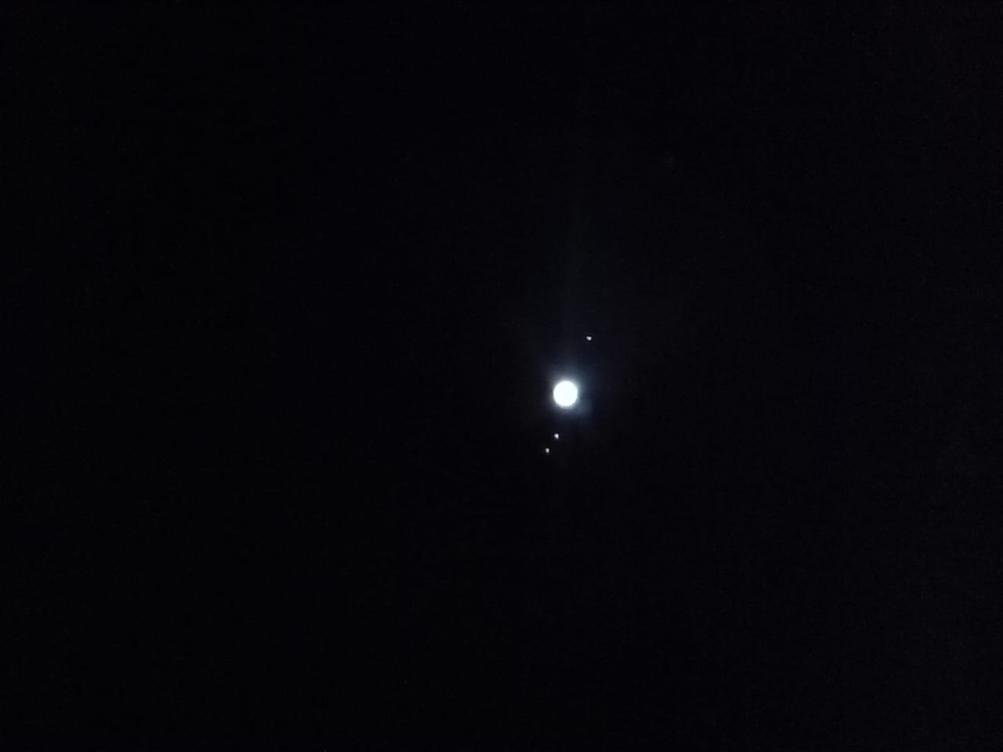
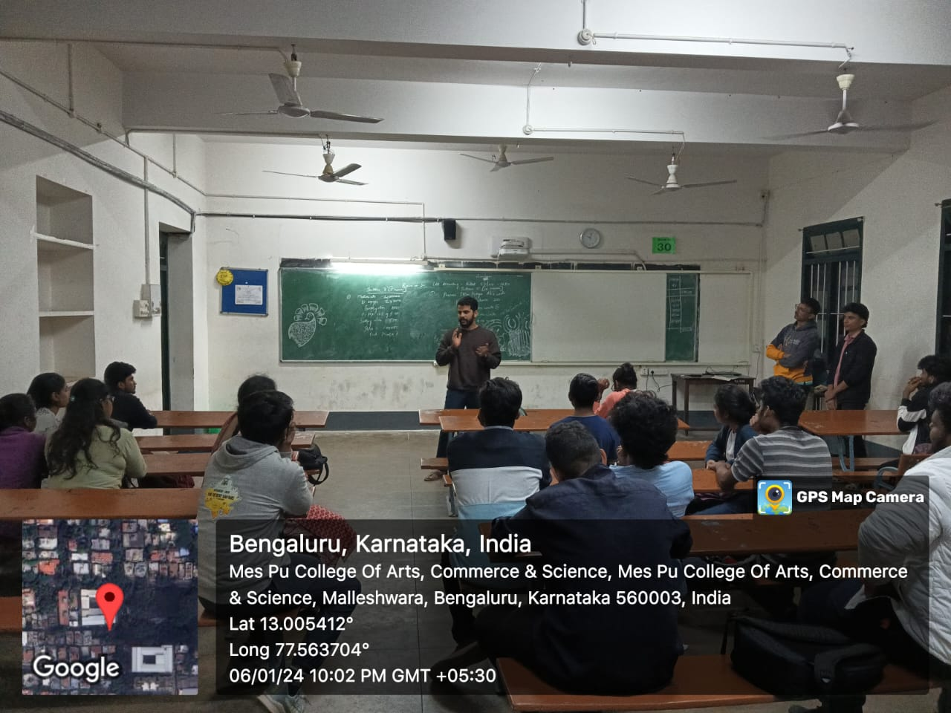
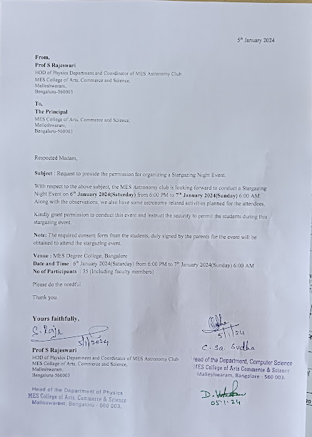

Previous Events conducted by MES Astronomy Club
Event 1 : Inaugural meet
- Narendren S
Date - 9th December, 2021
No. of Attendees - 47
Location - MES College of Arts, Commerce & Science
Event Summary : An Inaugural meet of MES Astronomy Club was held in the presence of Principal and Senior faculty members of Physics department.
Event Description : The Inaugural meet started with the gathering of all the members of the newly chartered MES Astronomy Club. We had the formal introduction of Principal, Dr Usha Rani followed by her address to the gathering and next we introduced our Club Advisor Prof. K M Raghavendran (Retd. Associate Professor) followed by his address and briefing about the vision of the club and proceedings of it. Then we introduced our Faculty coordinator Dr. Manu, who gave us the detailed information about what the members can except form an astronomy club and how will the events be, etc., Post which we announced the 1st event i.e., the Visit to Jawaharlal Nehru Planetarium, Bangalore and we also opened the Club Logo designing competition. We had an overwhelming response of 47 members attending the inaugural meet. All of us are thrilled to start this new journey and explore stars, planets and galaxies.

Event 2 : A Visit to Planetarium
-Vishnu R

Date - 15th December, 2021
No. of Attendees - 71
Location - Jawaharlal Nehru Planetarium, Bengaluru
Event Summary : MES Astronomy Club visited the Jawaharlal Nehru Planetarium on wednesday, 15th december, 2021. This was the first event organised by the newly formed astronomy club.
Event Description : The planetarium is maintained as a great centre for learning, fun and exploration by the director, Shri. Madhusudana H R. It was indeed a refreshing and positive sight to see that no matter the age of the person, the planetarium had something for everyone to take away. We reached the campus of the planetarium at 2:45 PM. In the following 30 mins all the members were gathered up together and an attendance was taken. We then excitedly headed to the basement where Madhusudan sir had arranged seating for all of us following social distancing norms. We had an unbelievably fun and educational demonstration by Madhusudan sir. He started off by forming soap bubbles with childlike joy and questioned us as to why soap bubbles behave the way they do. And slowly but surely he elevated our knowledge about the curious world of soap bubbles. He spoke about how calculus of variation is related to soap bubbles. He also showed us some applications of using soap bubble frames and how we can solve real world problems with them. We all made our way to the planetarium show at 4:30 PM. The show was named “Celestial Fireworks” and I can confirm it was a spectacular show. The show ended at 5:15 PM. We all assembled for a quick group photograph, said our goodbyes and dispersed with a feeling of joy and satisfaction.
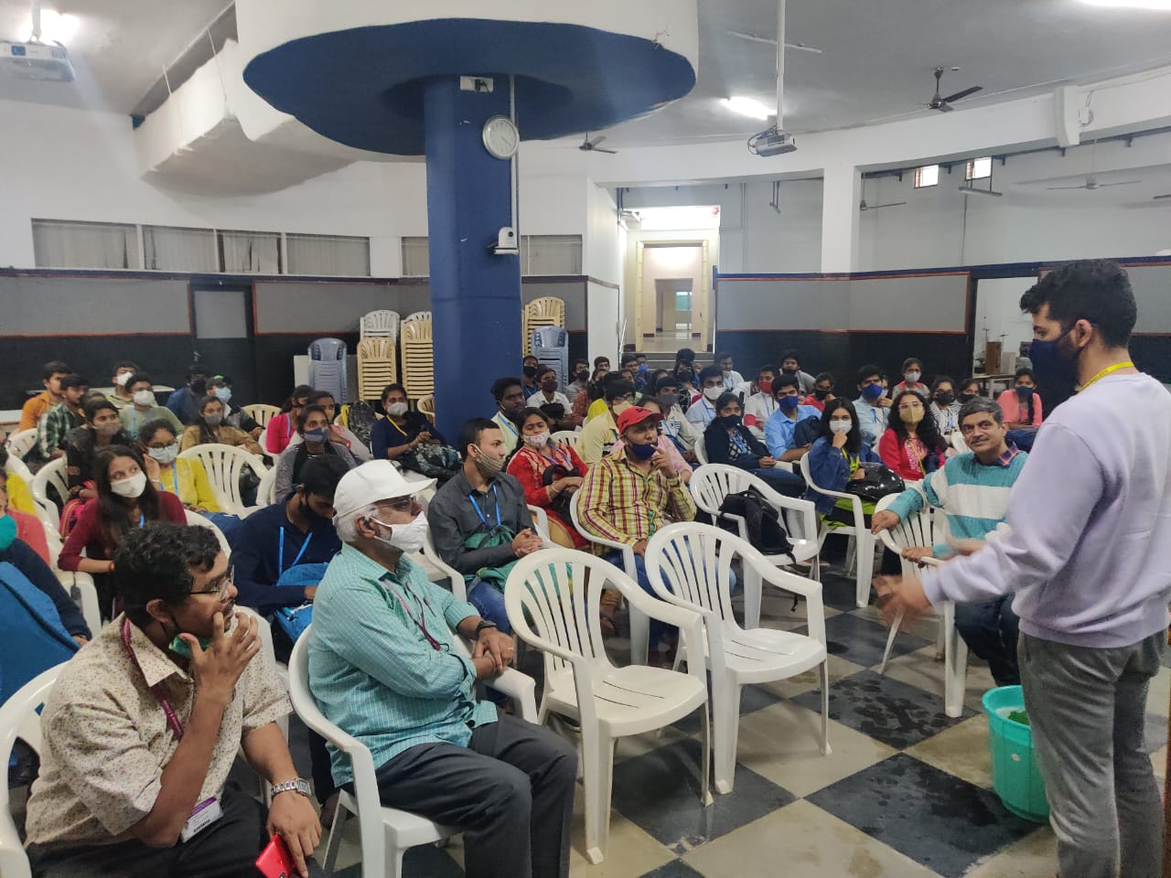
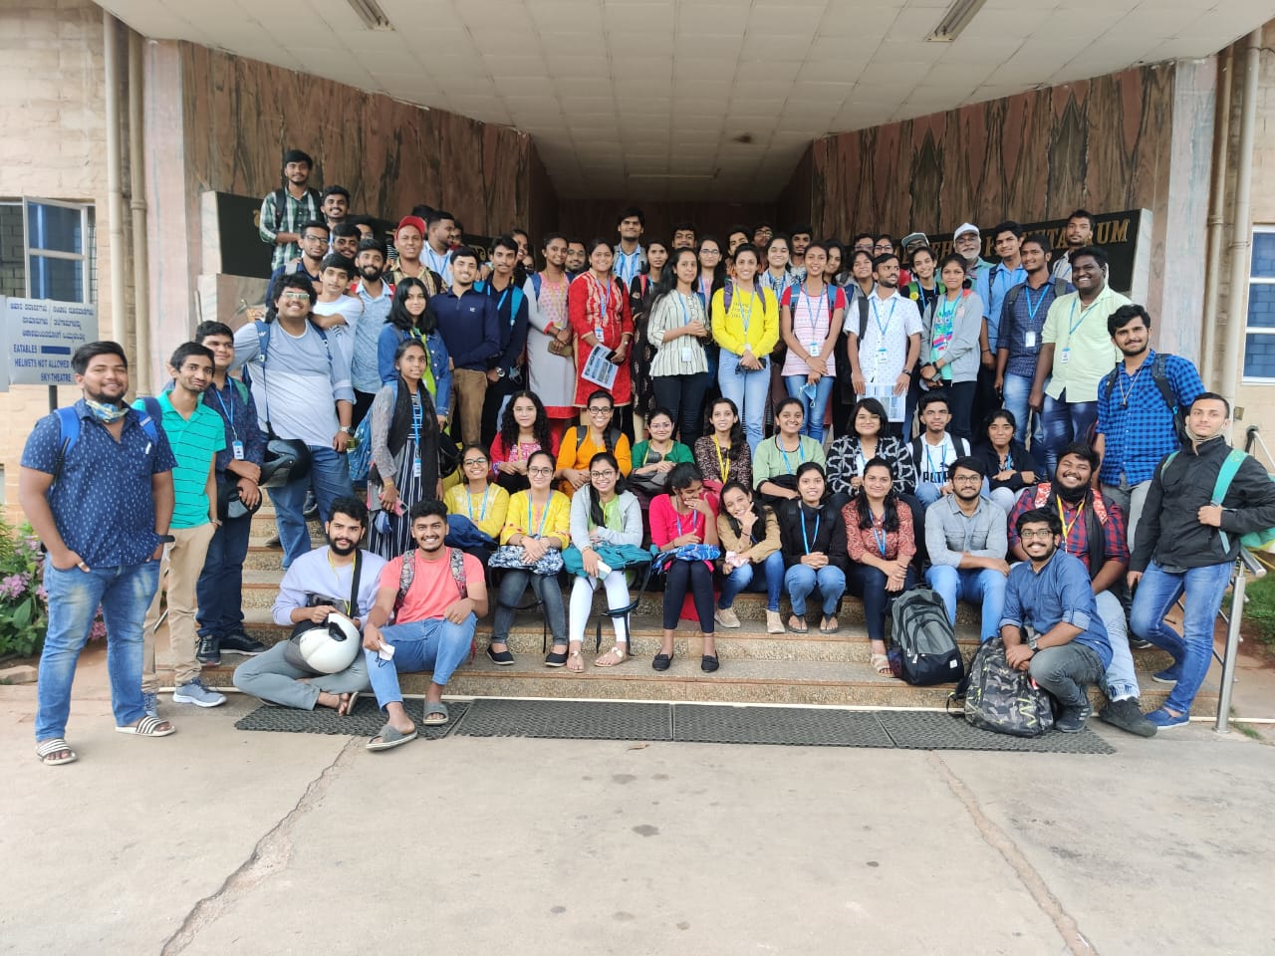

Event 3 : Club Logo Designing competition.

-Rohini G Acharya
Date - 10th Dec - 19th Dec, 2021
No. of Participants - 13
Location - MES College of Arts, Commerce & Science
Event Summary : A logo making competition was held to decide on the official MES Astronomy Club logo.
Event Description : To bring a sense of excitement and formality to the club, a logo making competition was announced on 9th Dec during the inaugural meet. The competition was from 10th to 15th Dec and members could use any graphic designing application to come up with an original idea for the club logo. There were many interesting entries for the event. All the logos were then put up on the club’s discord channel and a poll was conducted to decide the winning entry. The poll ended on 19th Dec with the logo made by Akshata Nadig and Manu Priya V R being chosen as the official logo for the club.

Event 4 : Club Logo Launch

-Rohini G Acharya
Date - 23rd December, 2021
No. of Attendees - 45
Location - MES College of Arts, Commerce & Science
Event Summary : The official logo of the MES Astronomy Club was launched followed by a video presentation on the history of telescopes and briefing for the next event.
Event Description : With the club logo being chosen it was now needed to formally reveal it to the members and this led to the official Logo Launch.On 23rd Dec The Principal Dr Usha Rani,Club Advisor Prof. K M Raghavendran,Faculty coordinator Dr. Manu, Student coordinators and the members gathered for the event. The logo was presented after which the designers for the logo Akshata Nadig and Manu Priya explained the significance of its design. This was followed by the Principal’s words of encouragement to the gathering. Later a video presentation was given by the Student coordinators on the history of telescopes and journey of Galileo Galilei and his contributions to astronomy and physics. After that instructions were given for the upcoming event and everyone dispersed.
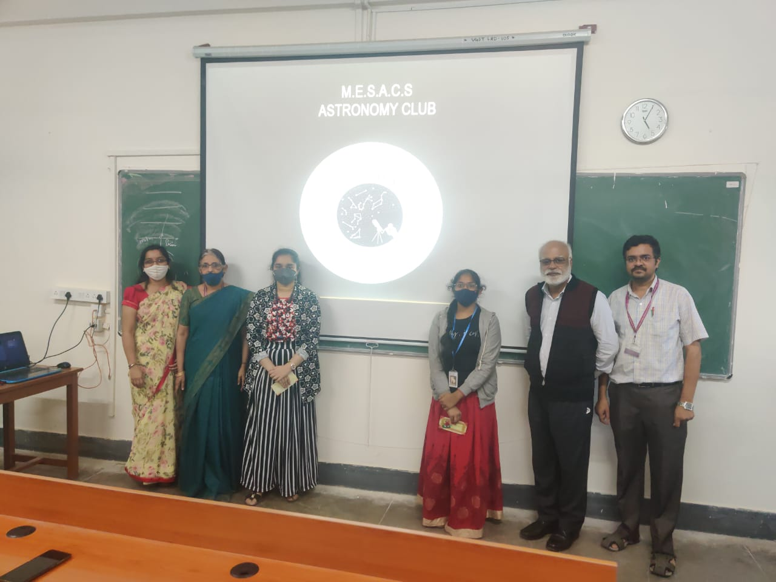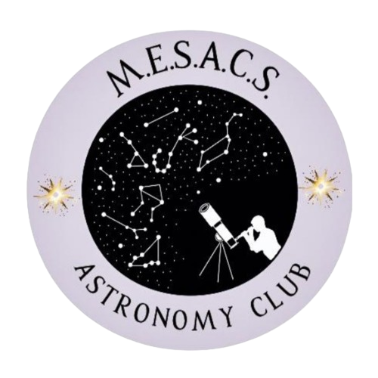

Event 5 : Stargazing Night
-Akshata Nadig
Date - 24th December, 2021
No. of Attendees - 43
Location - MES College of Arts, Commerce & Science
Event Summary : On 24th December 2021, At 6:30 pm, We club members gathered at MES College of Arts, Commerce and Science to observe Saturn, Jupiter, Moon and Orion Nebula.
Event Description : The observations were made through a Newtonian Telescope with a Dobsonian mount. We used three different magnifications i.e., 50x, 139x and 300x to view the above-mentioned celestial objects.
At 7:19 pm, We observed Saturn from the location MESACS-Bangalore [13.005522, 77.563572]. For 50x magnification, the planet was brightly visible but the division of rings was not clearly seen. Three of its moons were seen. For 139x magnification, the planet with its ring system appeared closer and clearer. The Cassini division was much more clearly seen. Three of its moons appeared more clearly.
At 7:55 pm, Jupiter was observed from the location as mentioned above. For 50x magnification, the planet was seen with five of its moons. The belts were vaguely seen. For 139x magnification, the cloud of belts across the atmosphere of the planet was clearly seen with four of its moons in the frame.
At 9 pm, we had taken break for an hour
Again, from 10 pm onwards, we observed the moon and other deep sky objects and the Moon till 4:53 am.

M42 Orion's nebula, For 50x magnification, the nebula appeared as a hazy pale blue cloud below Orion's belt surrounding the 'Trapezium' and other star formations. For 139x magnification, the 'Trapezium' was more clearly seen at the heart of the nebula.
We finally Concluded the star gazing night by watching the Moon. That night, It was the Waning gibbous moon. Which is relatively the best phase to Observe the moon. For 50x magnification, Major craters and peaks could be noticed. For 139x magnification, most of the smaller craters and mountain ranges could be clearly seen on the moon's surface. For 300x magnification The craters and mountain ranges were much more dense and very clear.

EVENT 6 : VISIT TO RAC IN UDHAGAMANDALAM
- Rohini G Acharya

Date: 14th – 16th July, 2022
No. of Attendees: 36
Location: Tata Institute of Fundamental Research, Udhagamandalam

Event Summary: The MES Astronomy Club had an outstation field trip to the Radio Astronomy Center and Cosmic Ray Laboratory in TIFR, Ooty from 14th to 16th July. The participants learnt about the working of the Cosmic Ray Laboratory and the Ooty Radio Telescope.

Event Description: There were thirty six participants including three student coordinators and three faculty coordinators. The participants assembled in the college premises on 14th July at 9.30PM where they were given the payment invoices for their trip dues and Astronomy Club button badges. They were also briefed about the weather conditions and code for conduct for the duration of the trip. Three Tempo Travelers were arranged for the transportation. The vehicles arrived at around 12:00 AM, 15th July after which everyone was allowed to settle in their allotted buses. The group departed from the college at 1.30 AM on 15th July for Ooty. The journey to Ooty was without any hiccups barring a few technical issues. There were a few stops for restroom breaks, and breakfast in the morning. The buses reached the cottages in Ooty at 10.30AM after travelling overnight. The participants were given time to freshen up, after which the group started for the trip to TIFR, Ooty. We arrived at TIFR at 12.30PM. Dr. Manu S briefed the students about radio astronomy. Post-briefing, we were shown the enormous Ooty Radio Telescope from a viewpoint and its working was explained. This was followed by a walk to the Cosmic Ray Laboratory. At CRL, Dr. Hariharan gave us a wonderful lecture on the fundamental concepts and working of the GRAPES-3 Experiment along with the achievements made along the years. As the primary purpose of the trip was fulfilled with great success and we have time on our hands, we visited the famous Chocolate and Tea factories. The time for lunch had passed, hence we proceeded to have dinner in the localities of Ooty and headed back to the cottages soon after. The group checked out of the cottages at around 10AM and after stopping for breakfast, we were taken to see the Pykara Falls whose beauty seemed to have increased in the rain. We then proceeded to Whispering Windows resort where everyone had a delicious lunch. After travelling a few more hours and stopping for a beverage break at Srirangapatna, we reached the college at around 11.45PM following which everyone left for their homes along with their guardians.
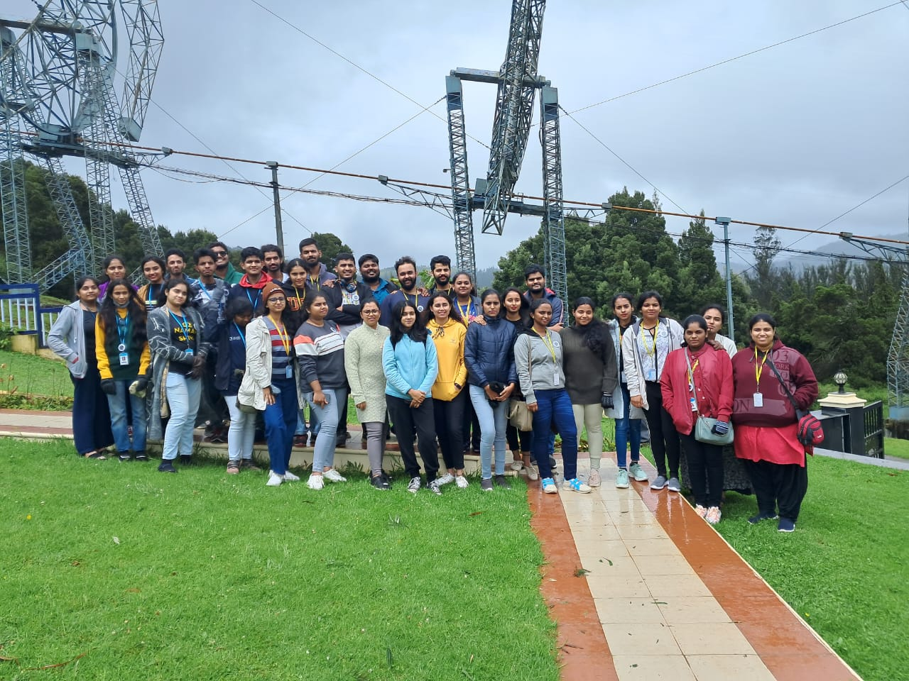

EVENT 7 : Inauguration event on 28th Nov 2022
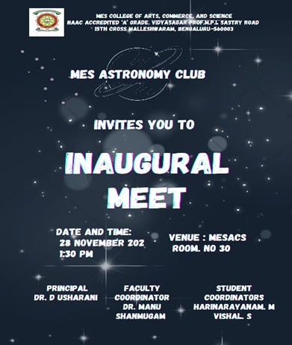
Date – November 28th ,2022.
Time – 1:30 pm
Venue – MES College of Arts Commerce and Science
No. of participants: 56
Event Summary - In the afternoon at 1:30, The Astronomy Club of MES College of Arts Commerce and Science conducted its inauguration meeting for the year 2022-23. The faculty coordinator of the club Dr. Manu Shanmugam from the physics department, welcomed the new members to the club. He then proceeded to talk about the events and the competitions that were conducted the previous year. He spoke about the field trip to the radio observatory in Ooty. He spoke about the star-gazing event that was conducted in the college premises. He later invited Vishnu Ramesh one of founding member of the club who spoke about the Hierarchy of power in the club, the premium plans and he then explained about the telescope and its importance and the club’s need for it and he went over the rules and regulations to be followed in the club.Professor S Rajeshwari the head of the physics department took over and talked about the funds for the club and how interesting the topic “Astronomy” is. Narendran who is also a founding member of the club gave a recap on all the points that were discussed during the meet. Lastly, Manu sir ended the meeting with a vote of thanks and the members dispersed at 3 pm.

EVENT 8: What if? Event on 10 Dec 2022
Date: December 10 ,2022
Time: 2.30 pm - 5.15pm
Venue: MES Degree College, Room No.42
No. of participants: 20
Judges:
Dr. Manu Shanmugam, Assistant professor, Department of Physics, MES College
Prof.Arjun C Murugan , Assistant professor, Department of Mathematics, MES College
Vishal S, Student, III Bsc PCM, MES College
Event Summary:
The competition started at 2.30 with the participants, judges, and organisers assembling at the venue.Questions were posed to the participants using a PowerPoint presentation. The first round had 10 teams with a maximum of 2 participants per team. They were given 90 seconds to discuss the answers to each question. After 5 questions the teams were given 1 min each to explain their answers. After grading, 5 teams advanced to the second round where they were given 120 seconds to think and 90 seconds to talk about it. This round also enabled the judges and onlookers to question the ideas of the participants. After 5 questions the judges finalised the top 3 teams to win the event. Vibha, and their team winning third place, Jhanvi, and their team in second place, and Rohini from 2nd year B.Sc. in first place. Refreshments were later provided and photos were taken after which everyone dispersed.
List of participants:
1.Vibha , Novyani ( I BSc)
2. Muskan Pandey , Jhanvi. B. S ( I BSc)
3. Rohini Kumari T ( II BSc)
4. Sudarshan , Keshav Anand ( III BSc, III BA)
5. Sai Tushar , Badrish. V. M ( II BSc)
6. Pavan Tej.G , Nandan.H.A (III BSc)
7. Sudarshan , Keshav Anand (III BSc, III BA)
8. Muskan Pandey , Jhanvi.B.S (I BSc)
9. Vishal , Keerthi (I BSc)
10. Shika.R , R.Keerthana(I BSc)
List of Finalists:
1. Sai Tushar, Badrish. V. M (II BSc)
2. Shyam. P. Bhat , G.N.Charan Reddy (II BSc)
3. Sowmya.M , Nithya Shree (III BSc)
4. Vibha, Vishal (II BSc)
5. Rohini Kumari T (II Bsc)

EVENT 9: Stargazing Event December 24th 2022
Date – December 24th ,2022.
Time – 6:30 pm
Venue – MES College of Arts Commerce and Science
No. of participants: 37
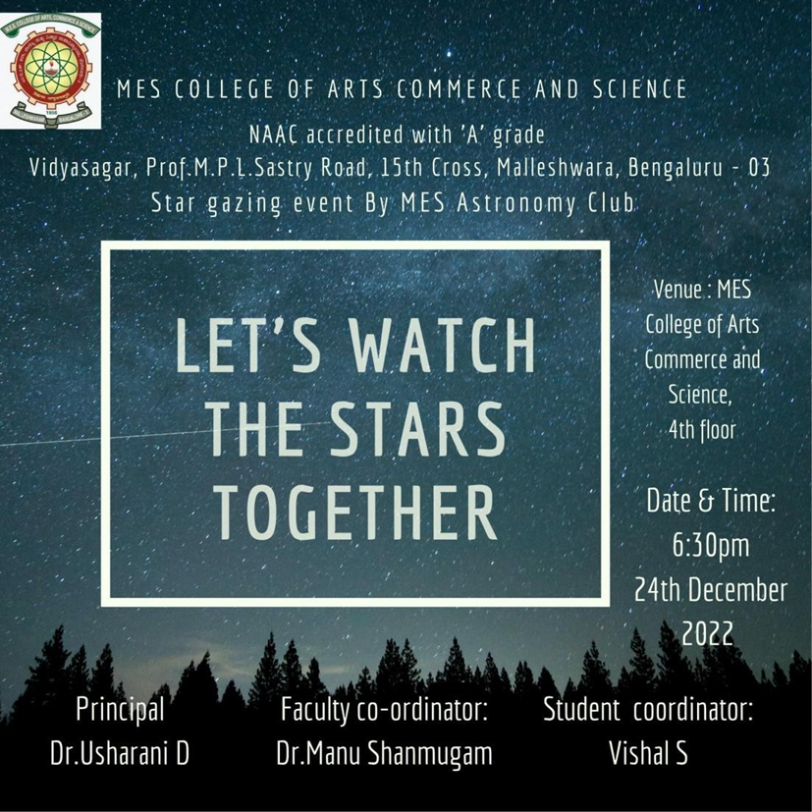
Event Summary - In the evening at 6:30 pm, The registered members of MES Astronomy Club of MESACS started to gather in Room number 30 for the stargazing event of stargazing. The equipment used for the observations was Celestron Equatorial Mount, 5.5 inches, Reflector telescope provided to us by MES Kishore Kendra. The club was accompanied by 11 PU students from MES Kishore Kendra and three teachers. At 6:45 pm, Rohini G Acharya briefly described the telescope to the participants. At 7:15 pm, we observed Saturn from MESACS Bengaluru At 33x magnification, the planet was brightly visible, the rings seemed to be diagonally oriented and could only be minimally differentiated. At 8:25 pm we had our dinner break after which 3 of the PU students returned home and 9 of them stayed back for the rest of the event. The event later resumed at 9:25 when everyone came back to Room 30. Rohini elaborated on the basics that one needs to know while handling a telescope and explained about the deep sky objects that the club was about to observe later that night. At 9:50 pm, the club had assembled at the rooftop to look at Jupiter, the planet was brightly visible with reddish brown bands at the poles, and also 4 of its moons were visible at 33x magnification. At this point, the organisers had another activity planned for the participants in which they were divided into groups of 5 and made to locate some deep sky objects during which Pleiades star cluster and Orion nebula were observed, later they were made to observe the same through a binocular of magnitude 8x40. The sky was covered by clouds from 10:30 pm to 12 am that night. Later on, at 12:20 am, Pleiades was observed under the telescope. Lastly, at 1:54 am Orion nebula was observed. Both the Messier objects were logged into the logbook. Sahana from 1st B.Sc logged the observations. The night sky had turned completely cloudy after and the organisers had to end the event there. The next morning at 6:30 am all the participants dispersed back to their houses.
Orion Nebula and DeMairan’s Nebula (M42) , (M43)

Pleiades Open Star Cluster (M45)
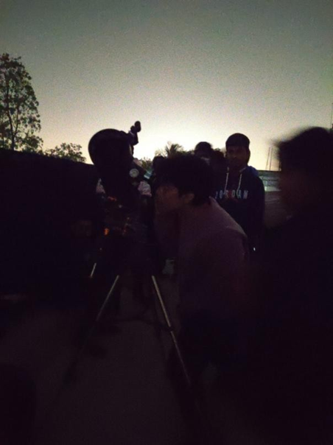
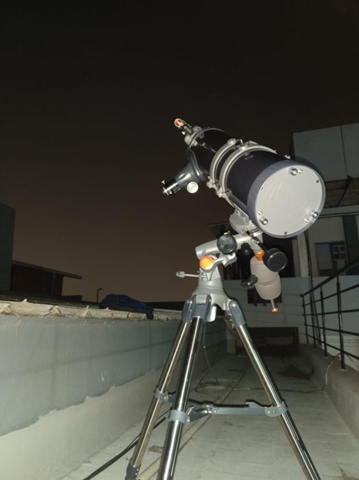
Feedback:
Feedback forms were provided to the participants and the following were some of their responses:
Rudresh Sampath, 3rd B.Sc.- The event was informative, fun, and well-organised. He said his benefit from the event was a ton of knowledge and said that he was looking forward to many such outdoor events.
Sai Tushar , 2nd B.Sc. - The event was informative, fun, and well-organised. He said that his takeaway from the event was operating a
telescope and was wishing to observe more celestial bodies.
Sahana , 1st B.Sc. - The event was informative, fun, and well-organised. She said her opinion on the event was that she got a wide knowledge about star gazing, and that she was expecting more such events from the club.
Rohan ,2nd PU, MES KK - The event was informative, fun, and well-organised. His views on the event was that he got to meet cool people and got to learn a few new and interesting things. Also mentioned that the staff had done the best out of what they had.
Parinith.S, 2nd PU, MES KK - The event was informative, fun, and well-organised. He said that his takeaway was that astronomy was cool. His suggestion to the club was that there had to be more binoculars for a group of 37 people which would have further helped for observation.

EVENT 10: A talk on James Webb Space Telescope
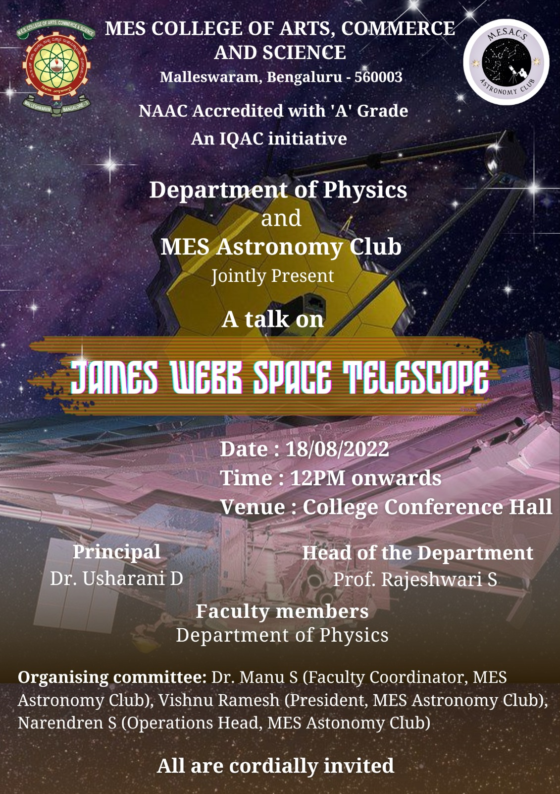
Date: 18/08/2022
Time: 12 PM onwards
Venue: Conference hall, MESACS
Organising Committee: Dr. Manu S (Faculty Coordinator, MES Astronomy Club), Vishnu Ramesh (President, MES Astronomy Club), Narendren S (Operations Head, MES Astronomy Club)
Event Summary:
The Department of Physics and MES Astronomy Club jointly organised a talk on James Webb Space Telescope on 18th August 2022 in MESACS campus. The programme started from 12 PM onwards based on the schedule below:
1.Welcome Address by Vishnu Ramesh
2.Address by Dr. Usharani D, Principal
3.Main presentation:
- Discovery of telescope and evolution (Charan reddy)
- Advent of modern Telescopes (Rohini Achary)
- Hubble telescope (Sufiyan)
- James Webb Space Telescope (Prof. Apoorva)
4.Astronomy Quiz Finale
5.Vote of thanks by Narendren S

