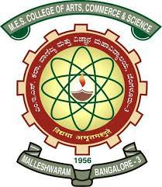
MES COLLEGE OF ARTS, COMMERCE & SCIENCE
‘Vidyasagara’ Prof. M.P.L Sastry Road (15TH Cross), Malleshwaram, Bangalore – 560 003
Phone No : 080-23341225 / 080-23347045 Email : mesdegreecollege@gmail.com
DEPARTMENT OF COMMERCE

THE CONSUMER CLUB
- NAME OF THE CLUB : THE CONSUMER CLUB - INVIGORATE.
- LOGO :

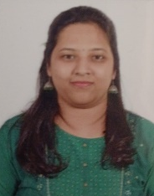
3.TEACHER CONVENOR AND COORDINATOR

Prof. INDU Y Prof. SINDHU BHAIRAVI G.U
CONVENOR CO-ORDINATOR
4.OFFICE BEARERS

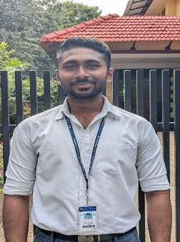
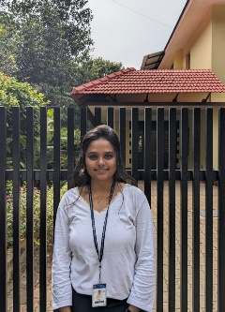
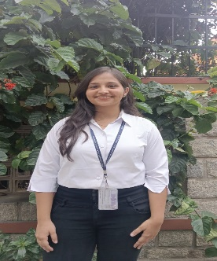
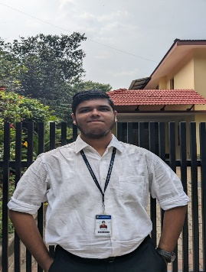
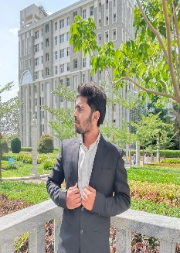
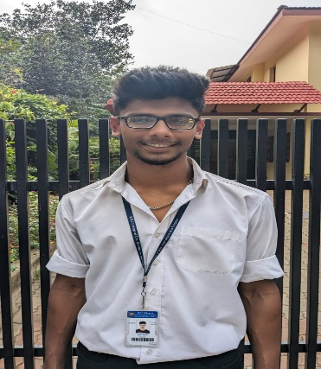
THE CORE COMMITTEE MEMBERS

B THANGA VIGNESH RANJANA K VIBHA D DESAI RAHUL R NAYAK MONISH M SANTOSH B

PRESIDENT VICE-PRESIDENT SECRETARY JOINT SECRETARY TREASURER SERGEANT AT ARMS
RESEARCH & DEVELOPMENT COMMITTEE
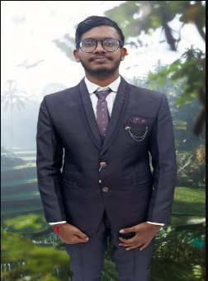
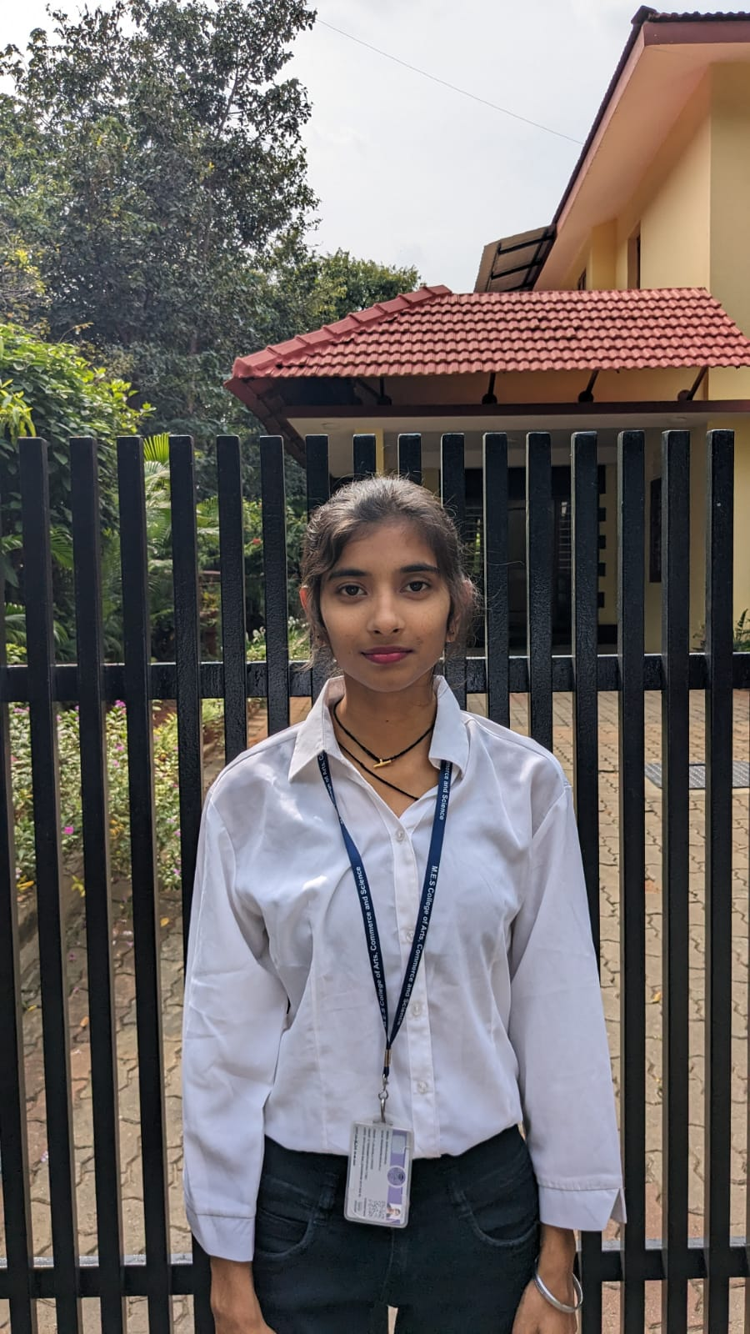
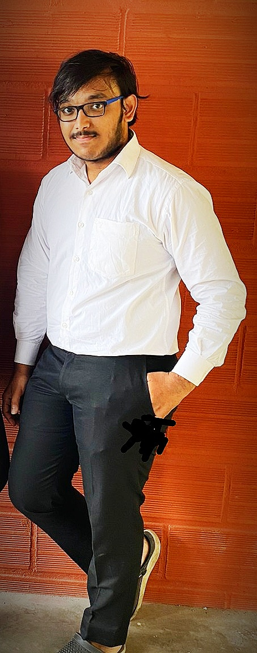
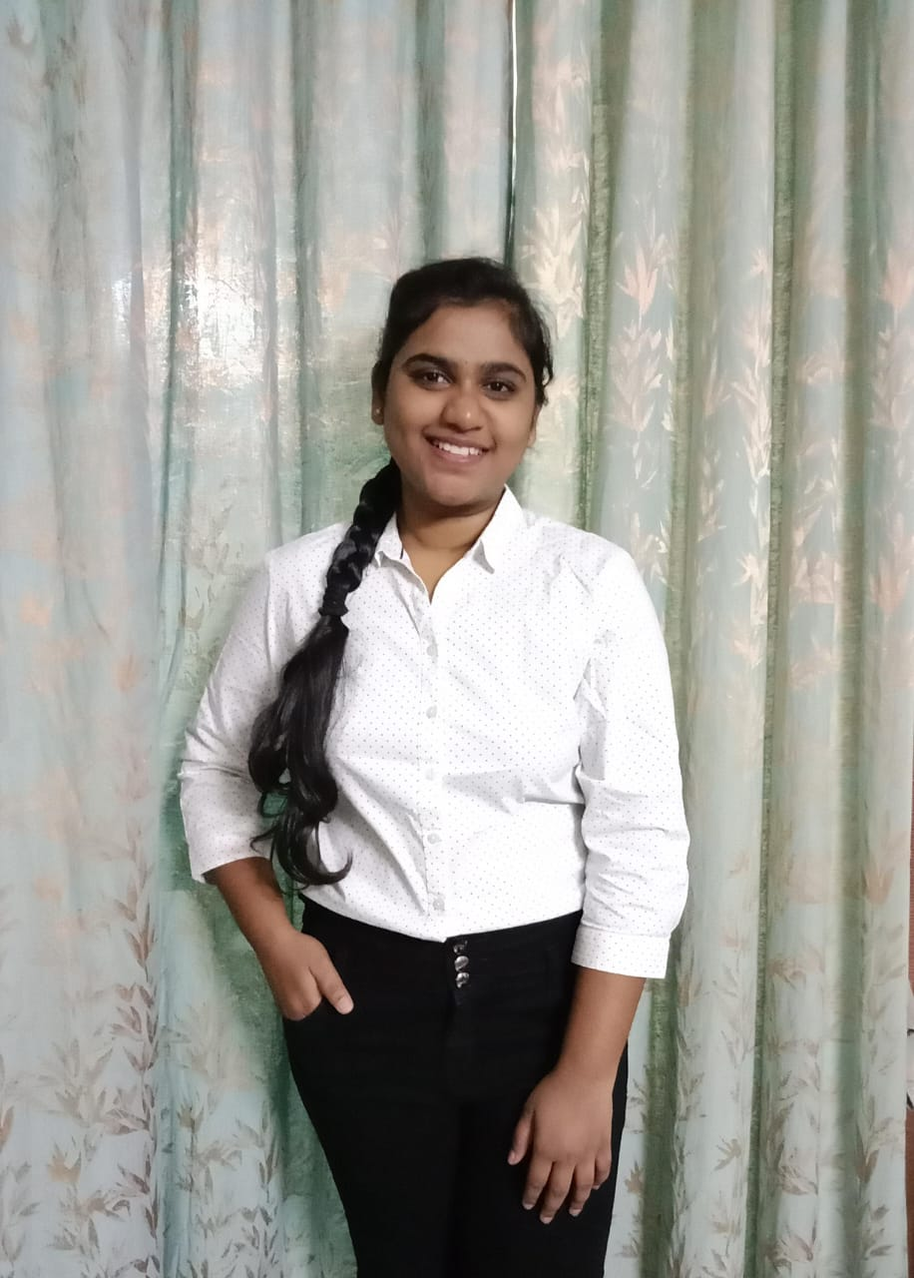

PAVAN KUMAR S SHRIYA KONDAL PRUTHVIK K HARINI M
R&D COMMITTEE HEAD R&D COMMITTEE HEAD R&D CO-HEAD R&D CO-HEAD

CREATIVE COMMITTEE
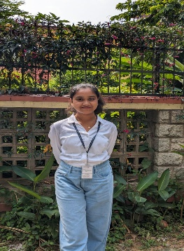
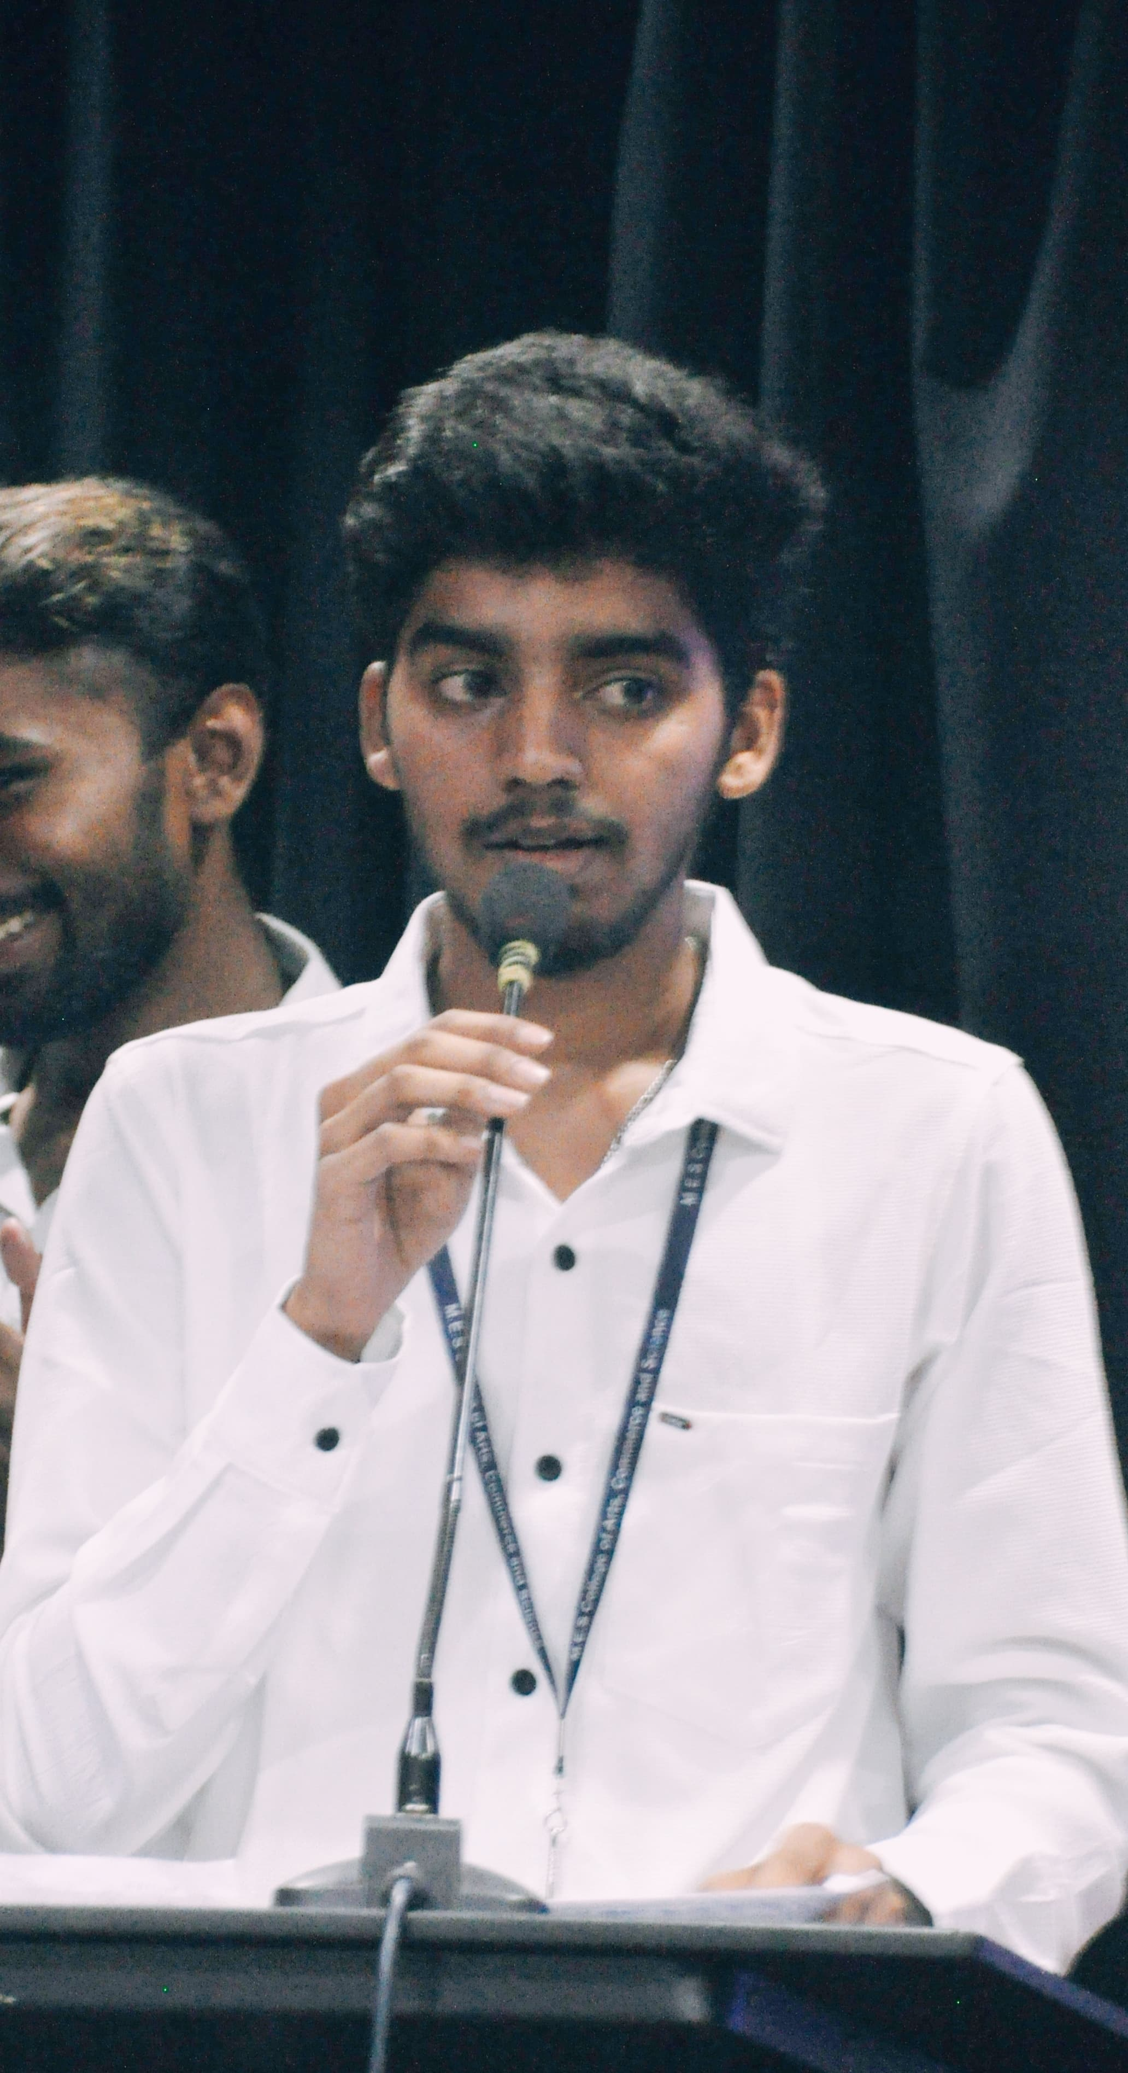
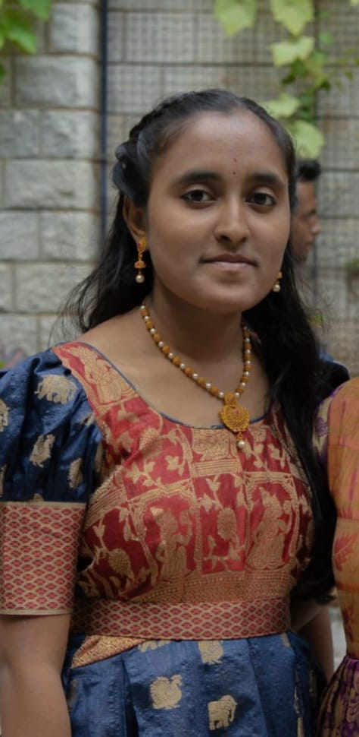
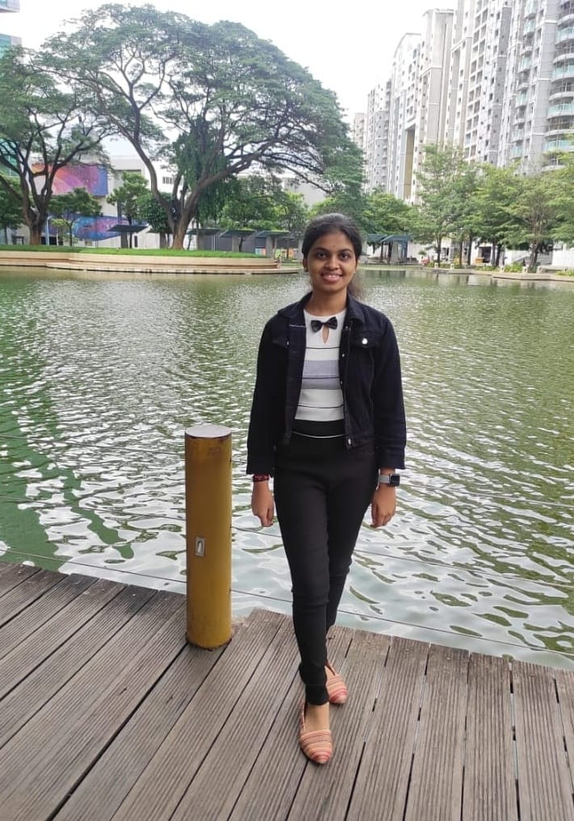

SANTOSH D KRUTHIKA H SHYLAJA K PADMA L
CREATIVE COMMITTEE CREATIE COMMITTEE CREATIVE COMMITTEE CREATIVE COMMITTEE
HEAD HEAD CO-HEAD CO-HEAD

PUBLIC RELATIONS COMMITTEE
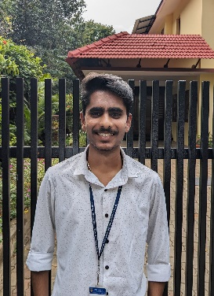
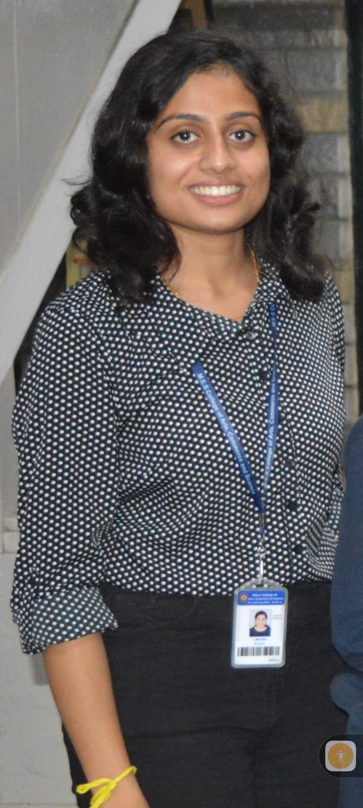

ROHAN GAURAV BRUNDA L AMRITHA
PR HEAD PR CO-HEAD PR CO-HEAD
STUDENT REPRESENTATIVES
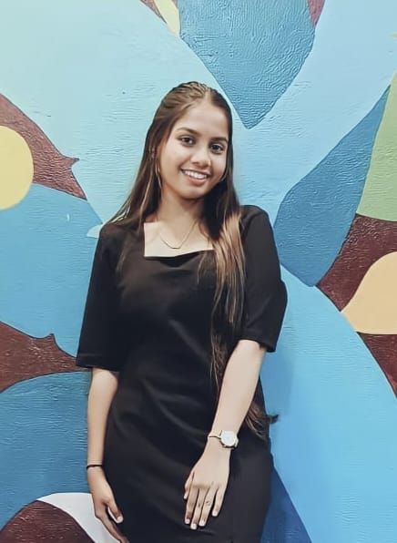
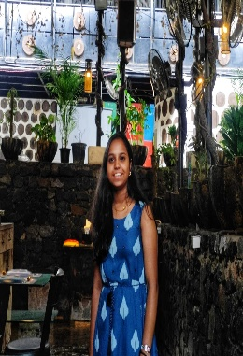
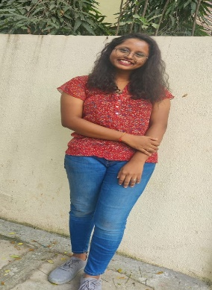
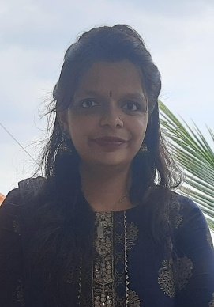

CHANDHANA MK DISHA PRASAD B MEDHA K PREETHA S

5.OBJECTIVE OF THE CELL :
- INTRODUCTION : The Consumer Club was initiated by the Department of Commerce in the year 2021. This was started under the guidance and mentorship of the Consumer Care Society in the tenure of Mr. Ashok M L, the President and Mr. Gopal Ratnam, the Secretary of the Consumer Care Society for the year 2022-23. The club was formally inaugurated on the 23rd of November, 2022.
- To provide opportunities for practical learning and understanding beyond the purview of lecture based learning.
- To pool in members out of voluntary interest to contribute towards the consumers of the society and expand their knowledge base.
- To provide endless opportunities for members to put to practice their budding ideas and imaginations and transform them into projects that hold a voice to bring a difference.
- To equip the man power of the club to be the voice for the consumers and their grievances on a large scale.
- To build a community of informed and well aware people in multiple disciplines.

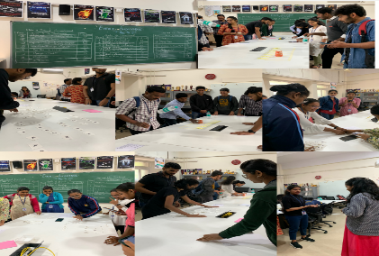
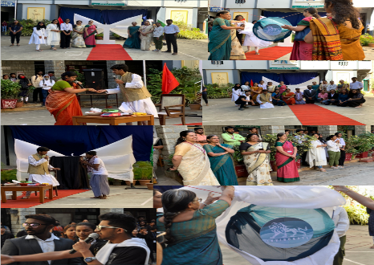
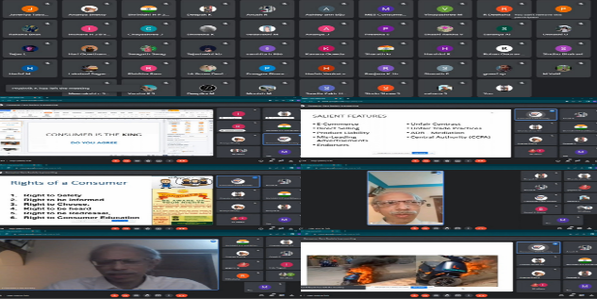
6. HIGHLIGHTS OF THE CLUB.

EVENT ANONYMOUS lOGO LAUNCH WEBINAR ON CPA 2019 AND CONSUMER RIGHTS
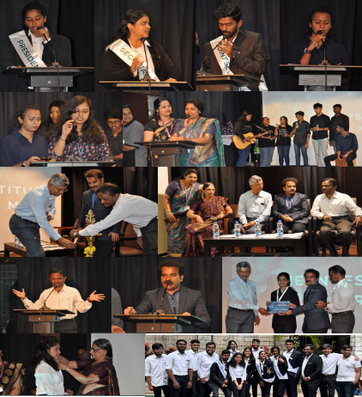
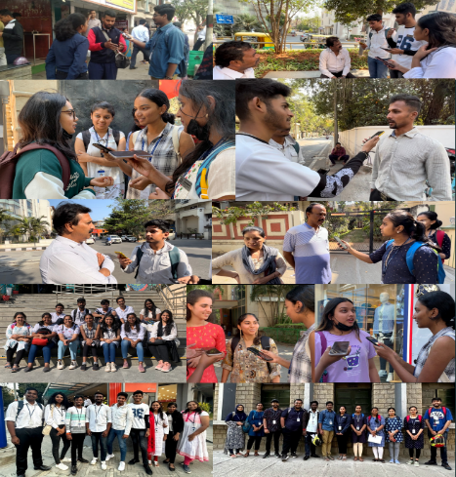
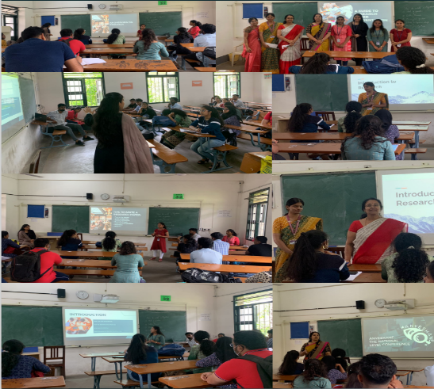

THE INVESTITURE CEREMONY PROBING KNOWING Survey A GUIDE TO RESEARCH PAPER PRESENTATION
2022-23 Waste management
Menstrual cup usage
Demat account - affect of budget 2023.
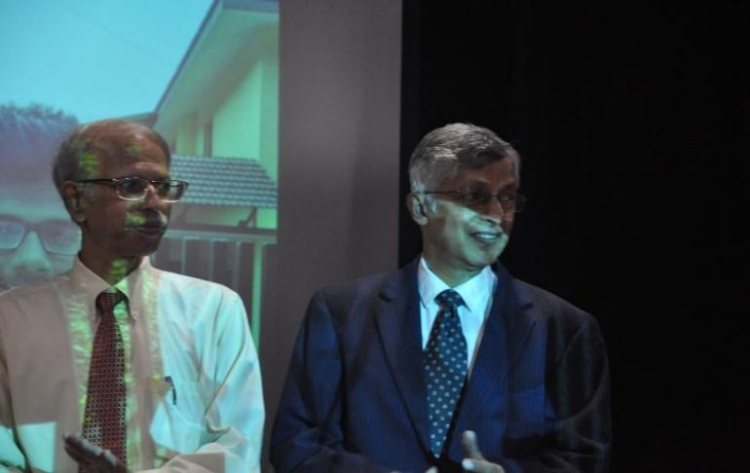
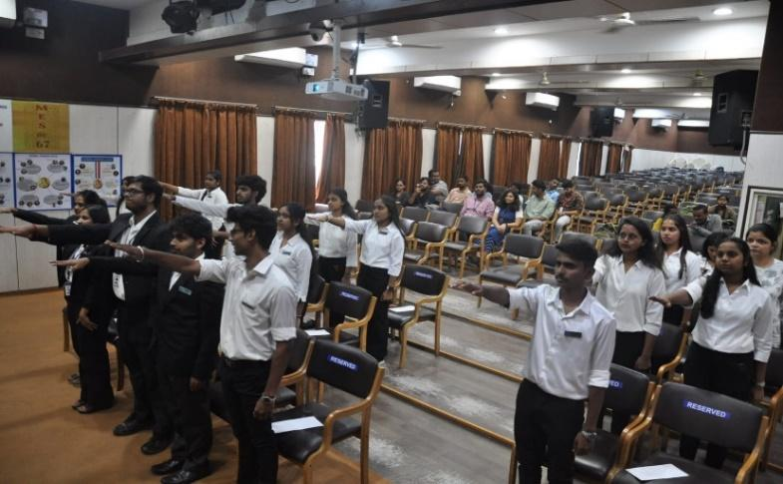
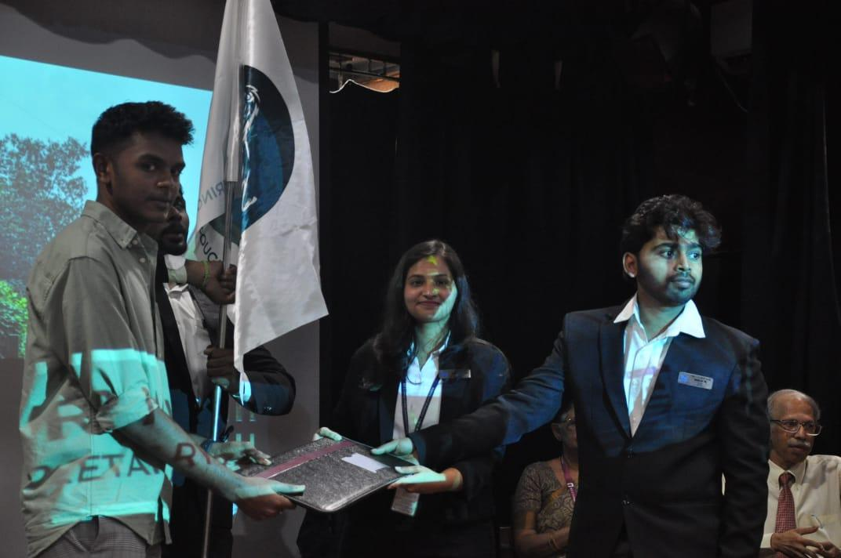
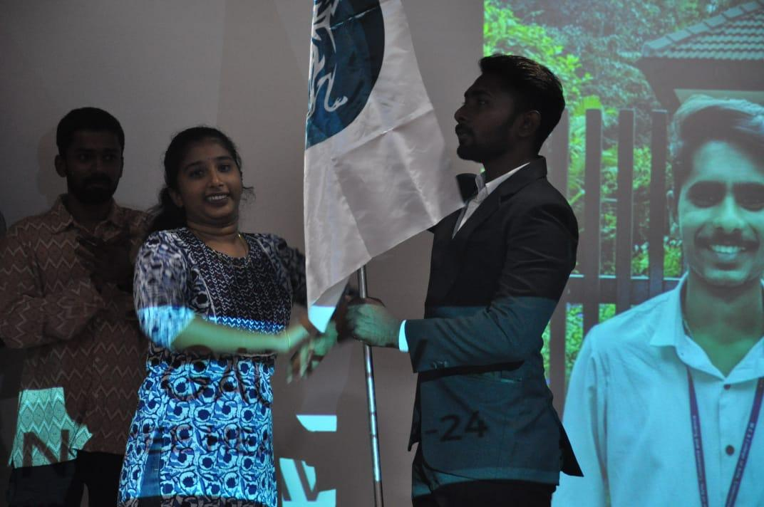
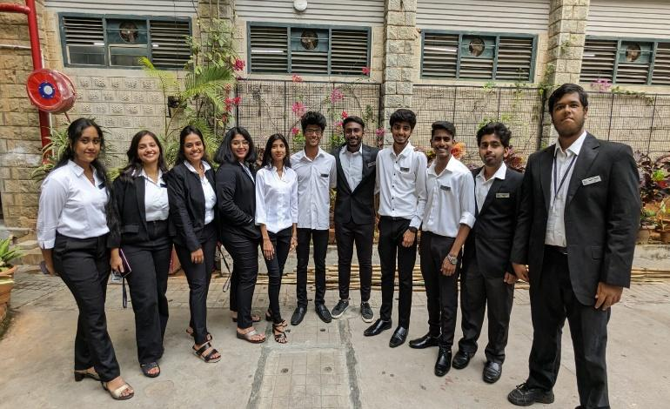
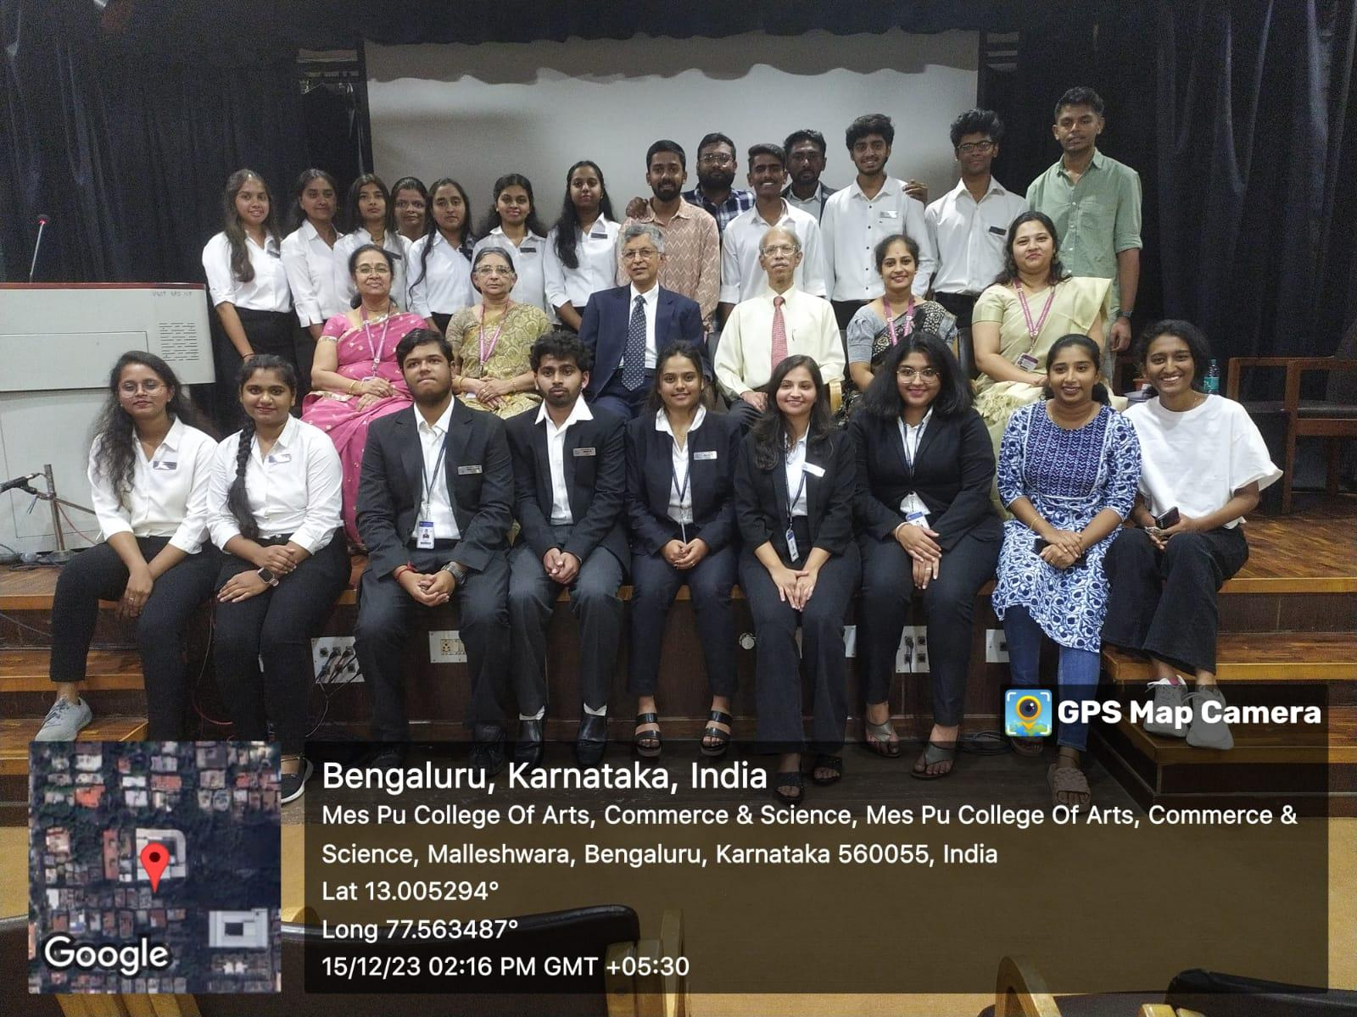
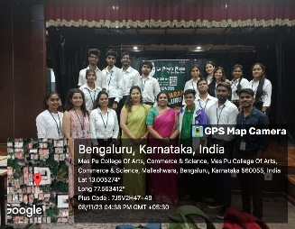
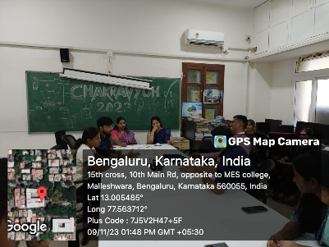
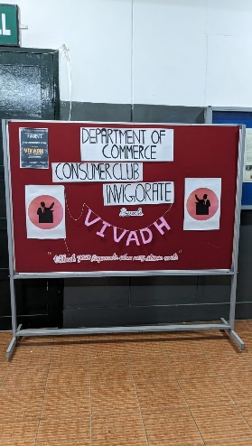
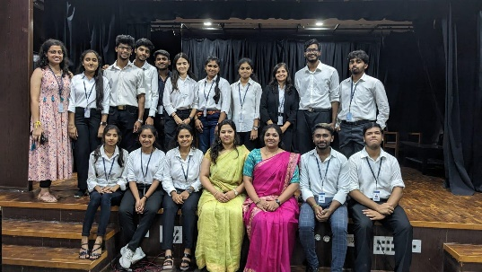

Vivadh a Debate competition held on
08th & 9th November 2023.

THE INVESTITURE CEREMONY
2023-24
UPCOMING EVENTS
- PODCASTS WITH FIELD EXPERTS
- CONSUMER QUIZZES AND ACTIVITIES FOR PUBLIC
- CONSUMER WELFARE EVENTS WITH FELLOW CONSUMER CLUBS
- FIELD TRIPS FOR PRACTICAL EXPOSURE AND LEARNING
- AWARENESS BASED MOVIE SCREENING
- PR INITIATIVES
7. SOCIAL MEDIA LINKS
INSTAGRAM : https://www.instagram.com/mes.invigorate?igsh=MzRlODBiNWFlZA==
YOUTUBE : https://youtube.com/@invigorate2023?si=Tt5tr_5AzxppnMnf

