NAME OF THE CLUB:
CREATIVE CORNER

CLUB LOGO:

TEACHER CONVENOR:

Asst. Prof. Divya . J
Department of English

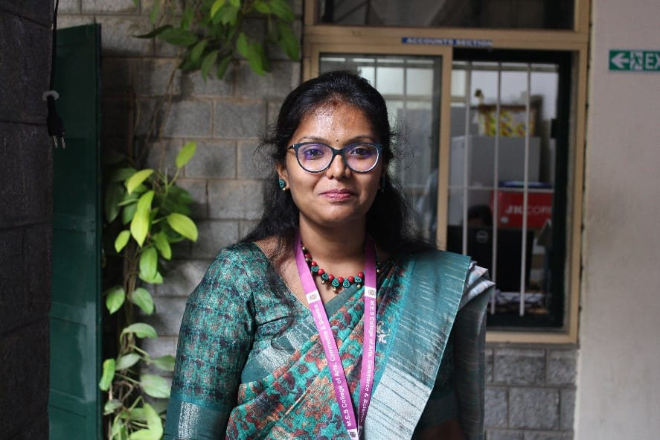

OFFICE BEARERS:

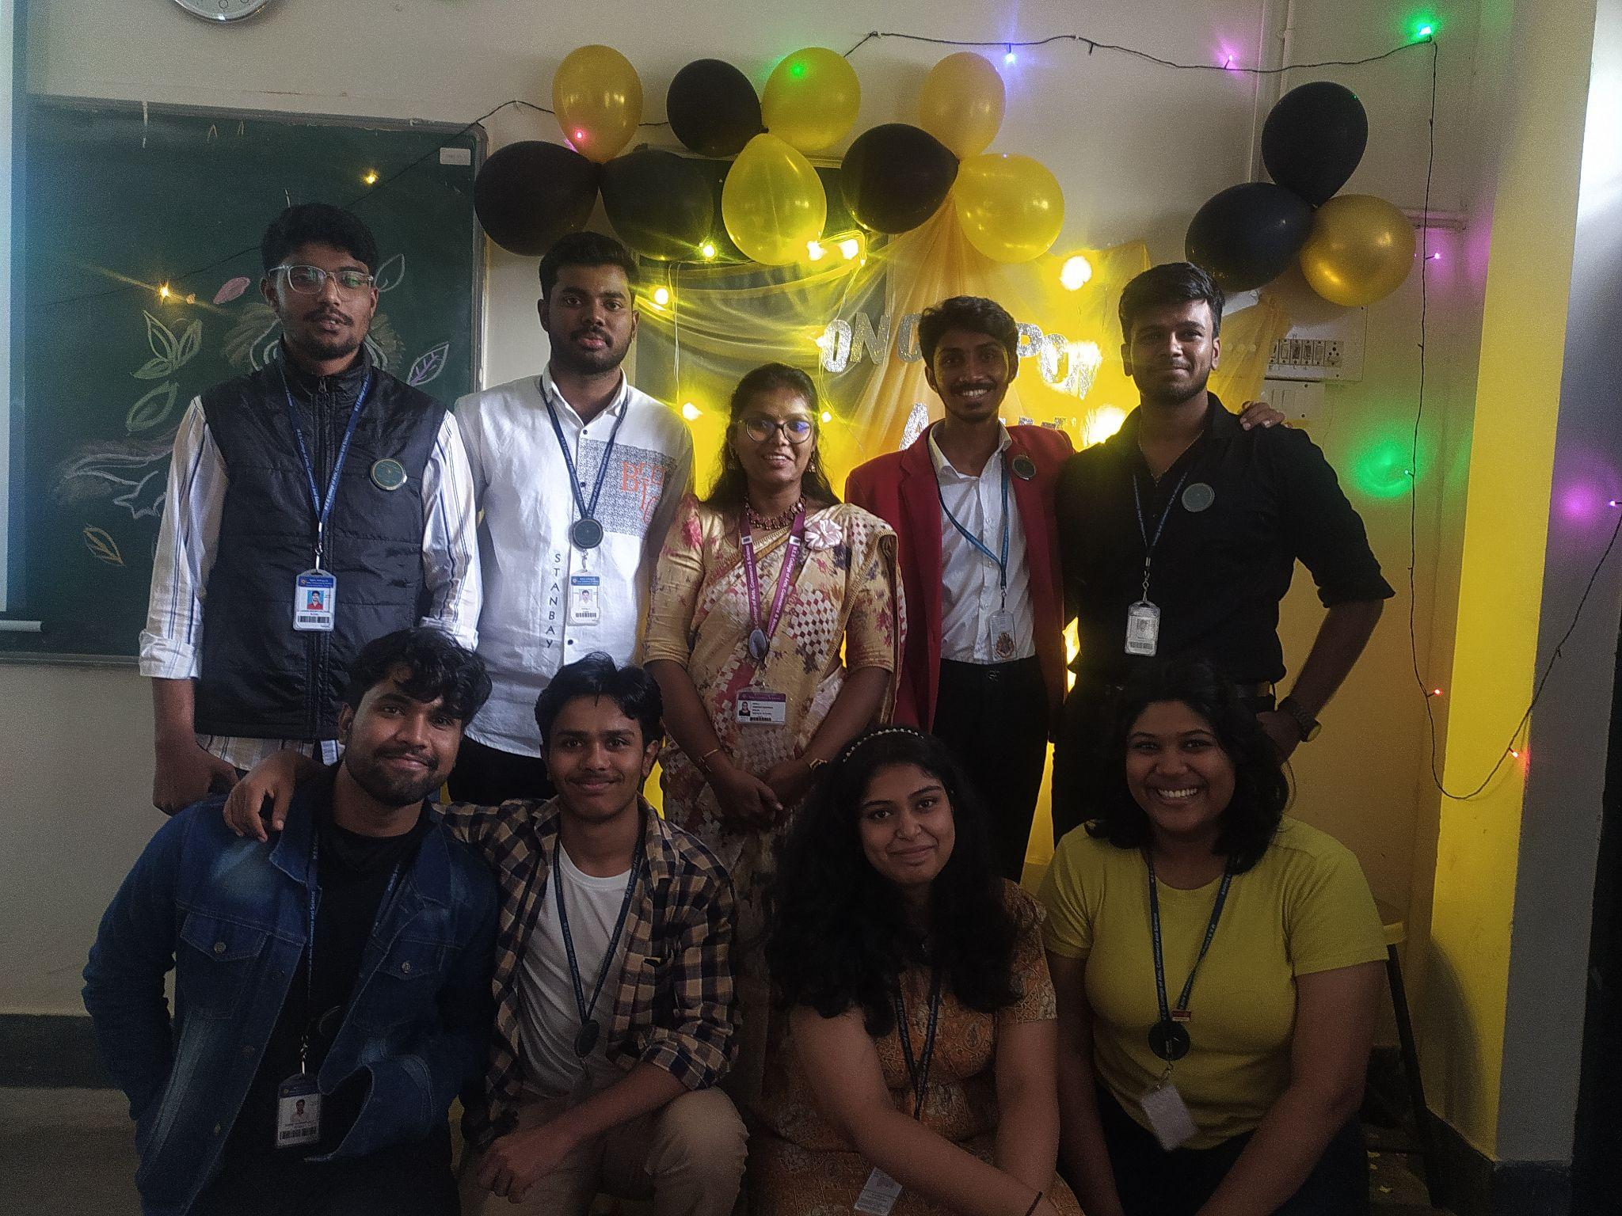

- President - Sai Keerthi. R
ROLES:
- Set the overall direction and vision for the club
- Represent the club in all forms of literary events

RESPONSIBILITIES:
- Ensure activities align with the club's mission.
- Ensure efficient operation and member engagement.
- Preside over all club meetings

2. Vice-President - Kritika Mohan. R A
ROLES
- Assist the president in operations of the club
- Maintain active communication between the members

RESPONSIBILITIES:
- Preside over operations in the absence of the president
- Preparation of event reports

- Administrator- Kushal. V
ROLES:
- To ensure the internal administration of the club
- Construct an agenda for all meetings and maintenance of records

RESPONSIBILITIES:
- Maintenance of minutes of meetings
- Ensure adequate document requirements are fulfilled

4. Associate Administrator- Sanjay Krishna
ROLES
- Assist the administrator in routine tasks
- Ensure smooth flow of information within the club and students

RESPONSIBILITIES:
- Preside as the administrator in his/her absence .
- All information to be conveyed to students is circulated adequately

5. Editor- Lakshmi Sagar
ROLES:
- Preparation of the Club Magazine- Meraki
- Oversee and review the content received for the magazine.

RESPONSIBILITIES:
- To ensure error-free, well-constructed information is circulated to the audience including brochures , magazines and messages.
- To uphold the quality of content published

6. Sub-Editor- Vedarth. V
ROLES:
- To assist in the reviewing of content for the magazine
- To assist the Editor of the club in operations.

RESPONSIBILITIES:
- To ensure error-free, well-constructed information is circulated to the audience including brochures , magazines and messages.
- To uphold the quality of content published

7. Technical Associate- Adarsh. U
ROLES
- To assist the club fulfil its technical requirements
- To ensure the innovative flow of thought to the audience through technology

RESPONSIBILITIES:
- Smooth implementation of technical requirements
- Assist in documentation and reporting.

8. Technical Associate( PR) - Shishir Kaverappa
ROLES:
- Assist the Technical Associate with operations
- Maintain social media handles

RESPONSIBILITIES:
- Ensure club visibility is always at its best across social media.
- Implement engaging activities and introduction of content to improve club relations with students.

NO. OF MEMBERS FOR THE ACADEMIC YEAR : 8

OBJECTIVES OF THE CLUB:
- Nurture individual talents and passions by helping members develop their creative skills and build confidence in their artistic expressions.
- Celebrate the diverse creative voices of the contributors and promote mutual appreciation of literature.
- Facilitate respectful discussions about literary works, diverse perspectives, and interpretations.

HIGHLIGHTS OF THE EVENTS (2023-24)

- ONCE UPON A TIME- GRIMM ENDINGS
The club organised its signature event- Once Upon A Time,an event to commemorate Children's Book Week on 9th November 2023. The theme for 2023-24 was Grimm Endings.The students were required to pick a Grimm Brothers fairytale of a Disney book adaptation, provide character analysis, contrats in the protagonists and the antagonists and finally, provide an alternative ending to the existing story.

The event saw a massive turnout of 36 teams, who were well-exposed to the world of literature whilst unleashing their creativity into their work in the course of the event.

Event brochure:
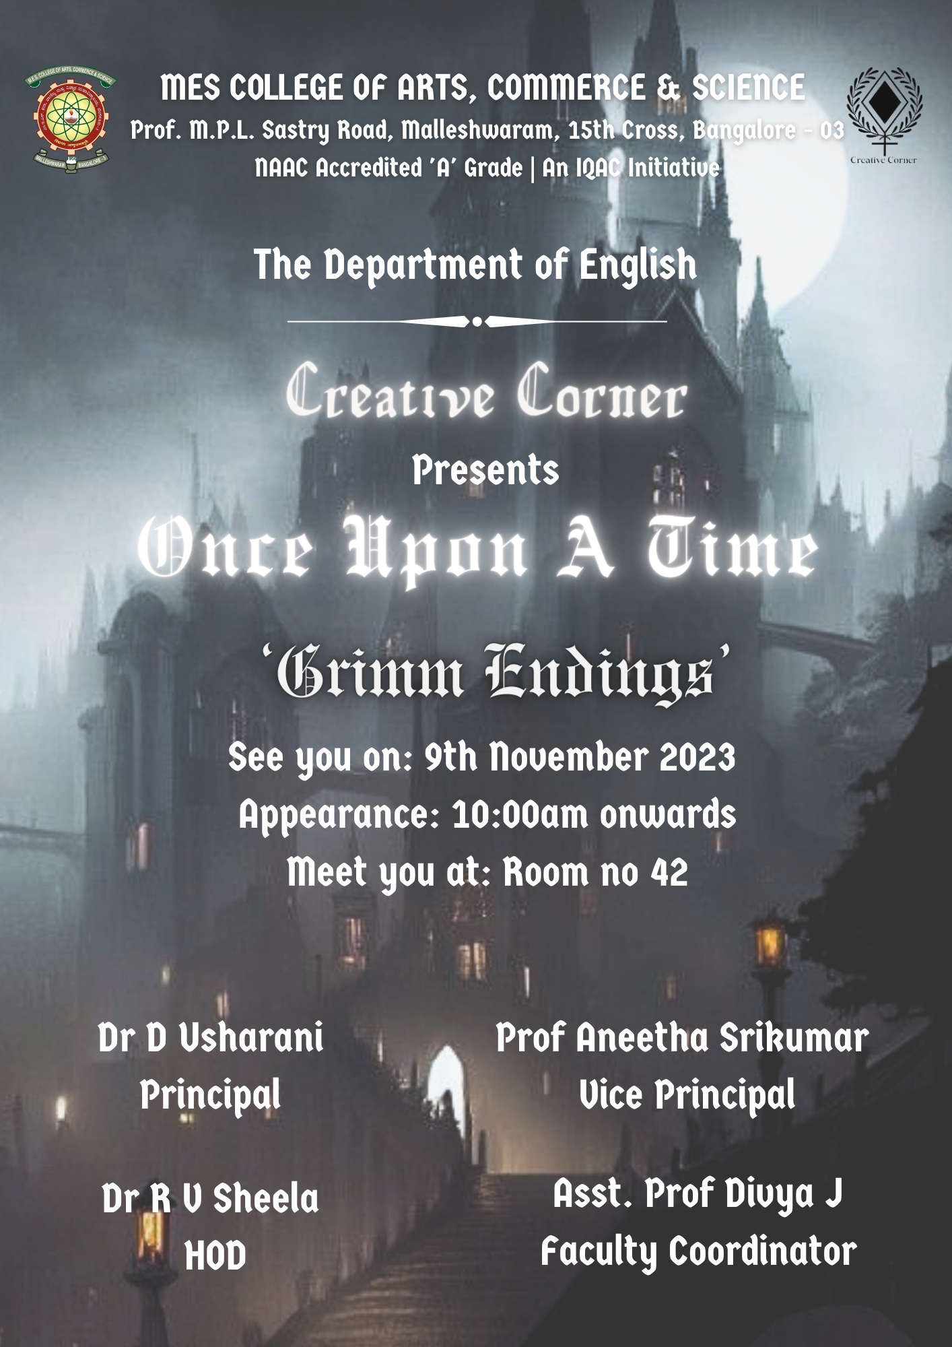

EVENT PICTURES

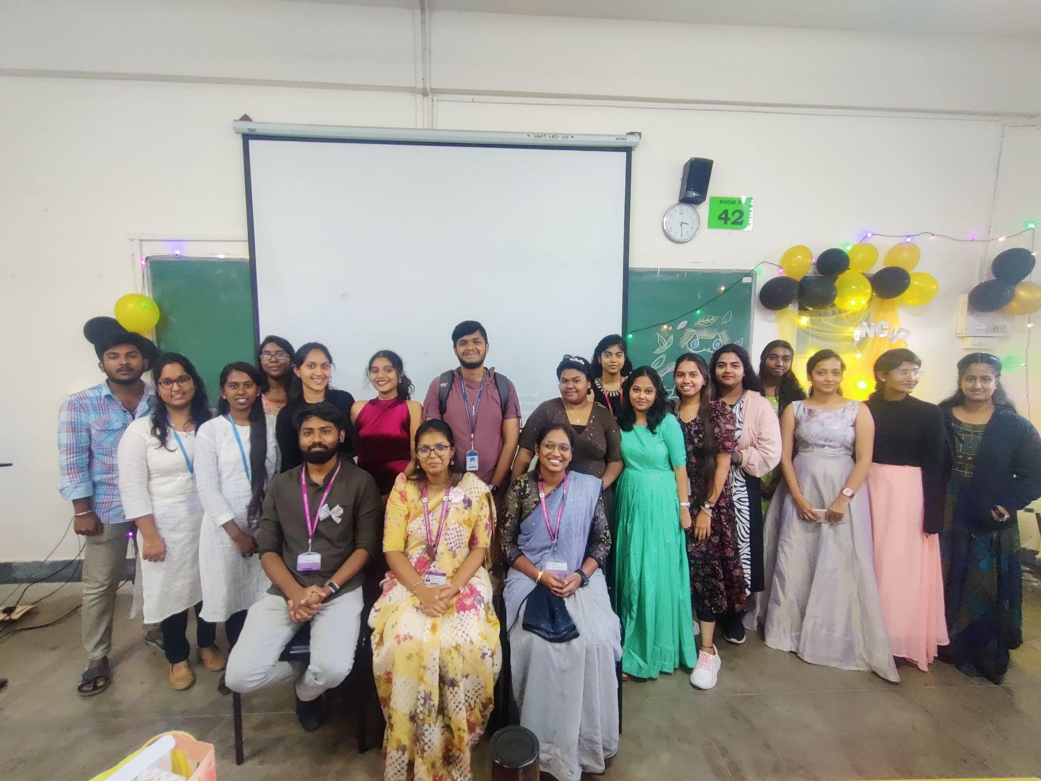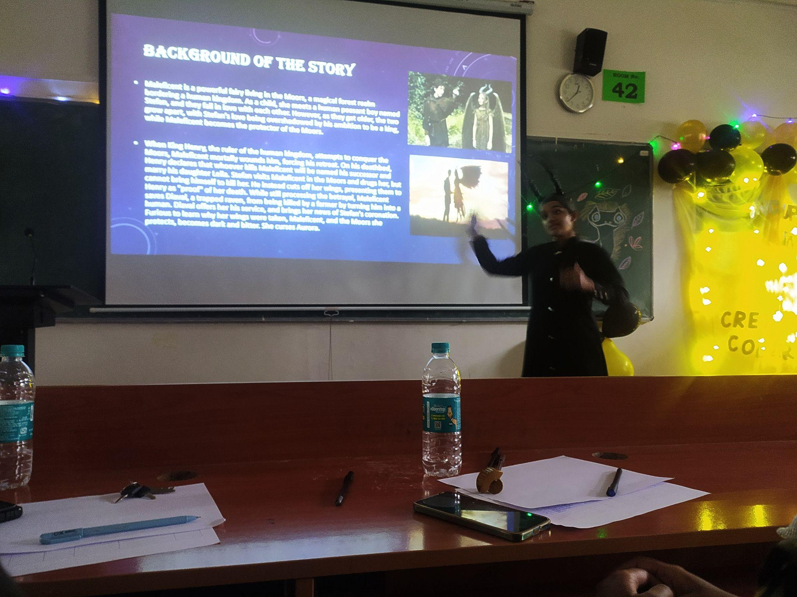

- LAUNCH OF THE 5TH EDITION OF MERAKI
The club, which also releases a student oriented magazine called Meraki, launched its fifth edition on 9th December 2023. The magazine contents include information on the Nobel Literature winner- Jon Fosse, Booker prize winners, short stories, literary pieces and artwork by students.

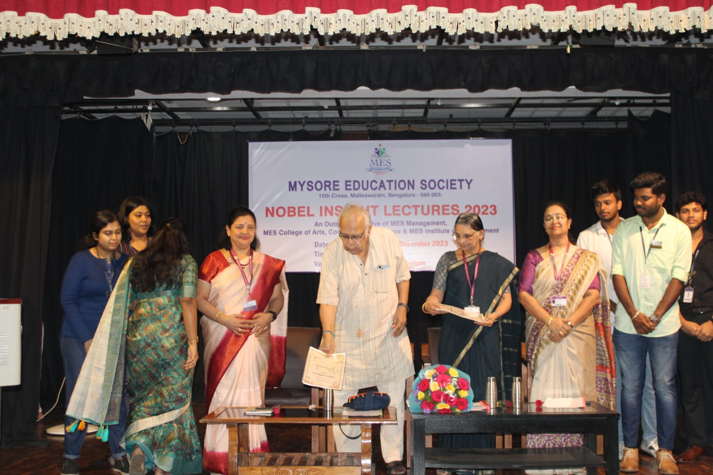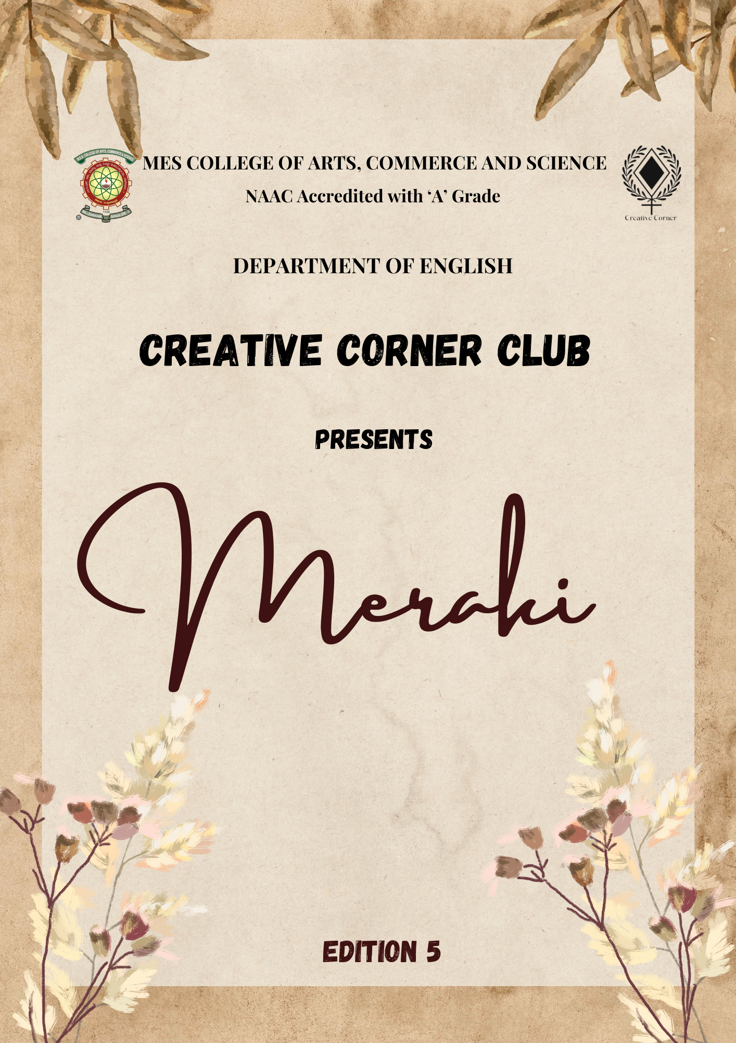

CONTACT INFORMATION/ ESSENTIAL LINKS

Instagram handle: @meraki.mes

https://www.instagram.com/meraki.mes?utm_source=ig_web_button_share_sheet&igsh=ZDNlZDc0MzIxNw==

EMAIL ID – creativecorner.mes@gmail.com

