ALBUM 2017
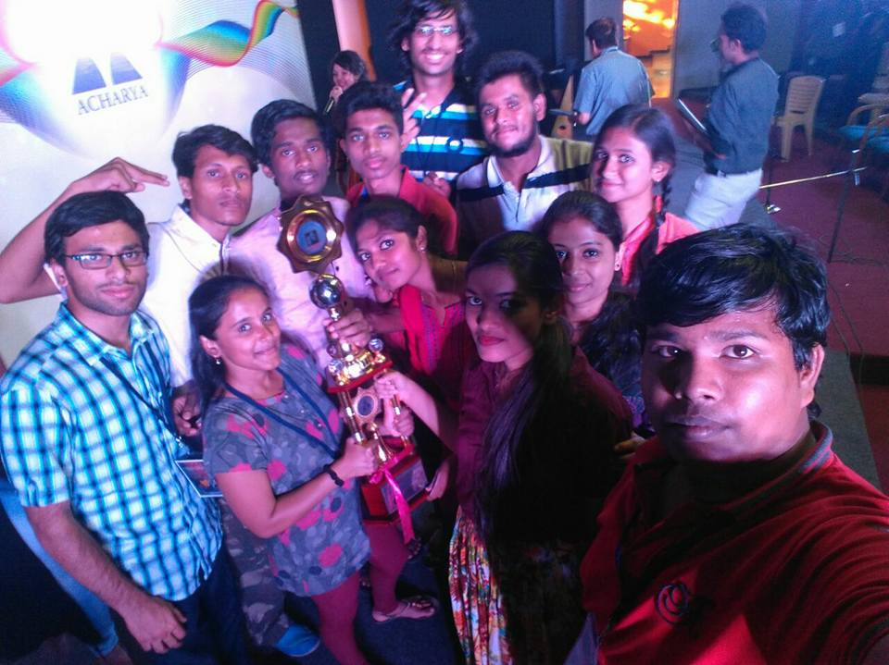
College Ranga Vaibhava team won Ist prize for perfoming “WOYZECK DRAMA” in Acharya college Rangadarpana competition held in March 2017

ALBUM 2018

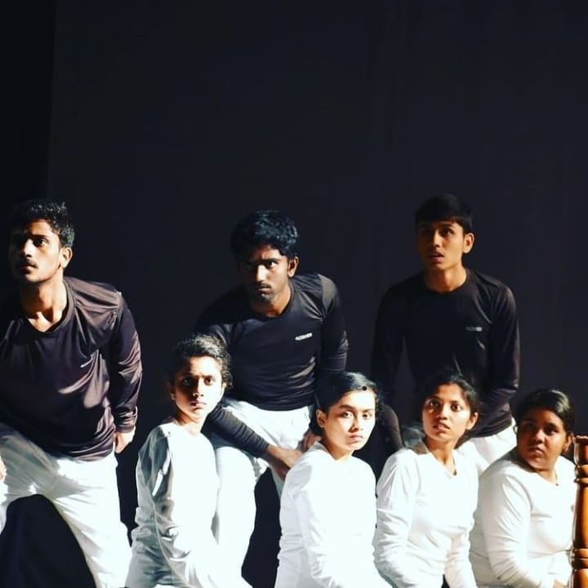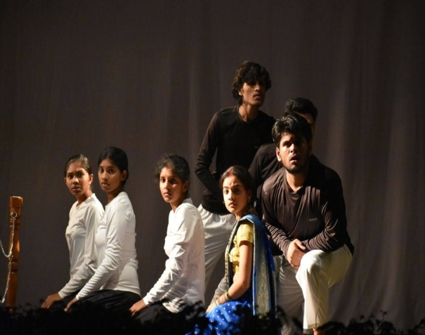

A glimpse from the drama “SEERE” by Rangavaibhava team of our college - 2018

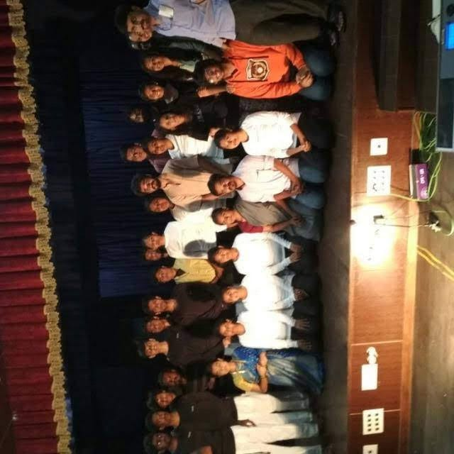
RANGAVAIBHAVA TEAM - 2018

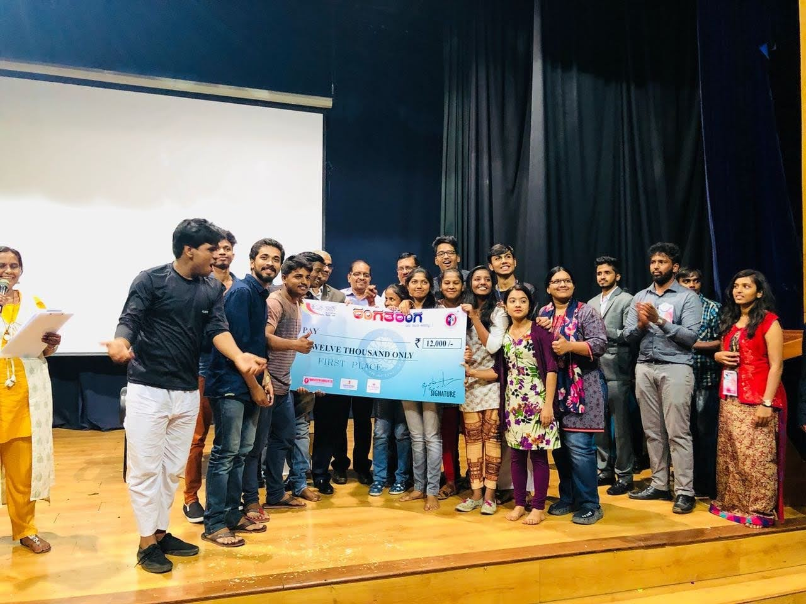
WINNING MOMENT: “SEERE”Drama team won First Place in Ranga Taranga Competition

ALBUM 2019

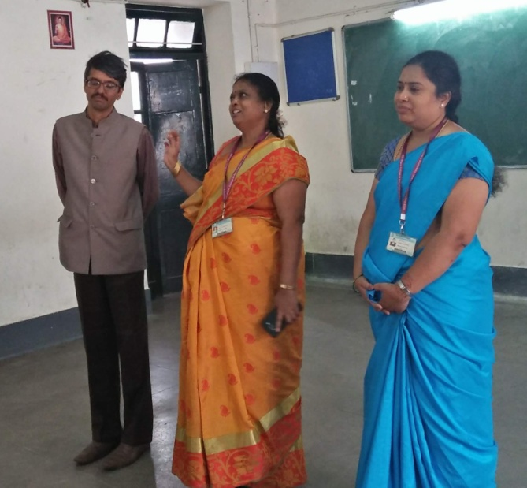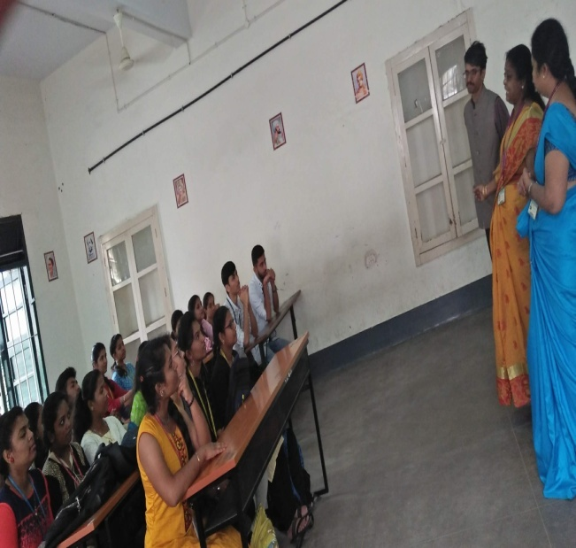

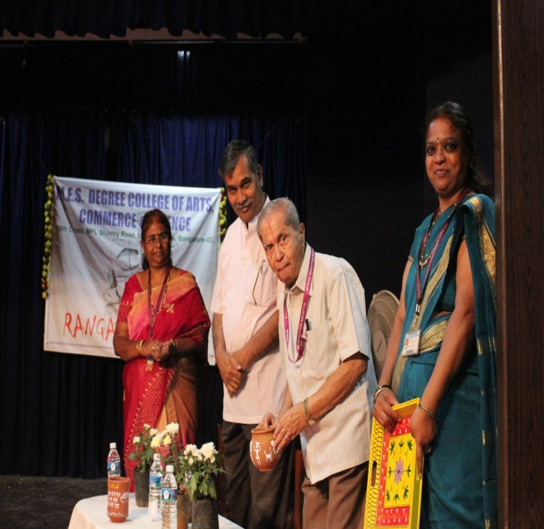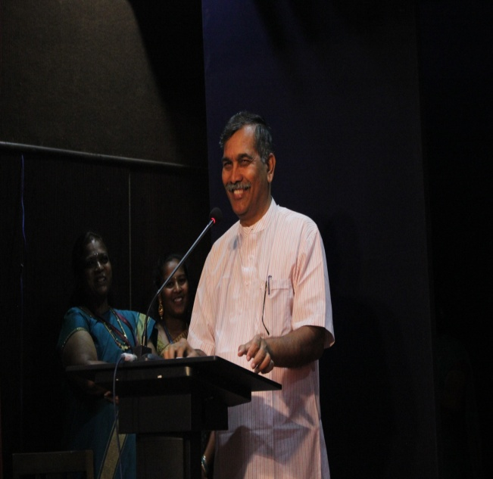

Inauguration of World Drama Day Chief Guest Dr B V Rajaram addressing the audeience

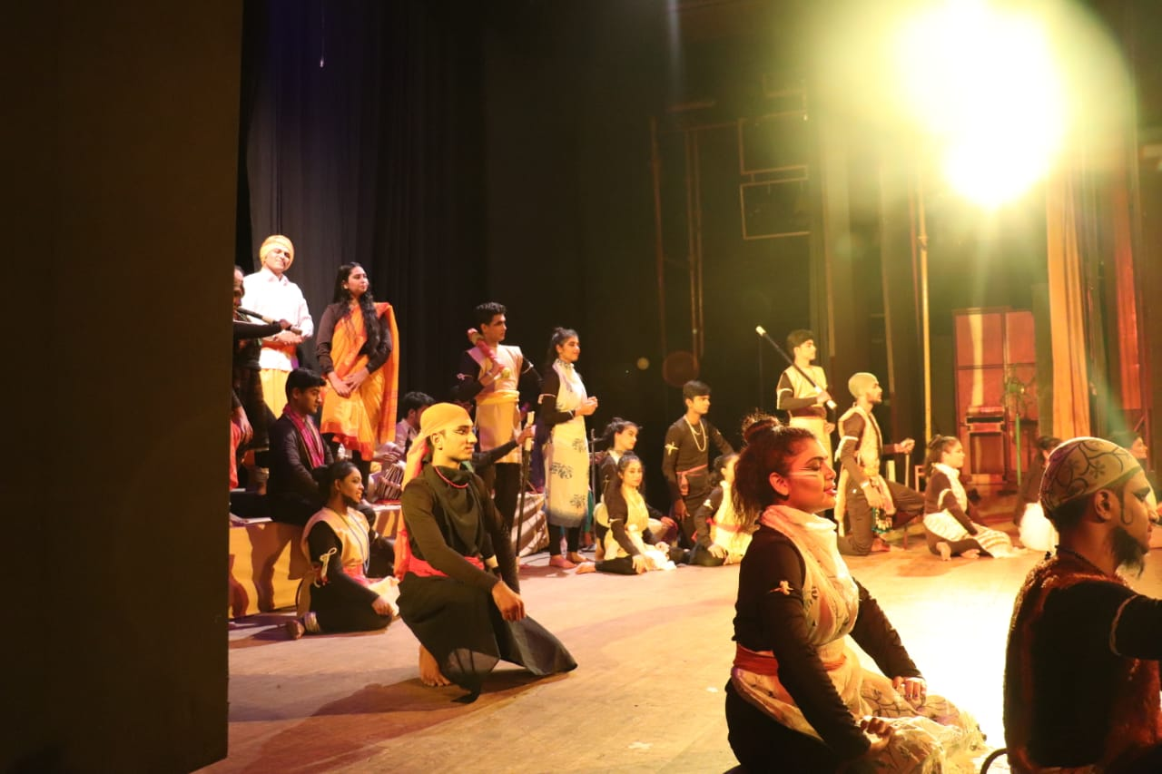
A Glimpse from the Drama “MARUTHI VIJAYA” perfomed by our Rangavaibhava team

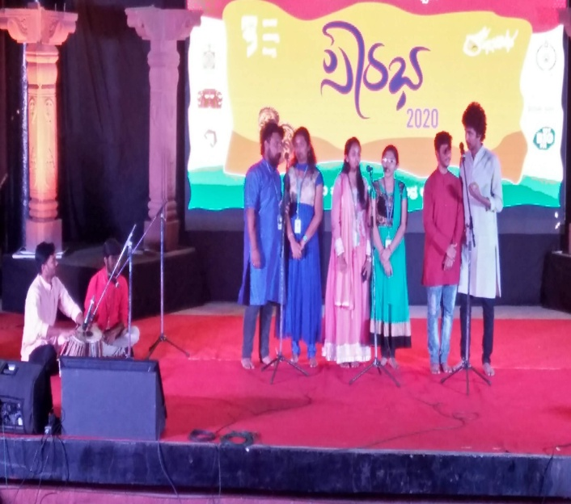
Rangavaibhava Music Team Perfoming in Ranga Saurabha Competitions

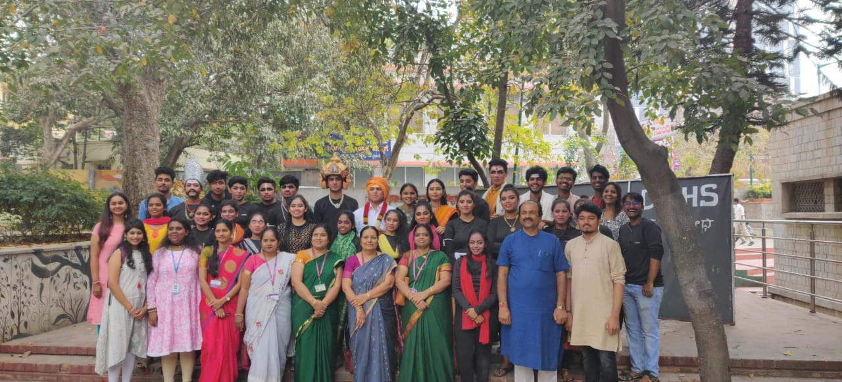
2019 Rangavaibhava Team with our Vice Principal Prof Shamshiya Rizwana in Center

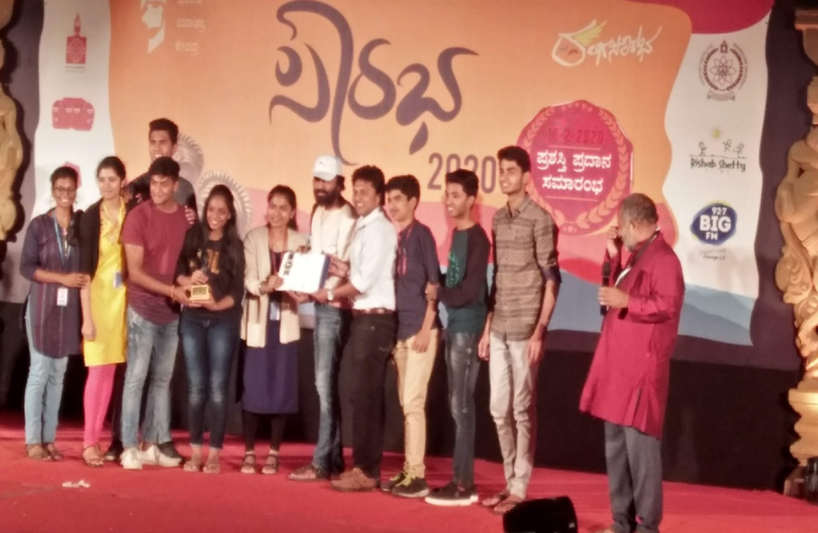
HAPPY MOMENT FOR OUR RANGAVAIBHAVA TEAM RECEIVING PRIZE

