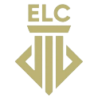
Electoral Literacy Club.
Faculty Profile:
- Name: Rekha Balwally
- Designation: Assistant Professor, Placement Officer, Convener (LAC, ELC)
- Qualification: B.A, LL.B, LL.M, PGDIPRL, NET LAW
- Areas of interest: Drawing, Painting, sketching, gardening, reading books.
- No of years of Teaching experience: 16
- Number of Papers presented: 6
- Number of Papers published: 2
- Faculty photo:
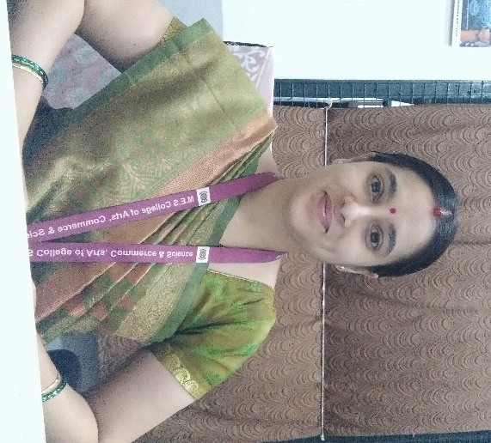

Vision: To develop a culture of electoral participation and maximize the informed and ethical voting and follow the principle 'Every vote counts' and 'No Voter to be Left Behind'. The club will have students as its members. One can become a member by registering herself/himself at the beginning of the academic year.
Mission: Educate and sensitize the youngsters about the politics of the country. To carry on activities as per SVEEP (Systematic Voter’s Education and Electoral Participation programme)
Office Bearers:
Noor Fathima: Lead of club
Responsibilities:
To co ordinate the activities of the cell .
To supervise and guide junior members.
To work with the team spirit.
No. of members for current academic year: 15
Objectives:
- Enhance Understanding of Electoral Systems
- Raise Awareness of Voting Rights
- Encourage Informed Decision-Making
- Facilitate Mock Elections and Simulations
- Instill Ethical Values in Politics
Best Practices of the cell:
- Voter ID registration
- SVEEP
- Conducting rally, awareness programmes and competitions.
- Mock Parliament session
- Panel discussion session
Some event links organised by ELC:
https://drive.google.com/drive/folders/1dt8lKHDpyiju-nArHJBIbo20gypD9Ujs?usp=drive_link
https://drive.google.com/drive/folders/1-I6upfjBiHIlPVJypzE0cobCMmlpBgMO
https://drive.google.com/drive/folders/1-83YytwlCVWoNiGGDzGnuP9qqOEhUDqc

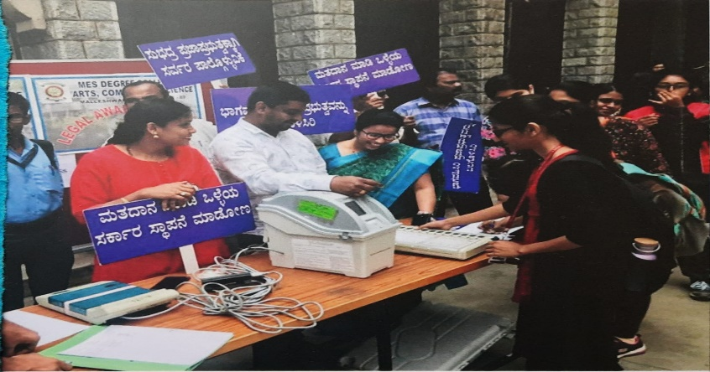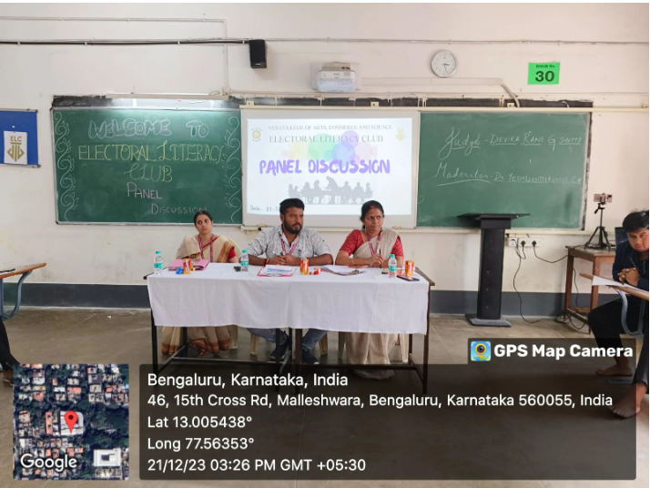
Voter ID registration done by ELC MES for first time voters
Panel discussion session
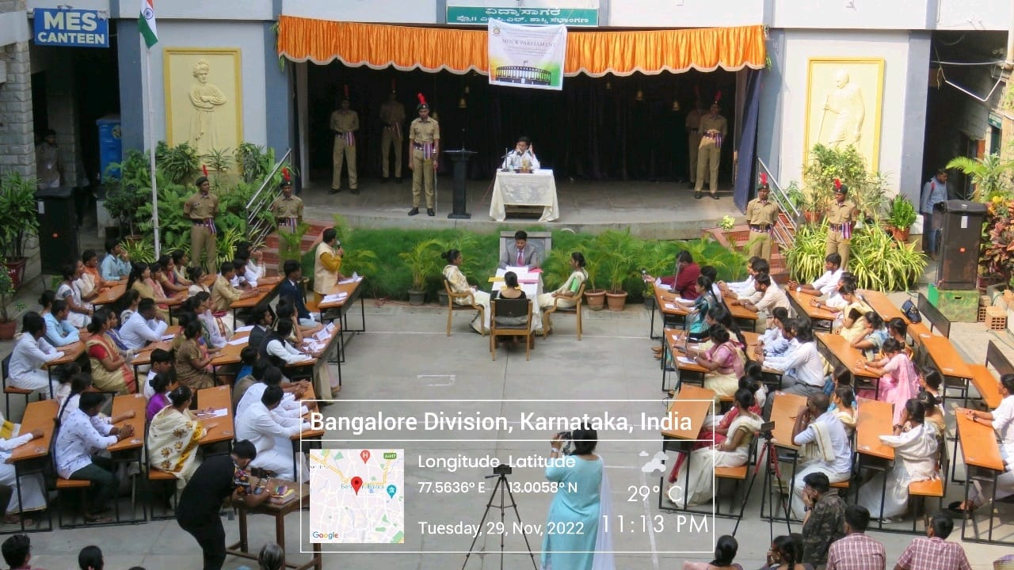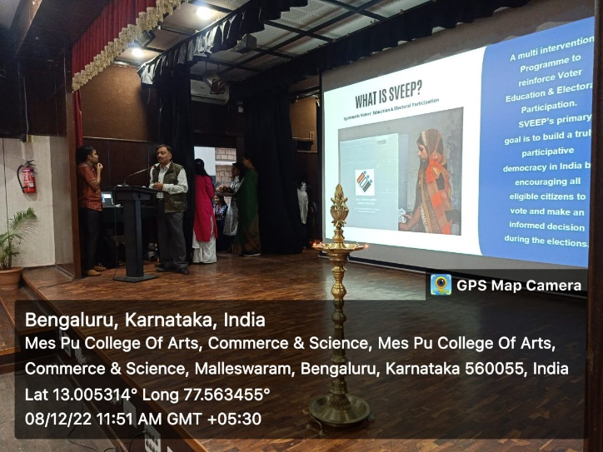
Mock Parliament Session
Voter enrolment and awareness programme organised by ELC in collaboration with SVEEP
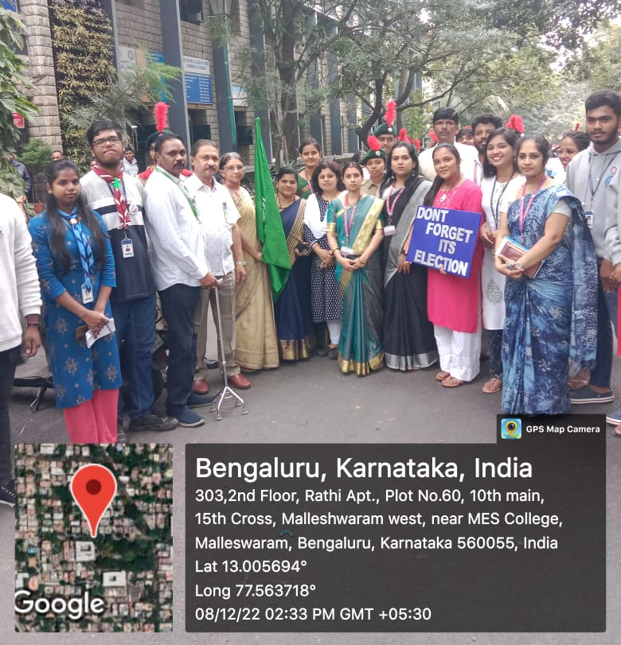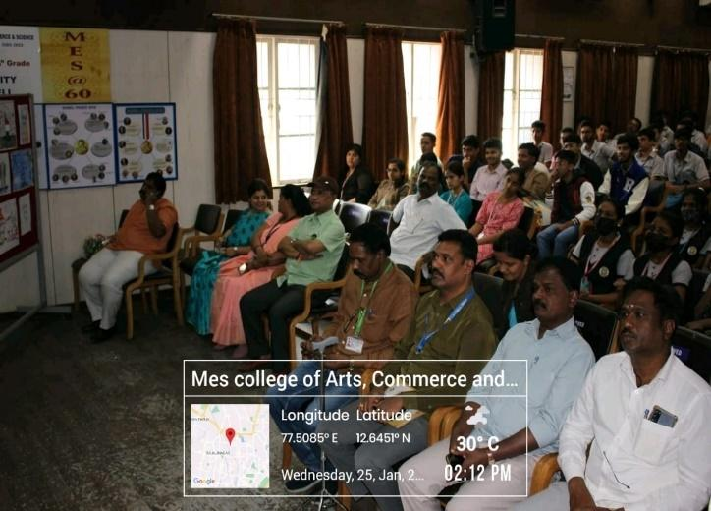
Rally and awareness programmes
National voter’s day celebration

Social media handles:
- Instagram: https://www.instagram.com/elcmes?igsh=MW9mMXh2djlkNHhpZA==
- Mail ID: meselc2022@gmail.com

