English Department
The English Department club is called Meraki.
There are 3 different clubs under Meraki.
1. Creative Corner
2. Film Club
3. Literary Club

Once Upon A Time
One of the most exhilarating events put forth by the Creative Corner of the English Department, ‘Once Upon A Time’ is an event which set its sight to extricate the confined thoughts of the students on the most adored children`s books around the world, which accent its purpose to celebrate Children`s Book Week. The event encouraged the students, to transverse into the intricate themes of the books and illustrates their findings, through essays and power point presentations and creative demonstration of their thoughts, the event also rallied the students to manifest their beloved character through dress ups, thus providing a channel to suffice their artistic pursuits. The event welcomed the students across all the streams and the total registrations encountered was 46 students from first, second and third year.

Objectives
- To channelize the imaginative and inventive ability of the students.
- To inspire the students to proffer oneself and present their opinions and perspective on the given subject matter.
- To reinforce the analytical prowess of the students.
- To revamp the skills in practical presentations and direct resources towards robust vocalization of thoughts and notions.
Winners List
Vivek Ram Final Year Bsc
JayKaran First year BA
Kshitij Mallya and Rohit Y V Second Bcom

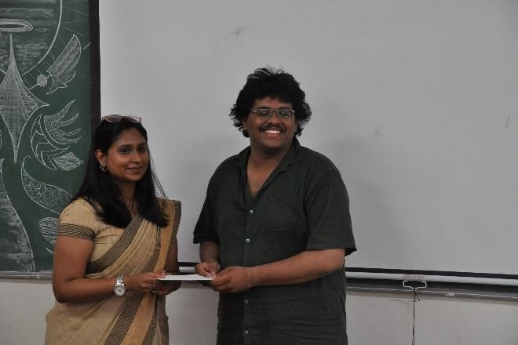
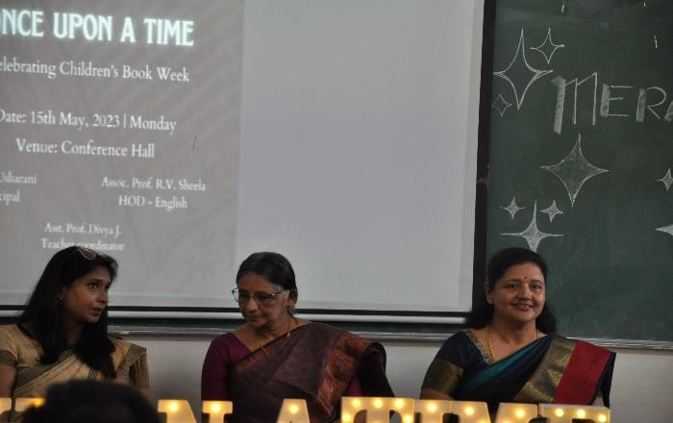
The inaugural Program Cash prize awarded to the winner by the
Chief guest Asst Prof. Pooja Pradeep Karaniya

Quizzitch
Inspired to seek the thrill and fascination of gallivanting in the mystically constructed world of Harry Potter, Meraki, the creative corner of Department of English, served the allurement of wonder and passion for the undying book series ‘Harry Potter’ by J K Rowling by orchestrating a platform for the students to flaunt their astronomical knowledge on the subject. With this regard a quiz competition was organized with three levels on 22nd of July, 2023 in room 30. The quiz solely focused on the literary aspects depicted in the book. And the environment which was designed to simulate the students ensembled the manner in which it was illustrated in the books with variety of souvenirs paying homage to the entire event and its theme. The registration received was 34 in total and the number of participants was 58 among which the participation was seen as 42 members in total.

Objectives:
- To develop and increase the engagement and reinforce the desire to make reading a pleasurable as well as a learning activity.
- Fostering healthy competition among the students.
- Promote critical thinking in analyzing the themes discussed in the book.

List of Event Awardees:
A Dattaprasad - Second BA
Sanjay K and Harshitha Reddy – Second Bsc and BA

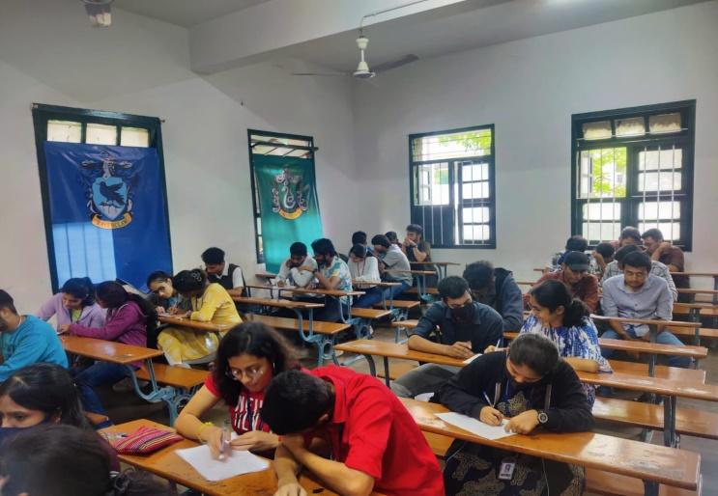
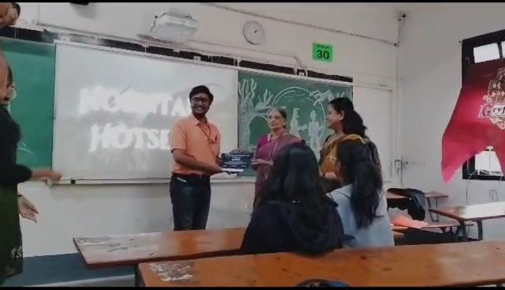

Venue room 30 Participants in round 1 Distribution of prizes to winners

SAMVADA: THE CONVERSATION OF LIFE
The English department of MES College of Arts, Commerce, and Science arranged an interactive session on 18th July 2023 between the students and a very well-known author Vasudhendra Shroff. Vasudhendra Shroff is a Sahitya Academy award winner. He has written such amazing works, a few notables among them are; 'Tejo-tungabhadra', 'Mohanswamy', and 'Nam Amma Andre nangishta'. He is also known for being an activist for the rights of LGBTQ+. He also accepted his sexuality to the public. The talk was fascinating and informative.
Shroff started his talk with his interest in classical music. He shared how his favorite violinist T.N Krishnan made him fall in love with classical music with his skills in playing Violin. He said that no matter how old one is, there is always one particular passion that will make us feel that we are still young at age. It will always remind us about our youth even when we are old. He asked the gathering to hold on to that one particular passion and never let it go because that will make us feel alive.