IT Club Report
DEPARTMENT OF COMPUTER SCIENCE

IT club was established by the faculty of Department of Computer Science in the year 2013.First intercollegiate fest was conducted in that year and student members were taken into the club. Various events related to IT were conducted every year by the department. The following are the events conducted during the academic year 2022-23:

- Webinar, “Programming Language: How to Master” on 16 sep 2022
Understanding Programming Language concepts and Learning a new language is key to the professions that can be chosen after the B.Sc course. This lecture aimed to provide tips for the students to master the programming Languages.

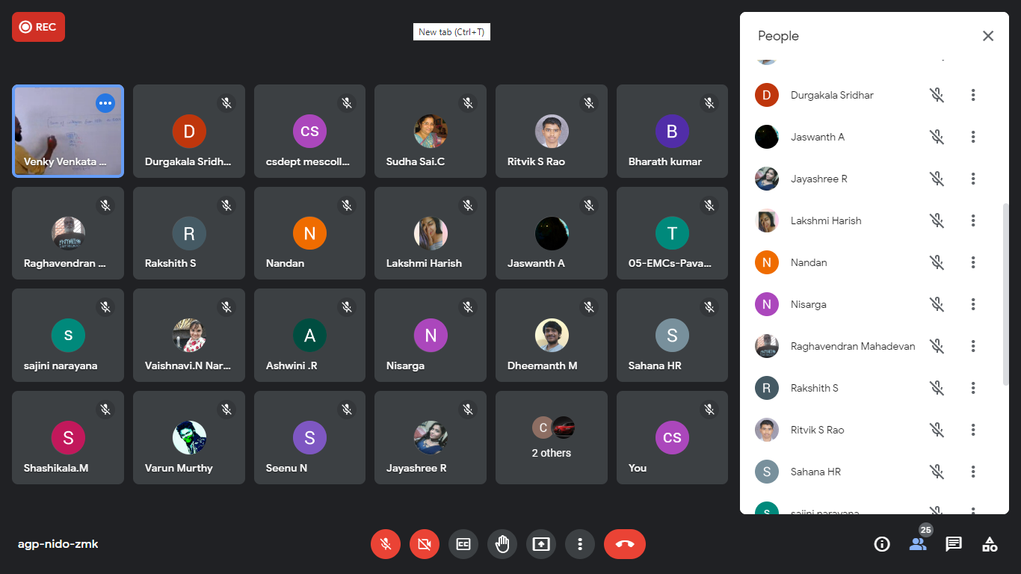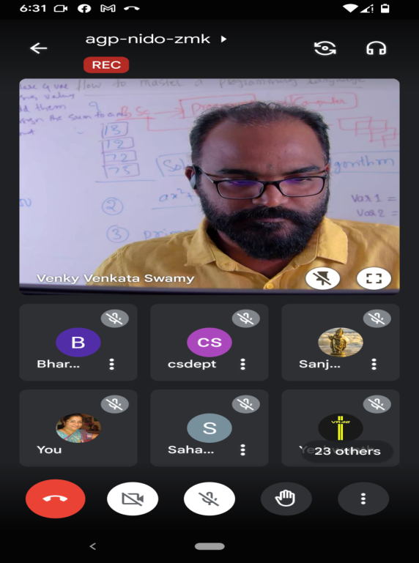
Webinar in progress by VENKY VENKATA SWAMY Founder and chief mentor of Vsdeveloper

2. World Computer Literacy day on 29 Nov 22
The Department of Computer Science wanted to celebrate World Computer Literacy day by promoting Digital Literacy to underserved groups and campaign about the importance of Computers and Digitization.

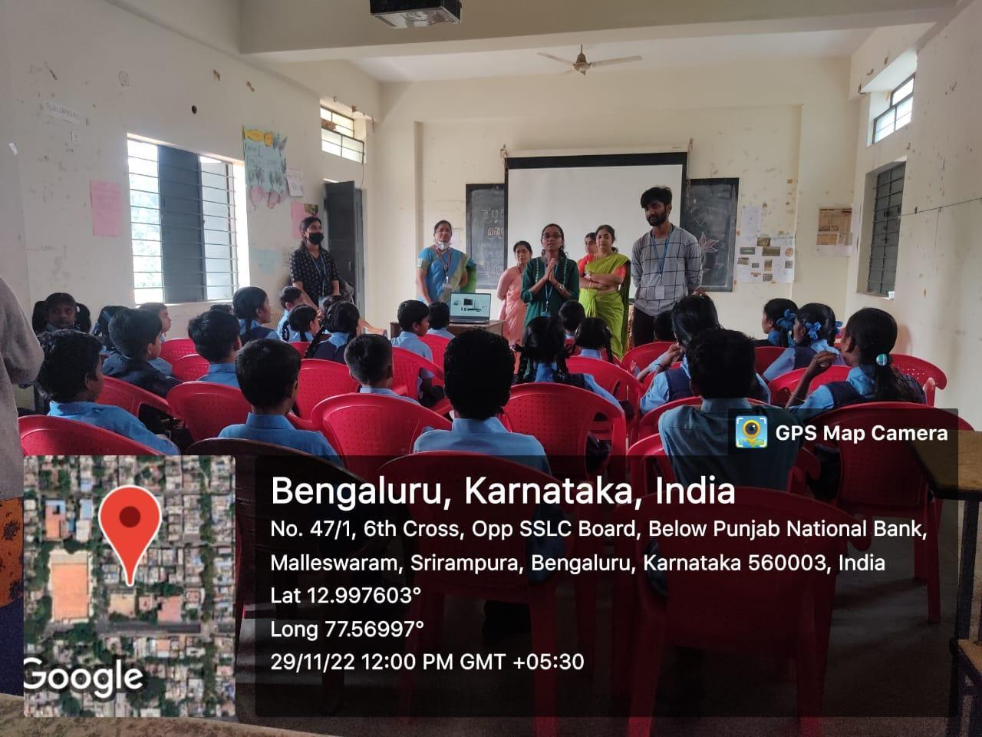
C.Sc Department faculty and students teaching the students of Govt. school,Malleswaram
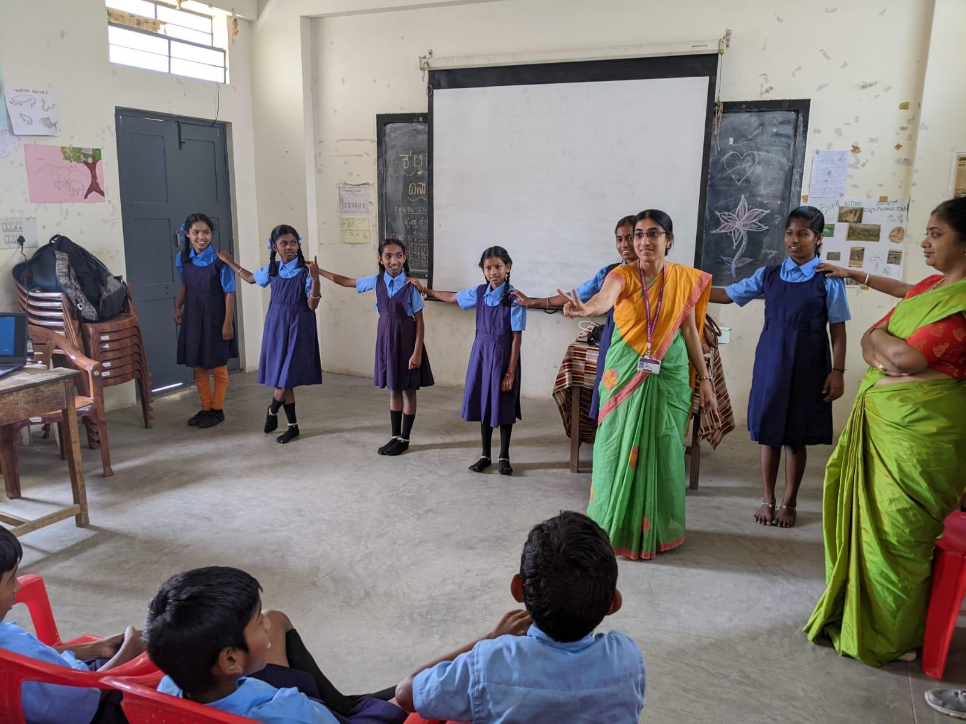
Smt.Sajini demonstrating binary number system to students.

3. Industry visit to IIIT BANGALORE on 20/12/2022
The visit was mainly focused on understanding how research work takes place in the field of computer science, and the technology and the equipment used. The students also learned about various graduate programmes that can be pursued after the completion of under-graduation

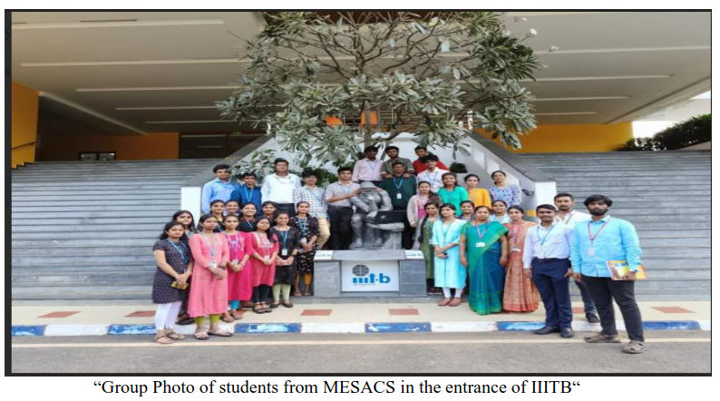

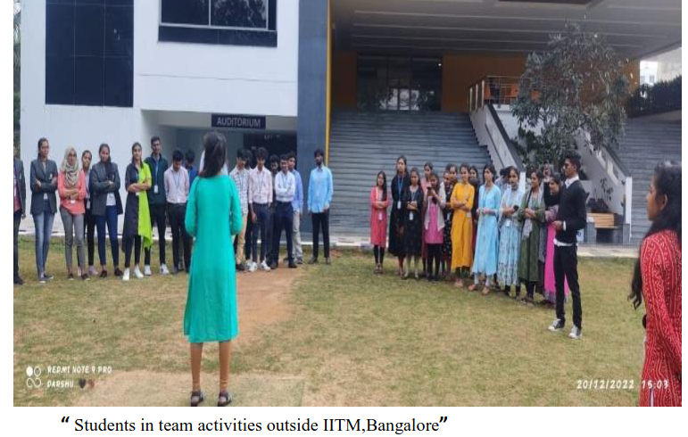

4. Poster Presentation on "Recent Trends in IT" on 21/12/2022
A poster presentation is a way to communicate understanding of a topic in a concise and visually engaging format. Poster presentation included two elements, a poster,a brief verbal explanation of the poster content or topic for 5 minutes.
Poster presentation was on recent trends in IT. The purpose of conducting poster presentations for first year students on "Recent trends in IT" is to make them aware of the recent technologies and advancements in the present scenario.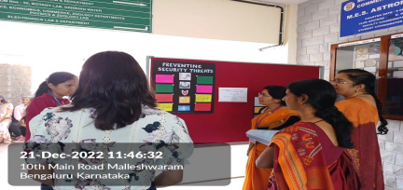
Presentation in progress on 21 Dec 2022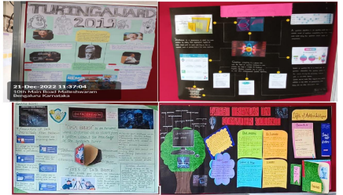
Sample posters
5. PowerPoint Presentation -II BSc Feb 2023
With the rise of technological advancements, there is a growing demand to gain knowledge and additional skills. In order to gain such skills that may help the students in their career, the Department of Computer Science under IT Club conducted PowerPoint presentations on “Recent trends in IT” by the II B.Sc III semester students.
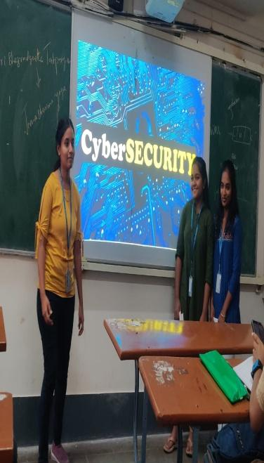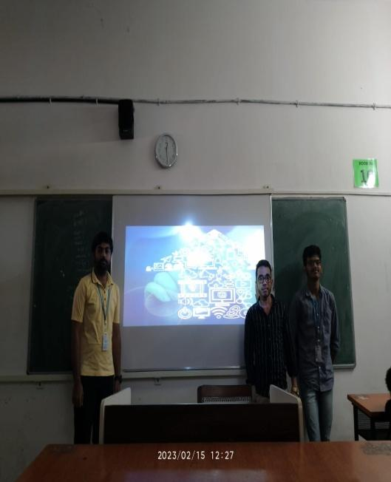
Students presenting on their chosen topic

6. Cloud Practitioner course for two semesters by Amazon web services .

AWS Academy Cloud Foundations is intended for students who seek an overall understanding of cloud computing concepts, independent of specific technical roles. It provides a detailed overview of cloud concepts, AWS core services, security, architecture, pricing, and support. The department conducted this course for 2 semesters for the benefit of its students.

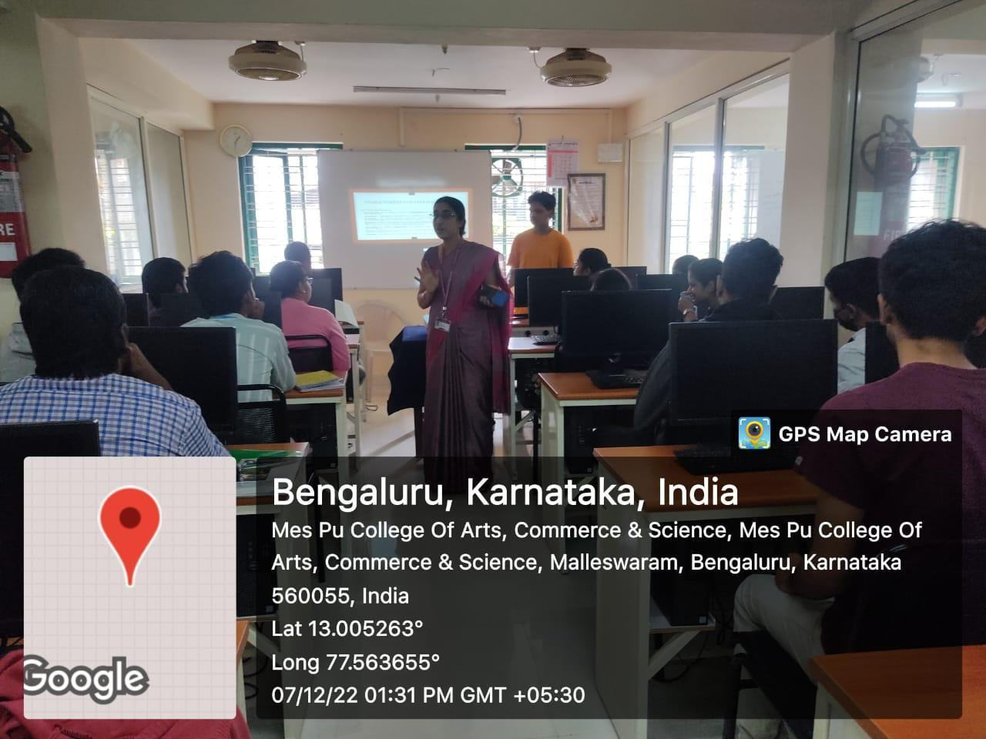

Orientation for the students

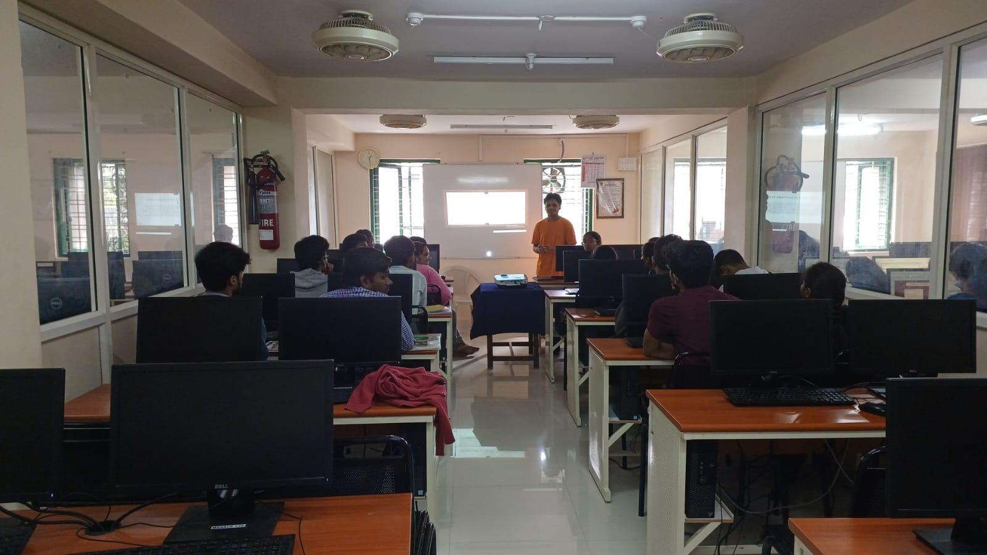

7. INNOVATIVE TEACHING AND LEARNING METHOD
“DOODLE ON CONCEPTS OF DATA STRUCTURE ” on 8th and 9th June 2023
Doodling is a form of expression and creativity that allows individuals to visually represent their thoughts, ideas, or emotions. Doodling helps students concentrate, organize their thoughts, and stimulate creativity. The activity was conducted in the Practical class for II semester students.
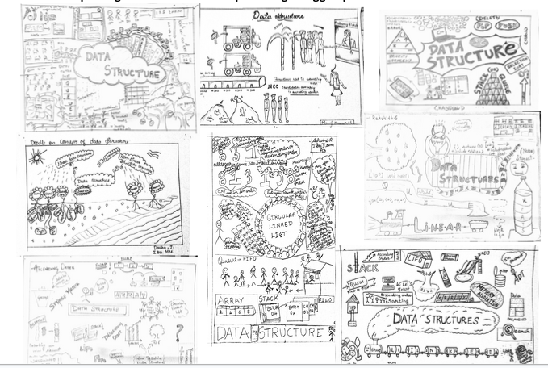
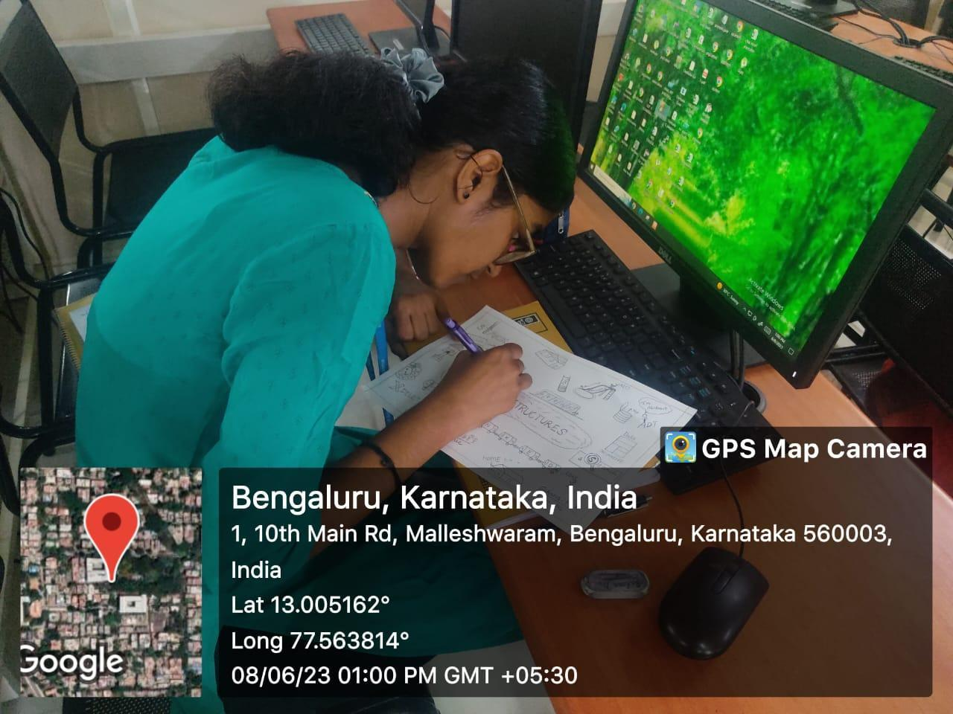
Samples of concepts Doodle created by students
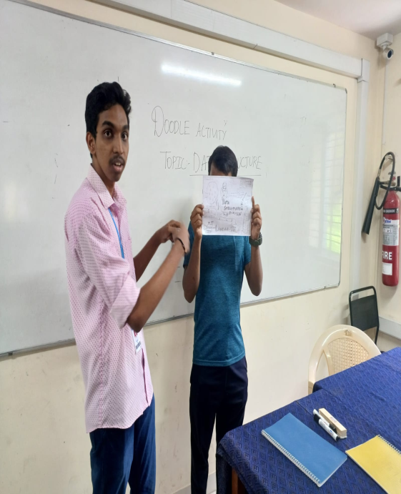
Students in explaining and creating their doodle wok.

8. A talk on Cloud Computing and Devops on 3rd July 2023
Cloud Computing is the delivery of computing services such as servers, storage, databases, networking, software, analytics, intelligence, and more, over the Cloud (Internet). The objective of the event is to introduce the basic concepts of cloud computing to the students and give them awareness about the need of cloud computing and its related technologies.

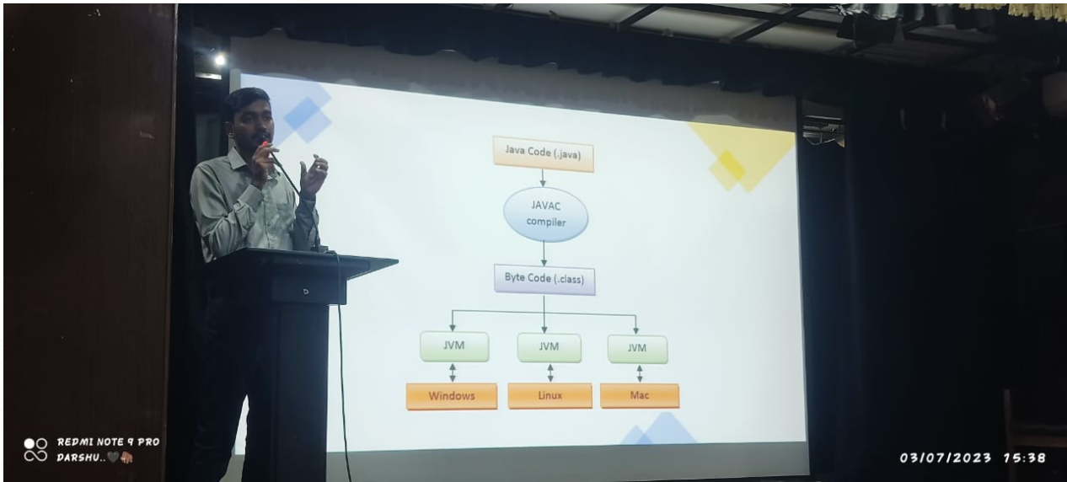
“Mr HariKrishnan addressing the students on cloud computing. ”

9 Algorithm Enacting during June-July 2023
The students of Computer Science need to know the techniques of algorithm and problem solving, applying various algorithms on given data structures and comparing the performance of these algorithms for their efficiency. To enable the students in this aspect of the subject, the Department of Computer Science , under IT Club conducted “Algorithm Enacting”, for Second semester and fourth semester students in Computer Science.
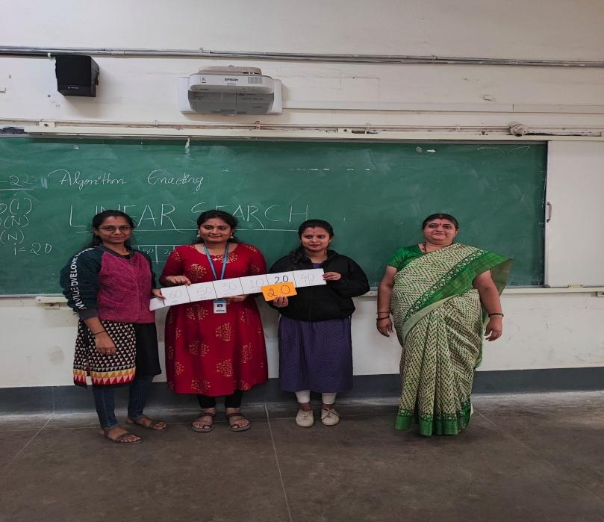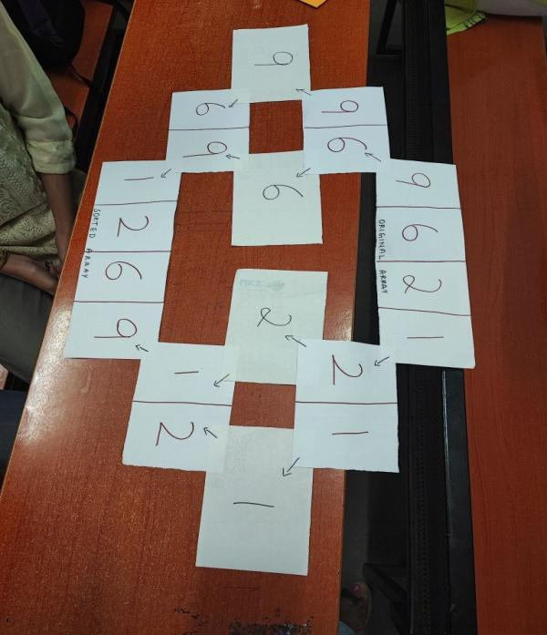
Students with Smt Durgakala enacting Linear Search

10. CYBER AWARENESS MONTH October 2022
The Department of Computer Science in an endeavour to create awareness about cyber security during Cyber Security Awareness month-October 2022, encouraged all faculty and students to participate in the quizzes and upload the certificates they have won in the google form circulated.The Department wants everyone to be aware about the cyber threats ,to be cautious and safe.

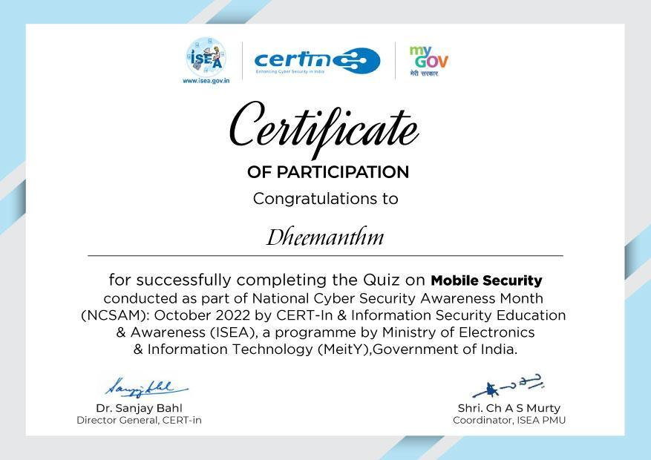
SAMPLE CERTIFICATE -BY GOVT OF INDIA

11 Awareness program on Cyber Crime and Cyber Bullying on 7th August 2023
The Department of Computer Science under the IT Club conducted this event to spread awareness about Cyber Bullying and Cyber Crime and inform students about the precautions that need to be taken in order to protect themselves and their acquaintances from cyber bullying.

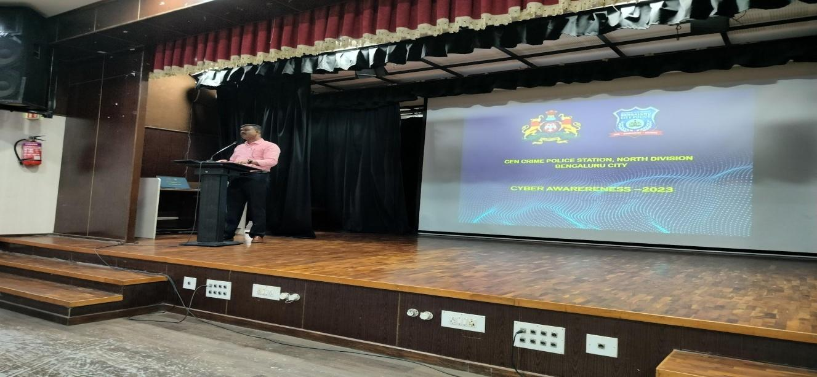
Mr.Nagaraj,,Assistant Sub inspector CEN Crime police station ,North division
on 7th August 2023
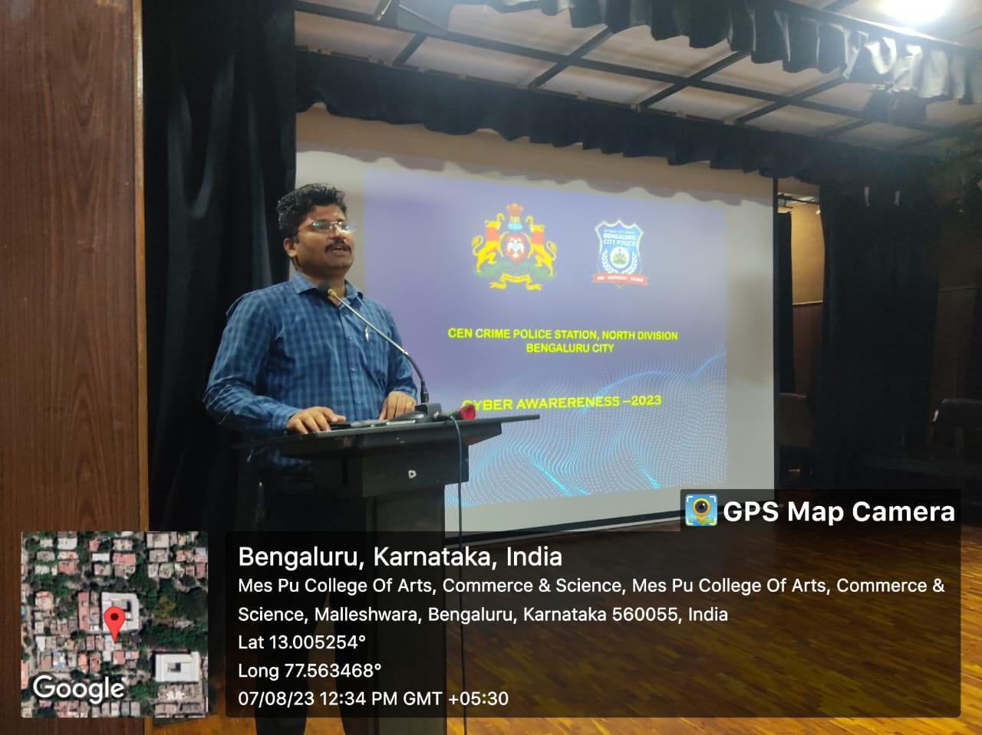
Mr.Vinayaka HP Addressing the students

12. Rexona Confidence Academy services , talk on – “ soft skills – first impression and body language . ” On 6th June 2023
IT Club and the Department of Computer Science , Placement cell in association with Hindustan Unilever Limited in collaboration with Rexona Confidence Academy services organized a talk on – “ soft skills – first impression and body language “ to educate and empower young women with soft skills and basic interview-skills.

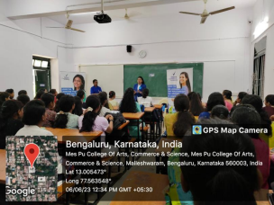
Resource person Ms.Soumya addressing the students

13. Internship
The objective of this program was to encourage the students to acquire and update their technical skills in order to meet the industry requirement.

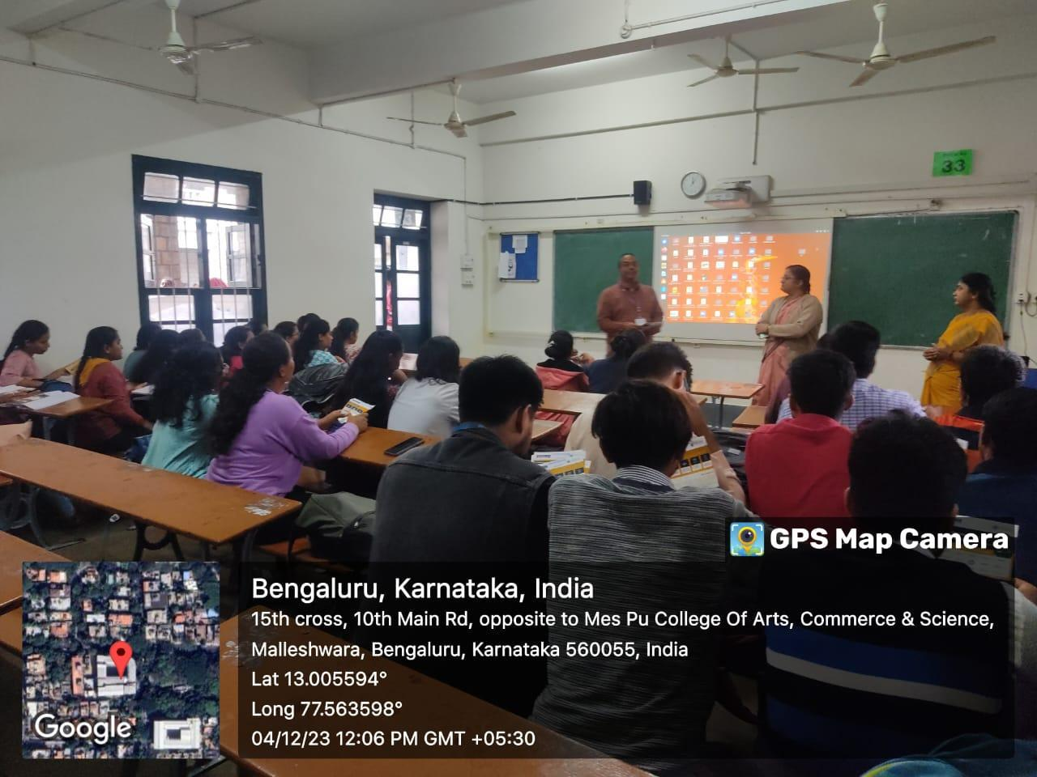
Mr. Suhas from Rooman technologies addressing the students of final year on internship offered by them.

14. Career guidance to students of Final year : Industry 4.0
The objective of the program is to provide valuable insights into the rapidly evolving field of Industry 4.0, enlightening students about the exciting job market opportunities and the skills and certifications necessary for future employment. Overview of career prospects in the Industry 4.0 landscape and insight on emerging roles and their significance were provided to the enthusiastic students.

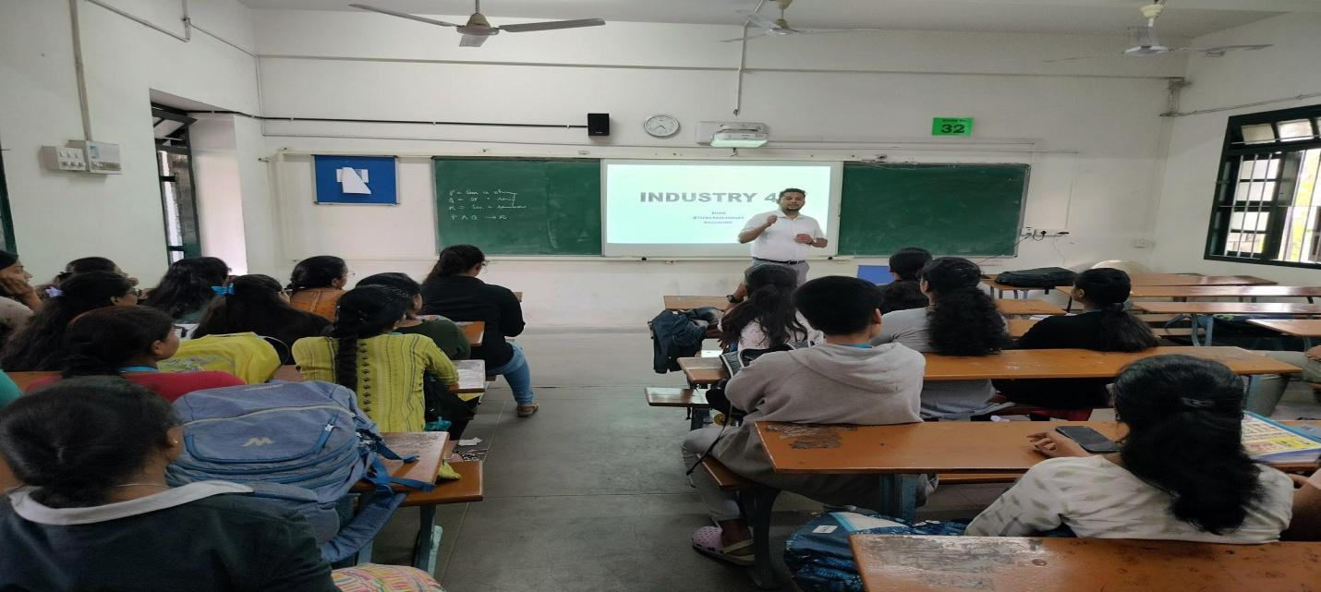
Mr.Khan addressing students

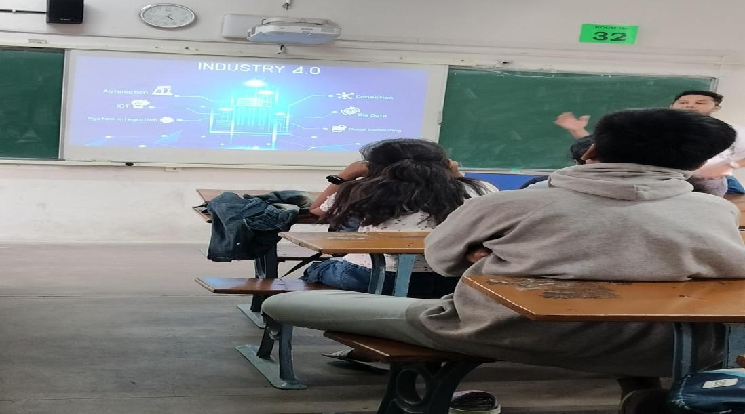 Keen students listening to the future of industries.
15. ANUDIP FOUNDATION SKILL AND CAREER DEVELOPMENT CENTER,
ON 8TH JUNE 2023 : internship

Technical skills are the specialized knowledge and expertise required to perform specific tasks and use specific tools and programs in real world situations. The objective of this program is to encourage the students to acquire and update their technical skills,soft skills in order to meet the industry requirement.
Mr.Shiva kumar of Anudip Foundation addressing III BSc students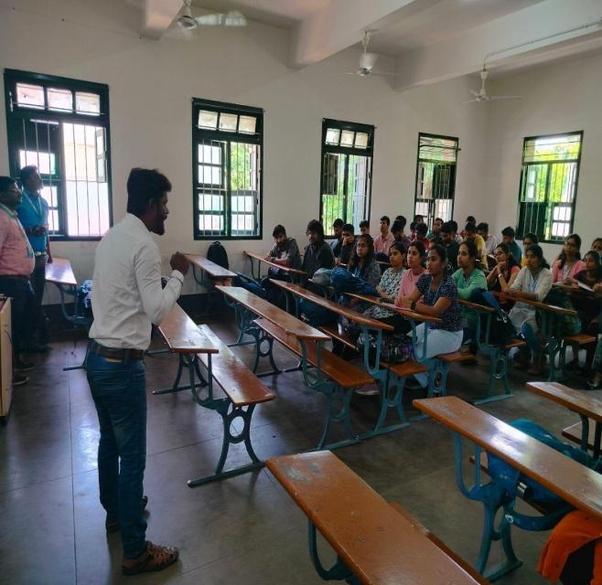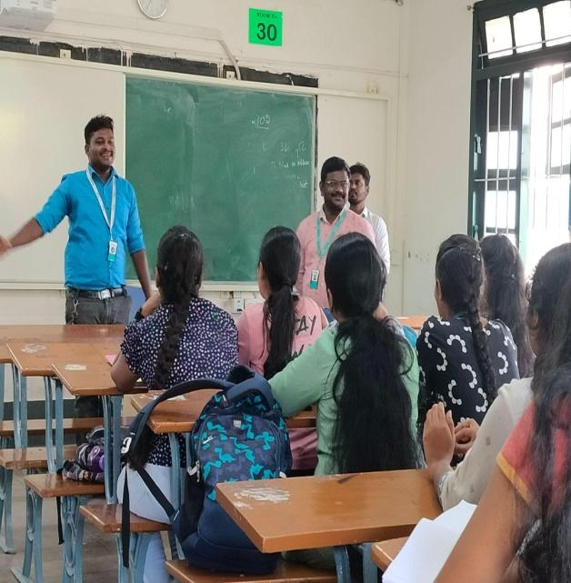
Mr.Pavan,Coordinator of Anudip Foundation addressing the students

16. Internship for final year students by Epic Minds on 5th Jan 2024
It’s vital for the students to have advanced computer and technology skills in order to excel in an IT position. This can include knowledge of upcoming Software Technologies,understanding of operating systems, working in spreadsheets,giving presentations etc. The objective of this program is to encourage the students to acquire and update their technical skills in order to meet the industry requirement.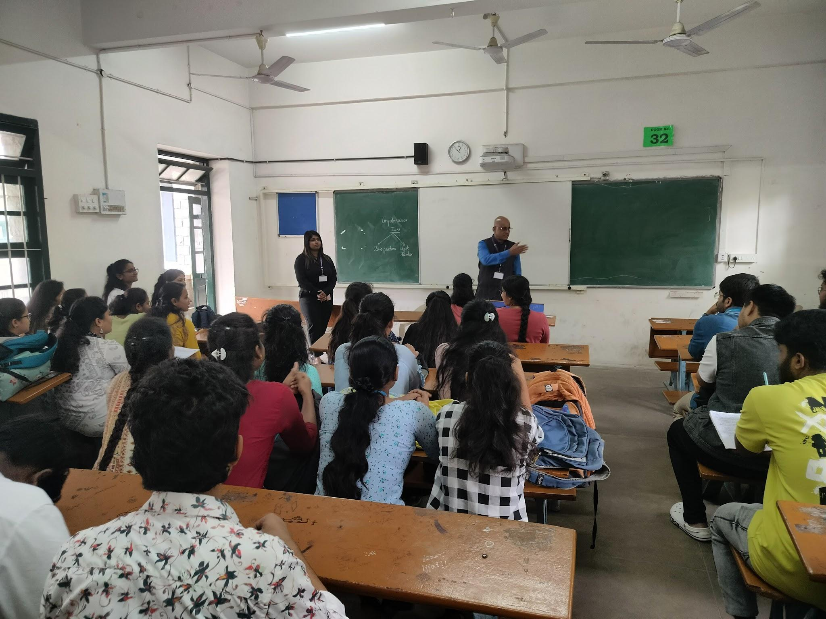Mr.Srinath.T and Team from Epic Minds ,addressing students

