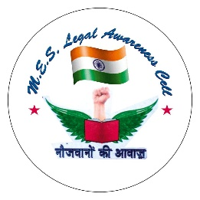
Legal Awareness Cell (estd. 2018)
Faculty Profile:
- Name: Rekha Balwally
- Designation: Assistant Professor, Placement Officer, Convener (LAC, ELC)
- Qualification: B.A, LL.B, LL.M, PGDIPRL, NET LAW
- Areas of interest: Drawing, Painting, sketching, gardening, reading books.
- No of years of Teaching experience: 16
- Number of Papers presented: 6
- Number of Papers published: 2
- Faculty photo:
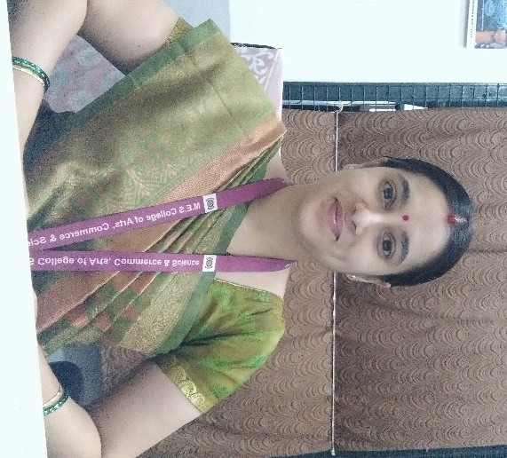

Vision: Empower Individuals and makes them active about the law. Organizes Lectures through legal experts, law officers and eminent lawyers on important everyday legal issues, laws, rules and Regulations. Aware students about the free legal services provided by various agencies.

Mission: To empower the youth of our country with the knowledge of their legal rights and duties, ultimately to be able to share power equally, gain full access to the means of development and to inspire a whole generation of women to work together towards achieving gender equality and justice.
Office Bearers:
- Keerthi Sundar: Lead of the club
- Harshitha Reddy: Lead of the club
No. of members for the current year: 20
Objectives:
- Promote Legal Aid Services
- Human Rights Education
- Consumer Rights Awareness
- Community Legal Workshops
- Access to Justice
Best Practice of the cell:
- Camp site visit
- Arranging talks on Fundamental rights and duties
- Attending Lok Adalat sessions
- Conducting rally and street plays
- Celebrating law day

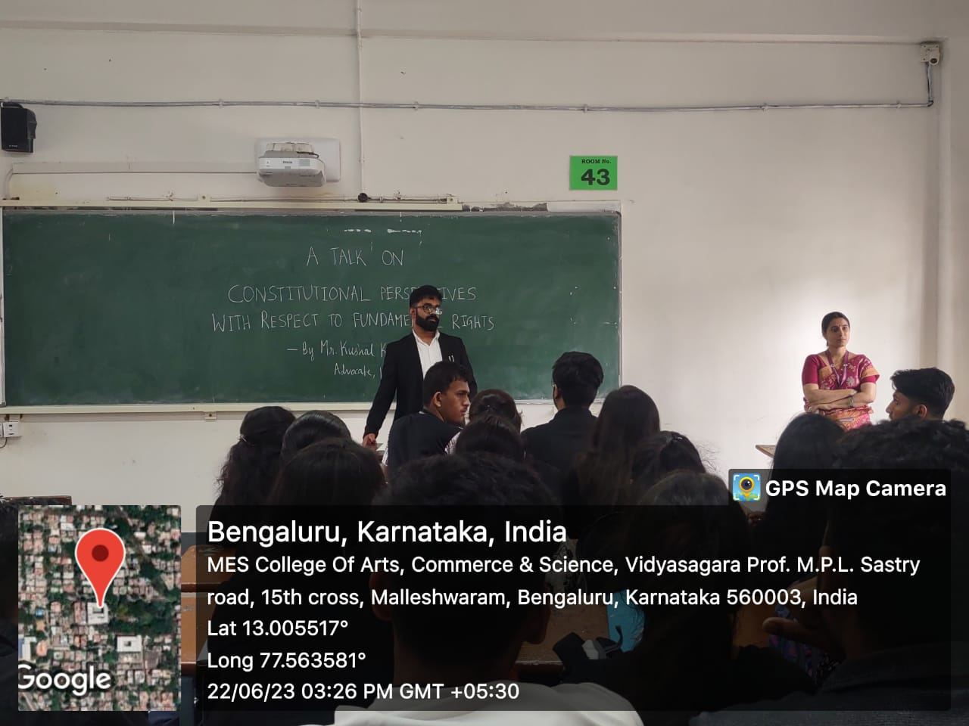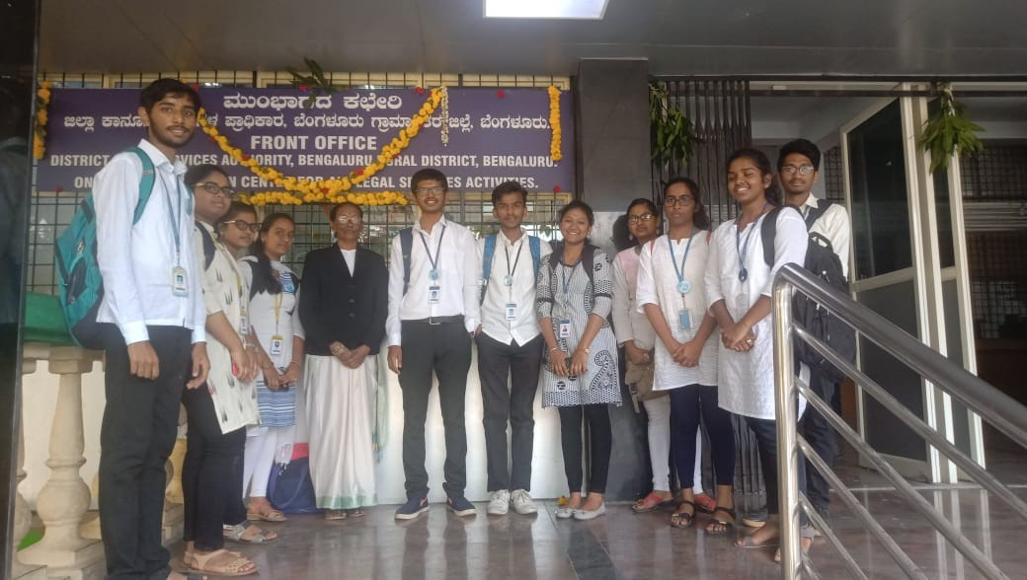
Talks on Fundamental Rights and Fundamental Duties

Participation in Lok Adalat session by LAC club of MES

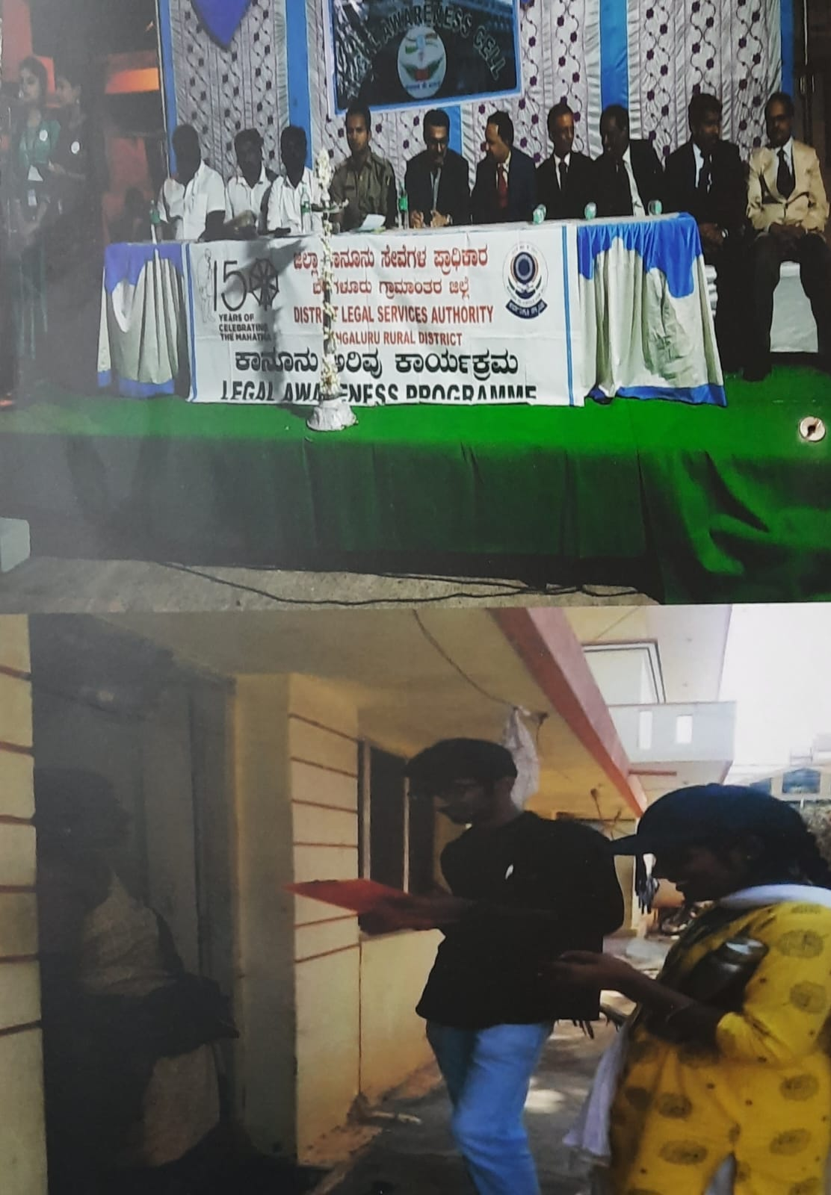
Camp site visits - legal survey, assist villagers about legal aid

A platform for villagers to meet the judges

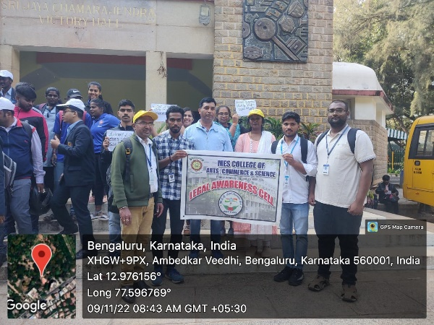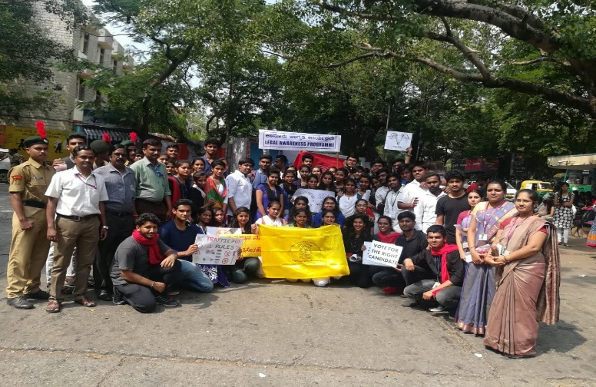
Participated in walkathon organized by SVEEP
Celebrating Law day

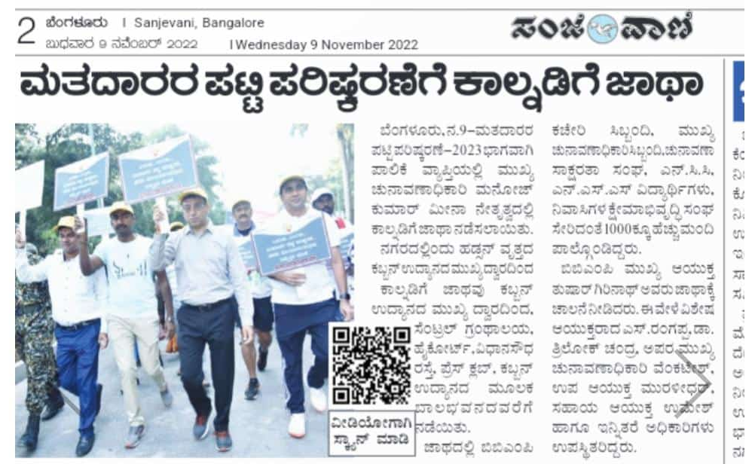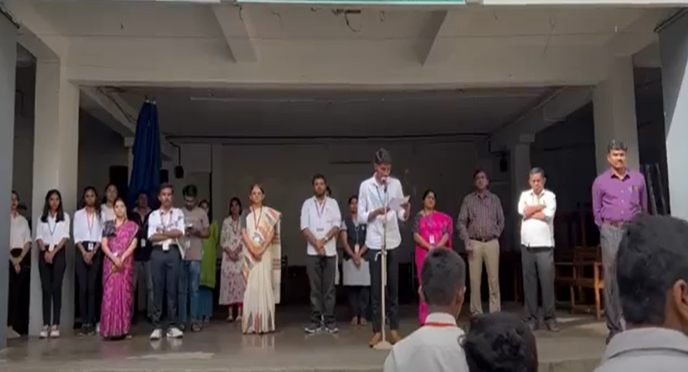
Participation in walkathon published in news paper
Celebrating constitution day in college quadrangle

