DETAILS FOR THE WEBSITE
- Name of the club: Natya Taranga
- Teacher Convenors: Asst. Prof. Sindhu Bhairavi G.U
- No. of members for the given academic year: 57 members
- Objectives of the club:
- To have a strong dance team for participating at in-house events and inter-collegiate fests.
- To encourage students to continue their passion.
- To provide a platform for the students to learn new dance forms.
- Highlights of the events done:
- Participated in various college fests.
- Participated in the programmes conducted by various departments of the college.
- Participated in Yuvajanotsava- a cultural competition conducted by MES Kalavedi,
and have won the Winners title for consecutive 2 times.
- Have conducted an interactive session titled Natyopasana with the famous dancer- Smt. Shama Krishna.
- Have participated in the NAAC cultural programme which received a lot of appreciation from the dignitaries.

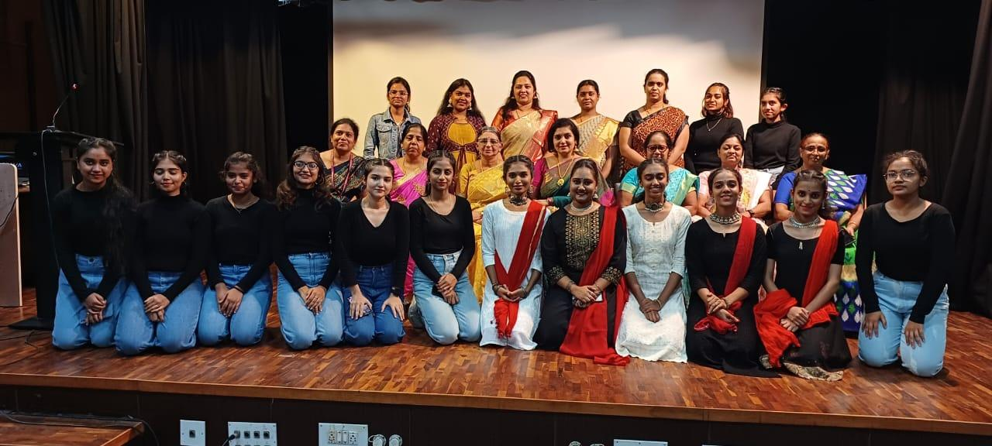
NATYOPASANA- INTERACTION WITH SMT. SHAMA KRISHNA

GLIMPSES OF YUVAJANOTSAVA
