Placement Cell
Faculty Profile:
- Name: Rekha Balwally
- Designation: Assistant Professor, Placement Officer, Convener (LAC, ELC)
- Qualification: B.A, LL.B, LL.M, PGDIPRL, NET LAW
- Areas of interest: Drawing, Painting, sketching, gardening, reading books.
- No of years of Teaching experience: 16
- Number of Papers presented: 6
- Number of Papers published: 2

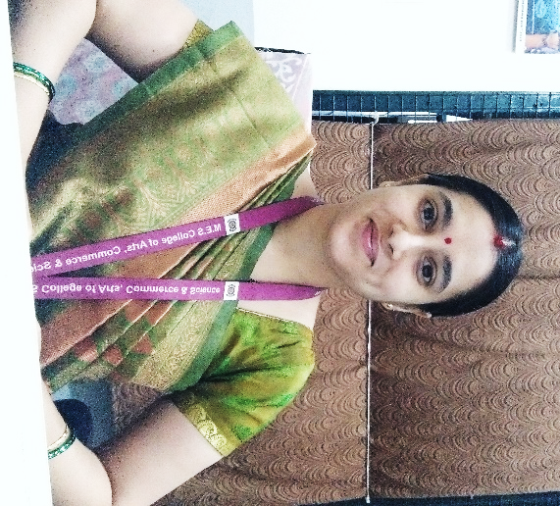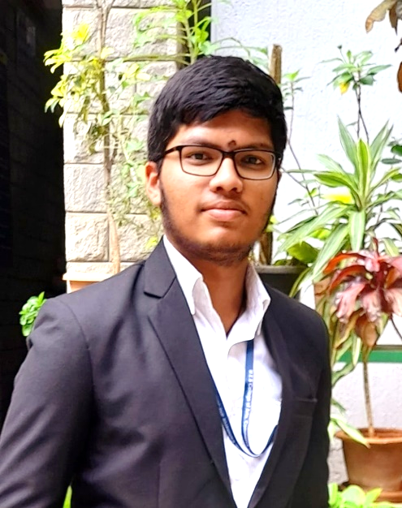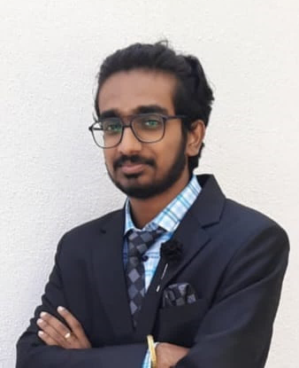
Rekha Balwally Srujan S Dhanush S
Placement Officer Placement Ambassador Placement Ambassador

Vision: Empower, Enrich, Enlighten, Enliven
Mission:
- To enhance knowledge and creativity, build capital network for next generation
- To remain pertinent in tomorrow’s world and try for the highest standards
- To enable the young graduates to stay ahead of the competition.
- To focus on overall personality development .
- To nurture leadership qualities and skills so as to reach out to the competitive global world.
Objectives:
- Employability Enhancement
- Job Placement Assistance
- Career Counseling
- Skill Development Programs
- Industry Networking

Best practices of the cell:
- Providing add-on courses
- Attending job fairs
- Conducting placement drives
- Having seminars
- Conducting CRT & DRT exams
Add-on courses provided by cell:
- Stocktale
- Tally Prime 3.0
- Basic and advanced excel
MoU / Tie-ups:
- SSRIIT
- Pro Edge Edu Tech
Overseas Education Session:
- AECC Global Academy SI UK University
Statistics of Placements:

Highest Packages:
Student Name: Varun Sathvik S
Company: Kaufman Rossin
Pay Package: 13 Lakhs CTC
Student Name: Thanu V Jadav
Company: Kaufman Rossin
Pay package: 6 Lakhs CTC
Student Name: Karun K
Company: Paytm
Pay Package: 4 Lakhs CTC

Feedback from the entrants to Corporate world:
- MES College is the place for quality education along with ready to work trainings by the Placement cell. It grooms an individual for corporate ready environment, ability to handle pressure and basic knowledge on work culture. It is a hotspot for all the mock sessions on various type of interviews.
Ponnanna K C
Ernst & Young

- I joined NT on Oct 8th and I think it was one of the best choice I have made to be a part of this organisation. In this regards I would definitely be thankful to my college, MES Placement cell that they have been very supportive and were with us at every stage of the recruitment process. Being online recruitment, it was not easy for us to go on in every stage without their patience and support.
Chandrika V
Northern Trust

- M.E.S Placement Cell helped me in getting placed in an Australian multinational banking and financial services company - The Australia and New Zealand Banking Group Limited (ANZ). The mock sessions and workshops conducted by the Placement Cell not just helped me attend the walk-in interview confidently but helped me successfully clear the interview. The add-on courses provided by the Placement Cell was one other contributing factor towards my career growth and development. In short, I would say, M.E.S Placement Cell has played a key role in my personal and professional growth. I extend my sincere gratitude to Rekha Mam and MES Placement Cell for their continued support, encouragement and guidance.
Soja Rachel Varghese
ANZ Banking Ltd

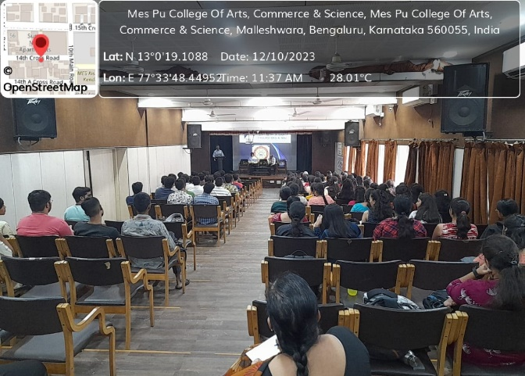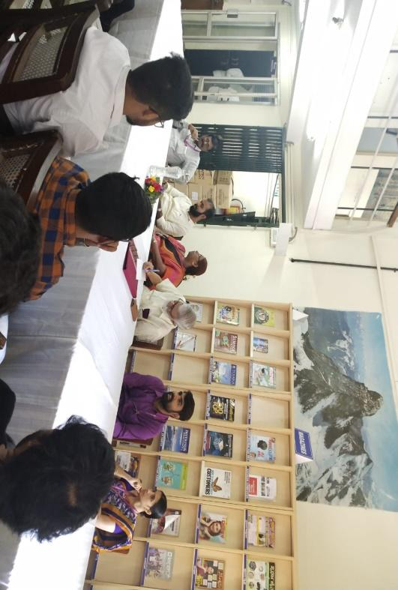
Students attending session organised by Placement cell

Alumni Connect organised by Placement Cell

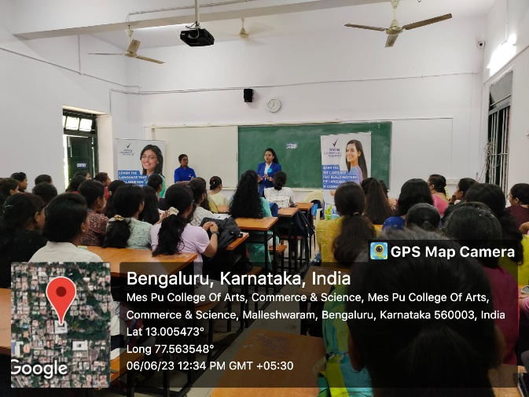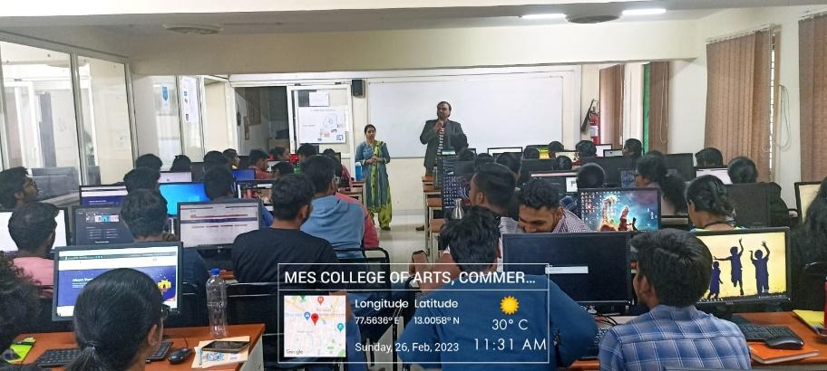
Pre-placements talks arranged by Placement Cell

Add-on course provided by Placement Cell

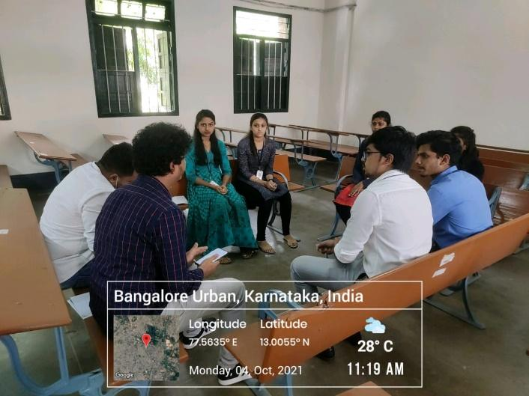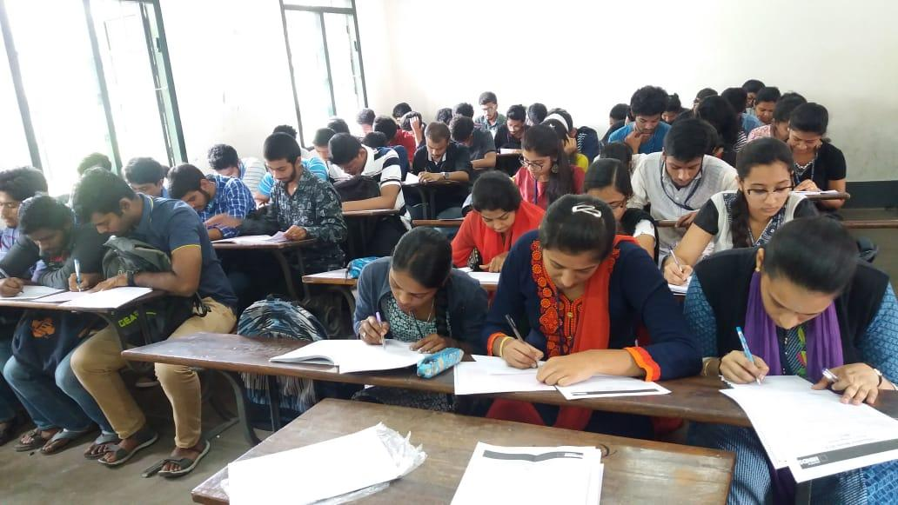
Placement drive organised by Placement Cell

Conducting CRT & DRT tests to help students to assess their performance levels

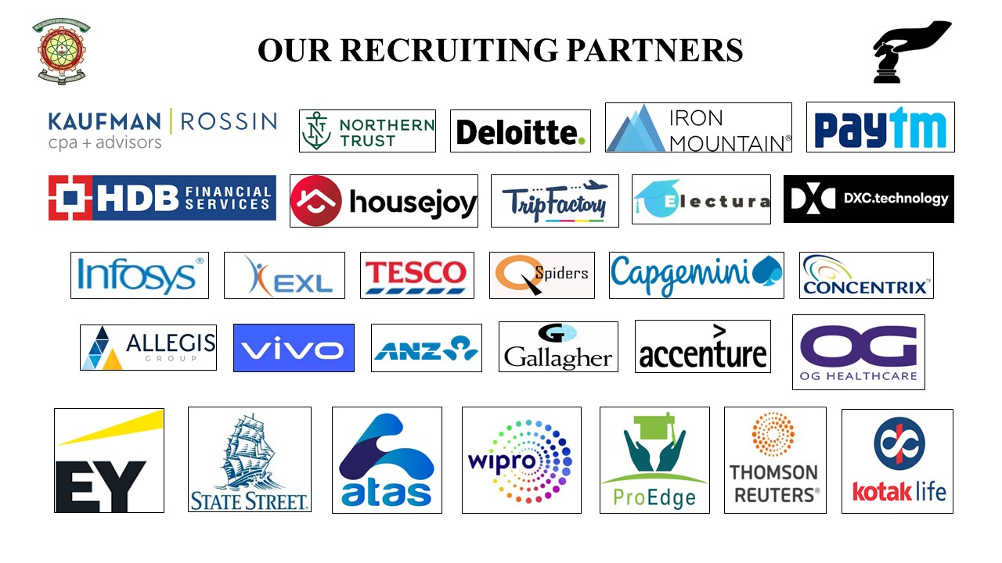

Mail Id: placementmesdcollege1617@gmail.com

