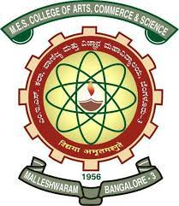
MES COLLEGE OF ARTS, COMMERCE & SCIENCE
‘Vidyasagara’ Prof. M.P.L Sastry Road (15TH Cross), Malleshwaram, Bangalore – 560 003
Phone No : 080-23341225 / 080-23347045 Email : mesdegreecollege@gmail.com

Women cell

- NAME OF THE CLUB :. Women cell

TEACHER CONVENOR OF WOMEN CELL
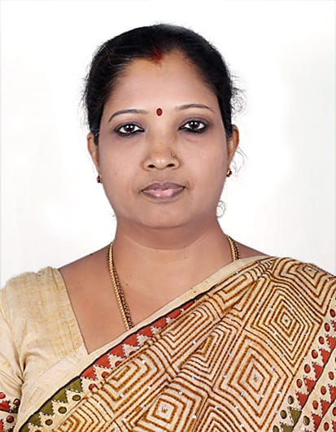 | 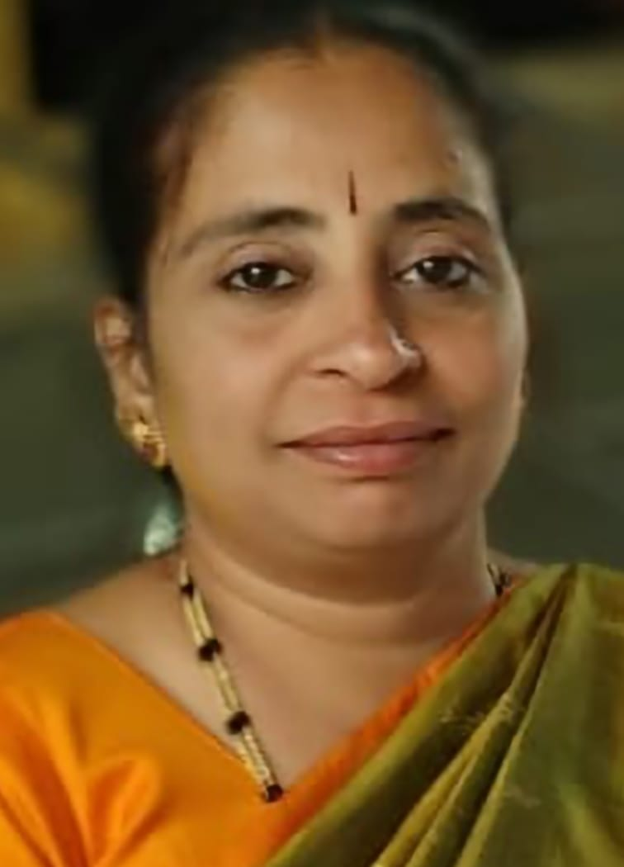

Dr Sushma V Jakati Dr Vanishree

6 HIGHLIGHTS OF THE WOMEN’S CELL FOR THE YEAR 2023-2024.
Our college girls student from women cell visited government school GHPS and GHS malleshwaram, Bengaluru 560003 on 12/01/2024 under the guidance of Dr Sushma V Jakati convenor of women cell to train and address girls students by common health issues, Hygiene, important of girls education, personality development for girls, nutrition for girl’s, how to focus on their goals, extracurricular activities, menstrual cycle, etc.

Names of the students Participating in various activities of Women cell:
Name | Topic | Class
S .Sindhu | Importance of girls education. | 3rd Bsc(mcs)
Vaishnavi G.A | Personality development for girls | 3rdBsc(pm)
Siri .M | Nutrition for girls& How to focus towards their goals. | 3rdBsc(mcs)
Keerthi Raj | Health and Hygiene | 2ndBsc(ms)
Yogashree | Harrasment | 2ndBsc(pm)
Yogini M.S | Extra curricular activities | 3rdBsc(pm)
Bhargavi D.N | Menstrual cycle | 3rdBsc(pm)
Muskhan pandey | Function of female body parts | 2ndBsc(pm)

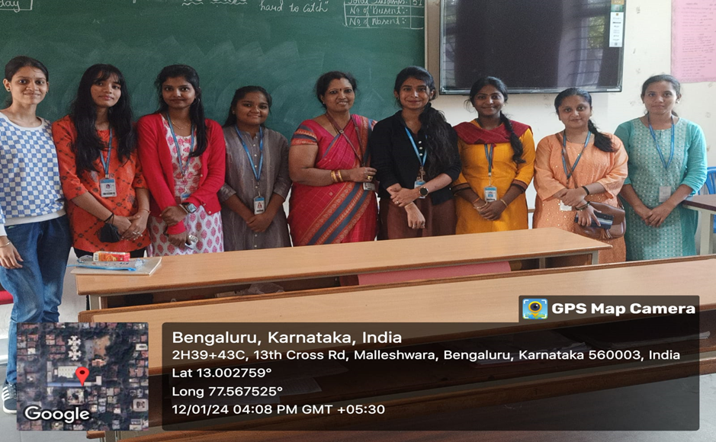
Team visited GHPS and GHS to guide girls students

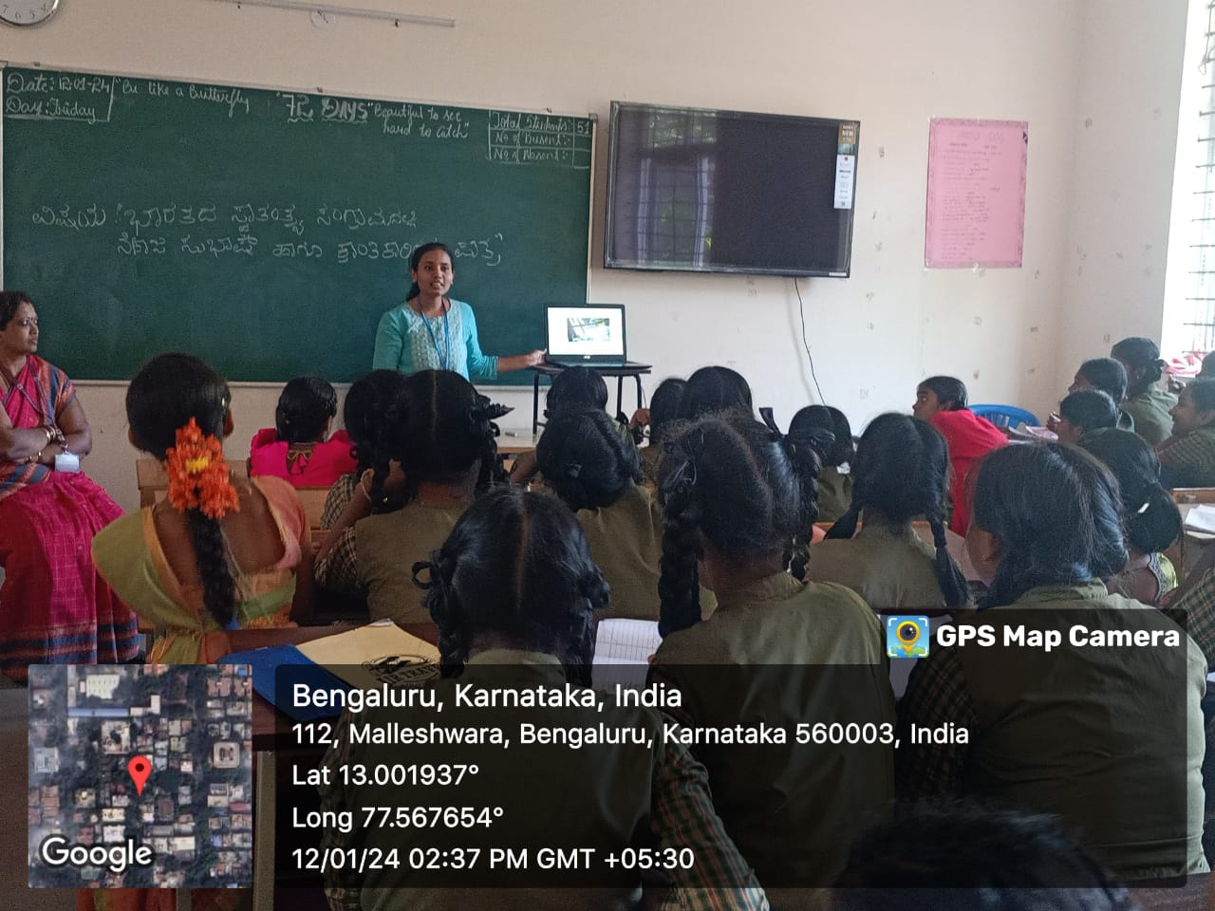

Sindhu explained about Importance of girls education

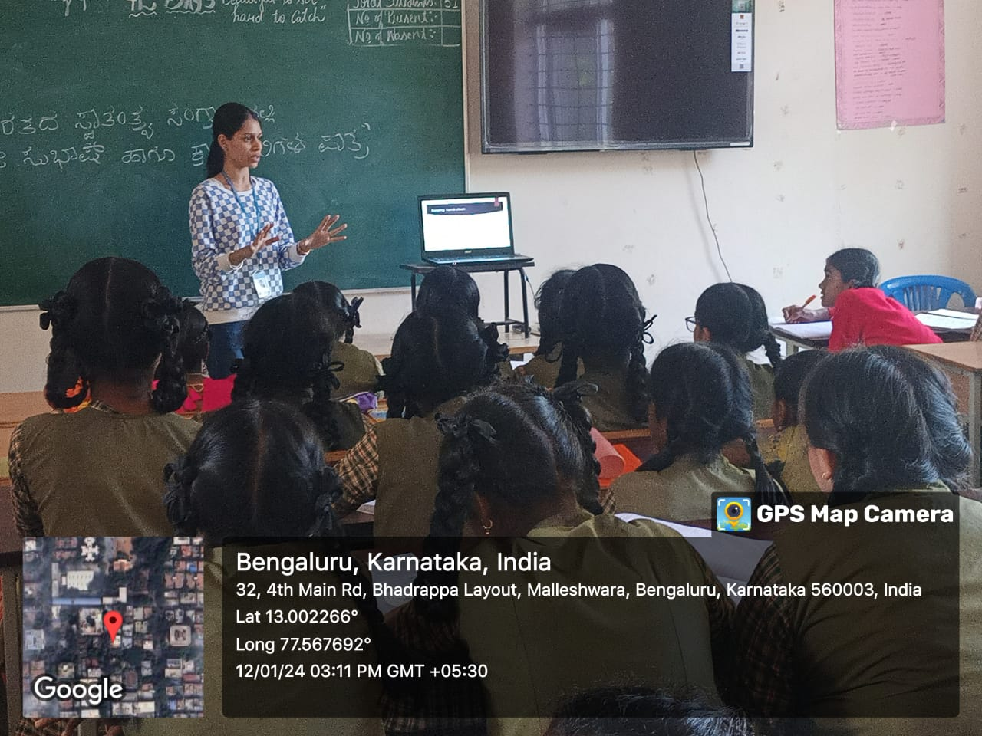

Keerthi raj explained about Health and Hygiene

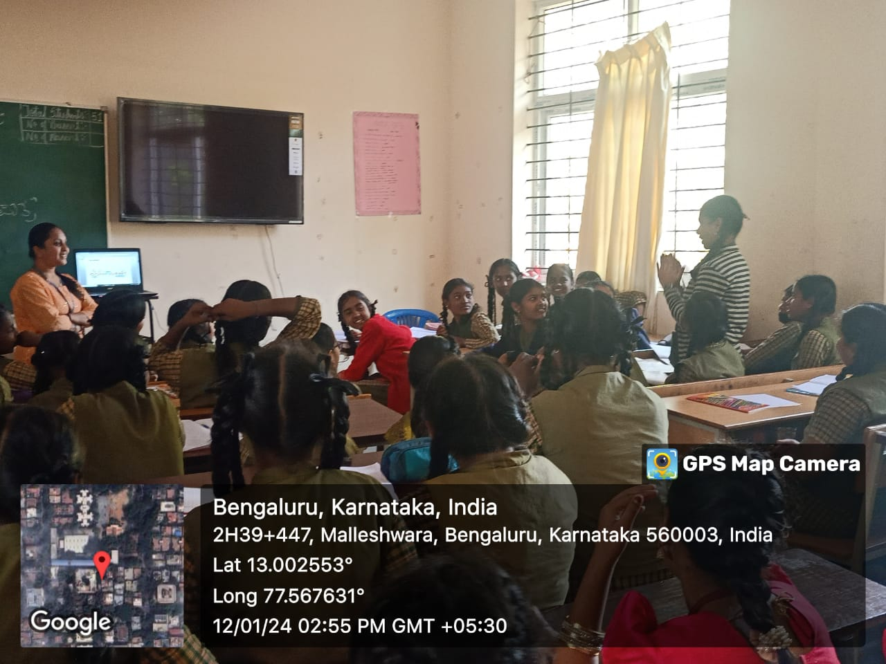
Vaishnavi G.A explained about Personality development for girls 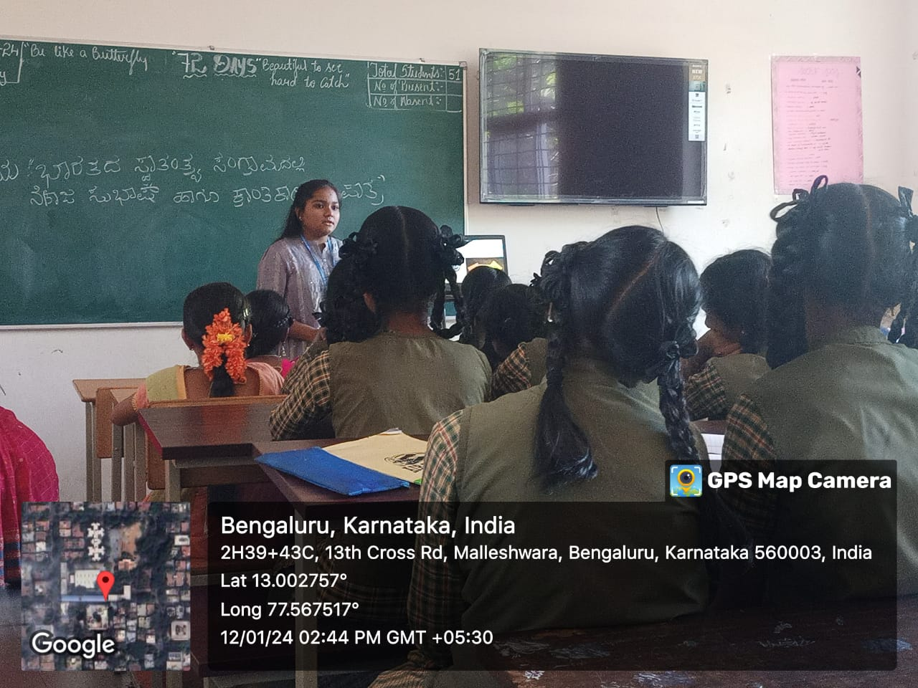

.
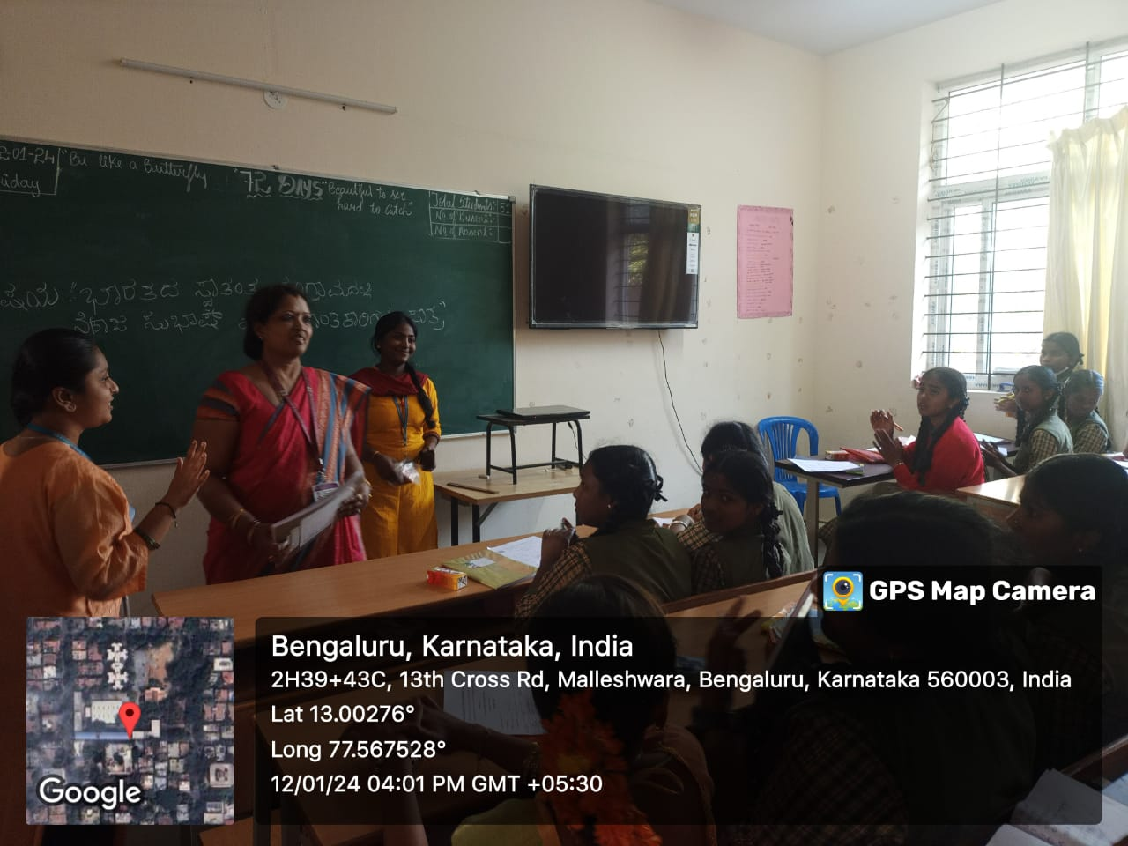
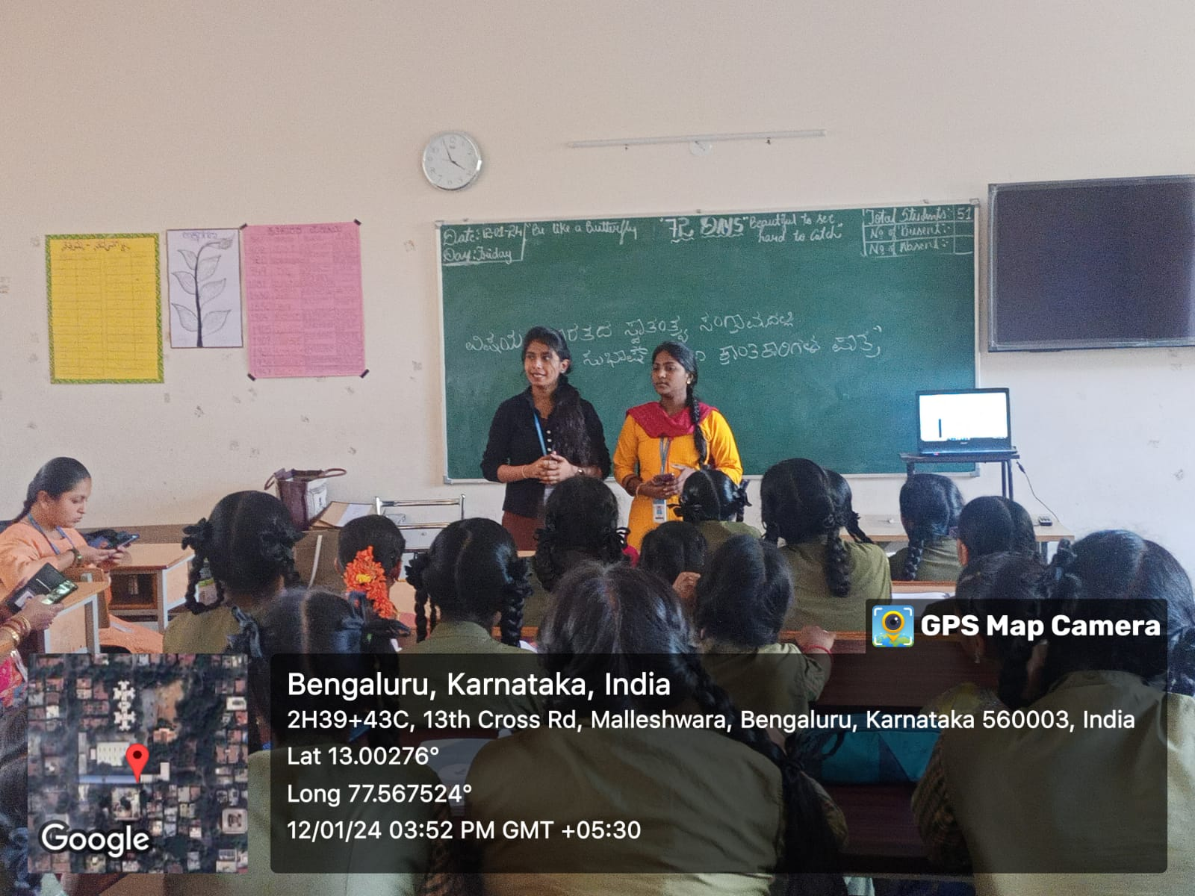
Dr Sushma V Jakati addressing students

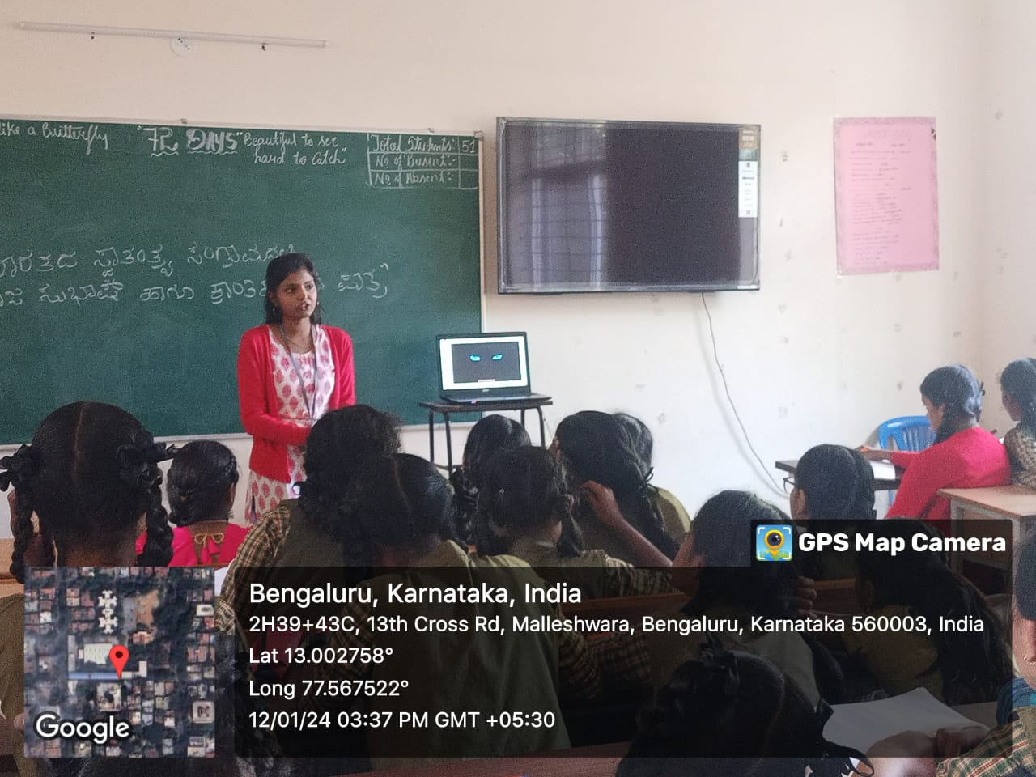
yogini explained about Extra curricular activities and bhargavi explained about Menstrual cycle
Siri .M explained about Nutrition for girls& How to focus towards their goals
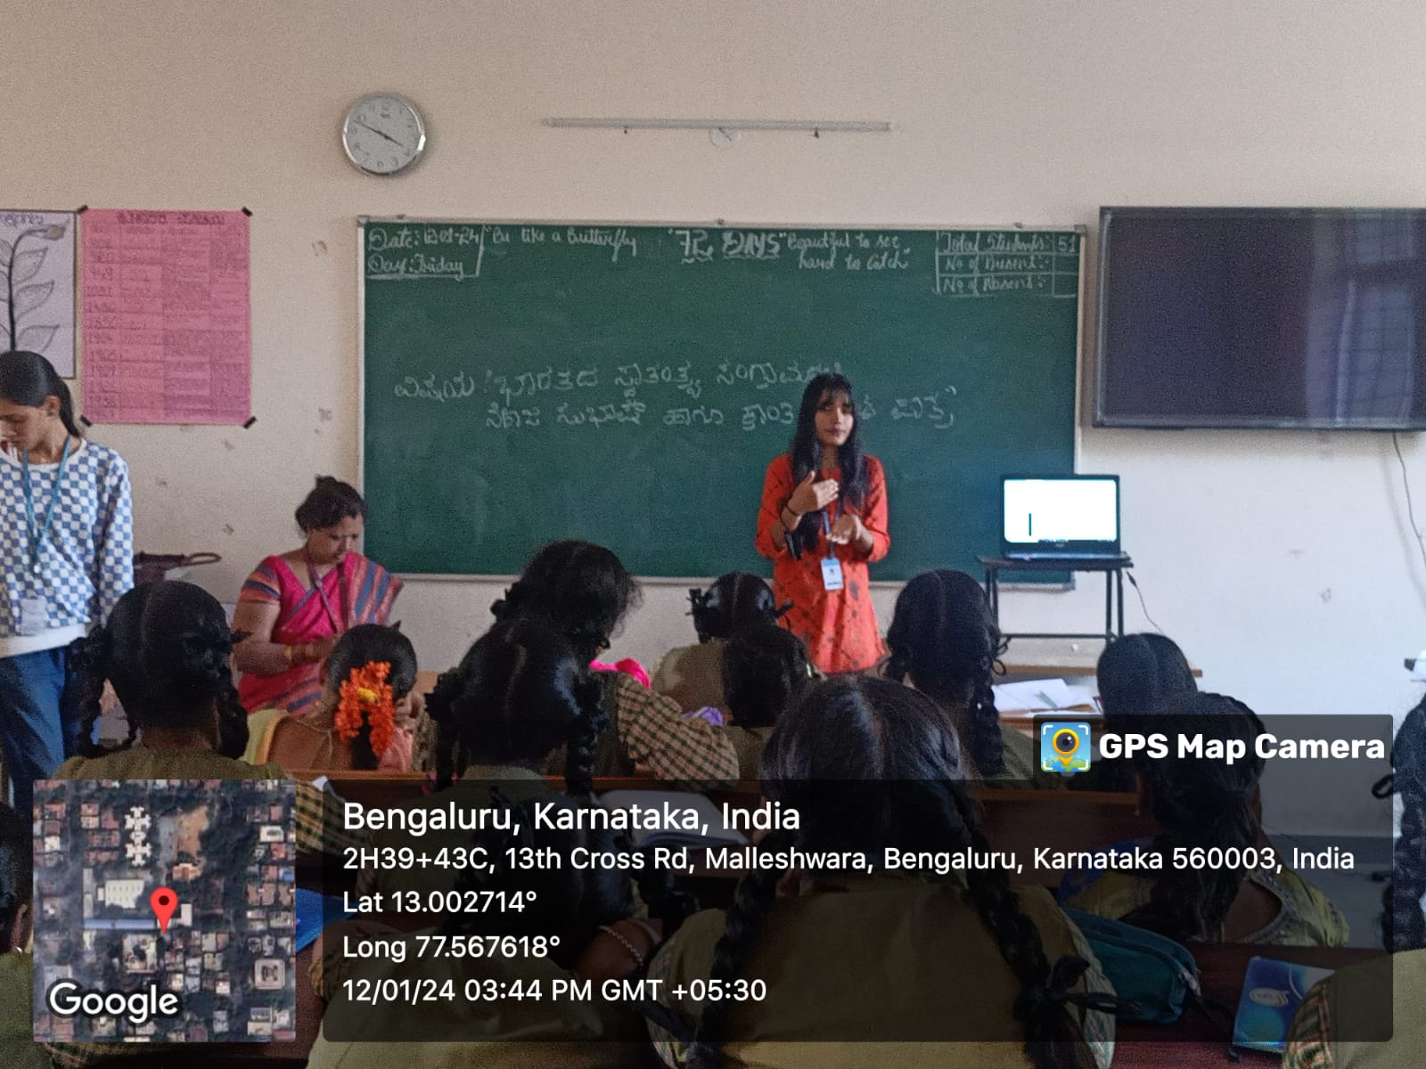
Muskhan pandey explained about Function of female body parts

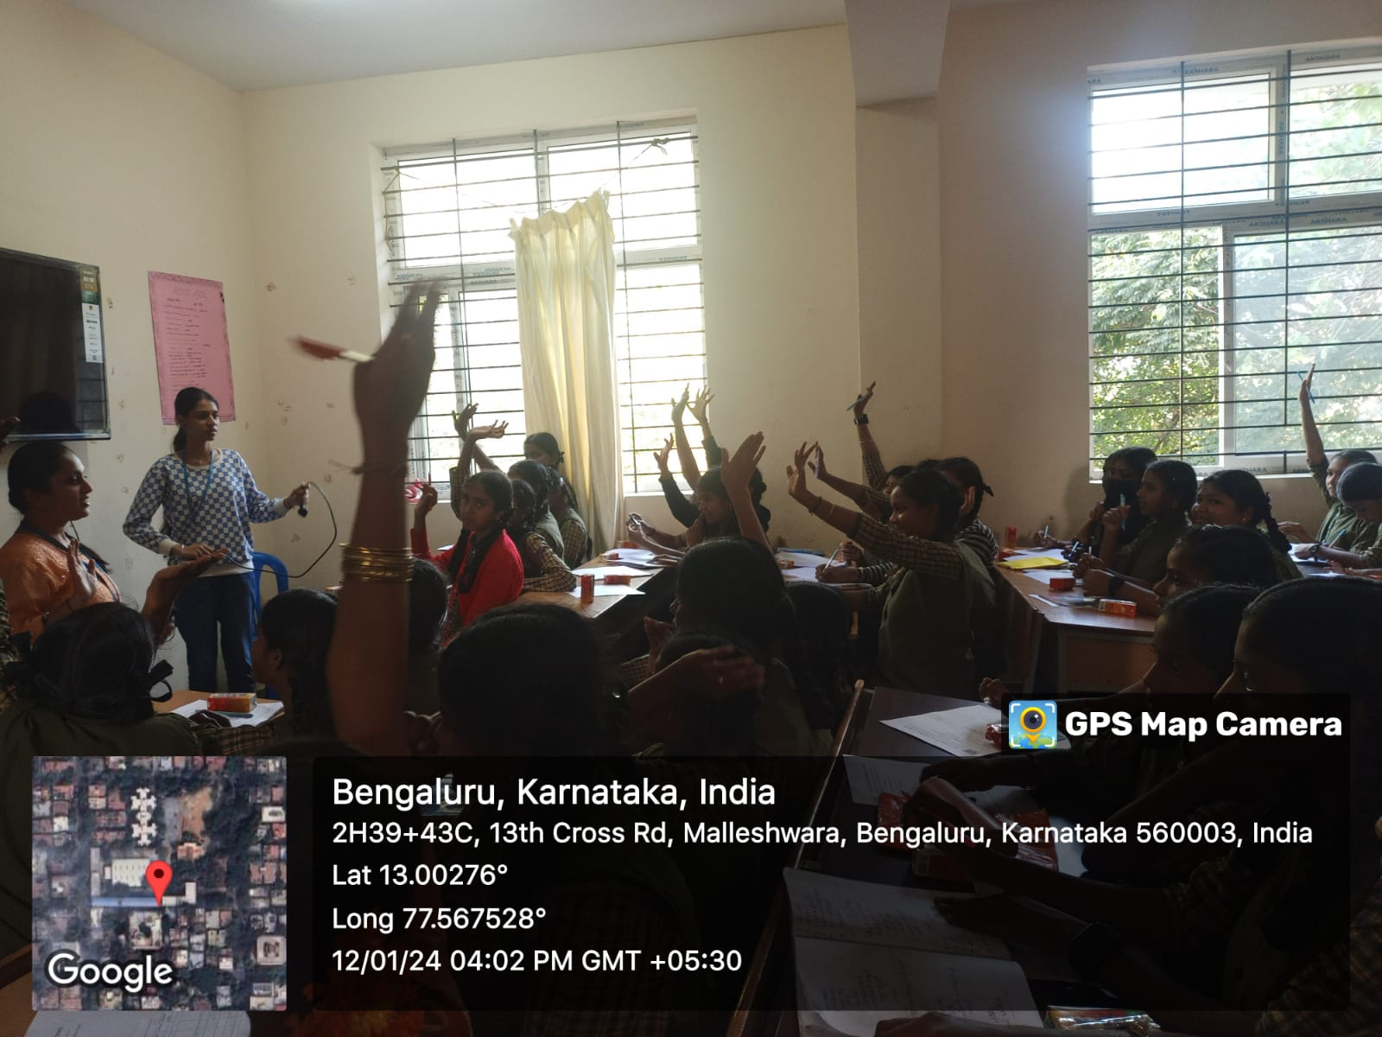

QUIZ competition for students

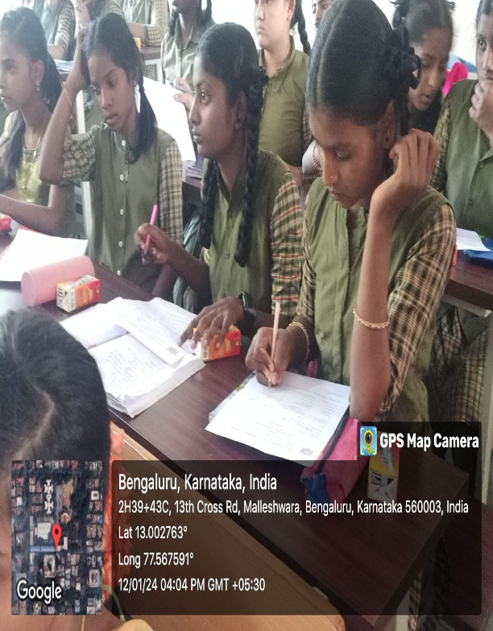
Activity conducted for students

UPCOMING EVENTS
- To arrange a talk or seminar on women’s health issues
- Government school visit to address girls students.
- To arrange speech by guest on women achievers
- Women entrepreneurs day celebration for our girl student to exhibit and sale their created products
- Program on women empowerment
- Women’s day celebration

