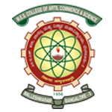
MES College of Arts, Commerce & Science
‘Vidyasagara’ Prof. M.P.L Sastry Road, 15th Cross, Malleswaram, Bengaluru-560003
NAAC Accredited with ‘A’ Grade

- NAME OF THE CLUB: MES ROVERS AND RANGERS UNIT.

- LOGO :

- OFFICE BEARERS :
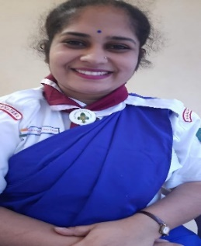
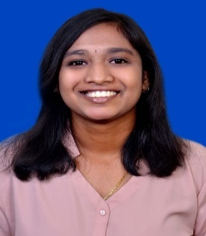

Smt. DEEPA DHARSHINI GP Smt. KEERTHI GP Sri. ARJUN VC
RANGER LEADER RANGER LEADER ROVER LEADER

4.NUMBER OF MEMBERS FOR GIVEN ACADEMIC YEAR: 20 ROVERS AND 40 RANGERS.

5.OBJECTIVE OF THE CELL:
- The Bharat Scouts and Guides (BSG) is a voluntary, non-political, uniformed youth organization in the country with a membership of around 6.2 million members spread pan India.
- It’s a leisure game where their physical, intellectual, emotional, social, and spiritual energies are developed to become truly constructive citizens.
- The students enrolled in higher education institutions enroll as Rovers and Rangers.
- MES Rovers and Rangers have been an active unit in the institution since 2019.
- MES Rovers and Rangers Units will engage the students with outdoor activities, service projects, and personal development. It will help the students to discover the world beyond the classrooms, build confidence, develop leadership acumen, inculcate skills and team building, and become responsible and active citizens of our country.
6.HIGHLIGHTS OF EVENTS DONE:
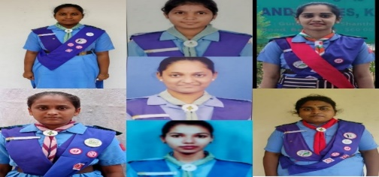
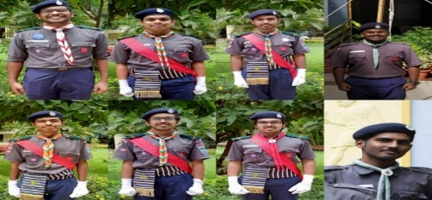

A number of 8 Rovers and 7 Rangers have secured Rajyapuraskar Examination in the year 2022.

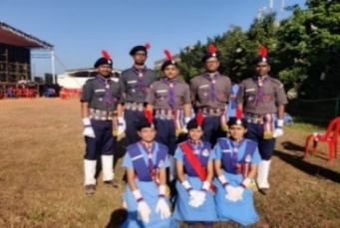
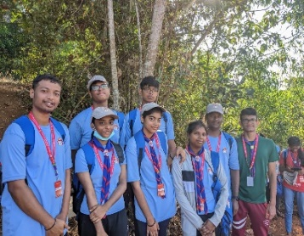
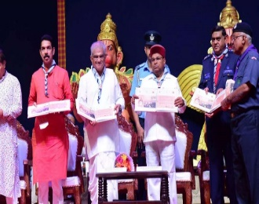
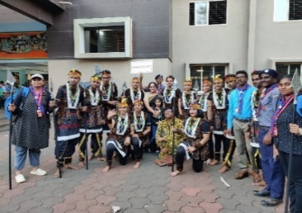
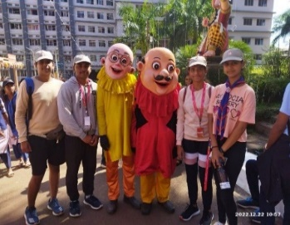
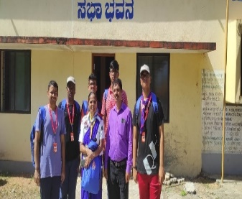

The International Cultural Jamboree in Moodabidire, Dakshina Kannada, Karnataka From 21st December – 27th December 2022, 7 Rovers and 7 Rangers of MES unit had participated in this Event.

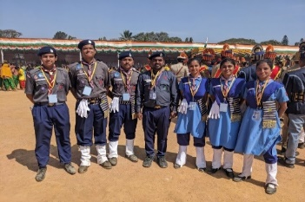
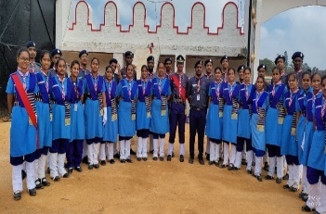
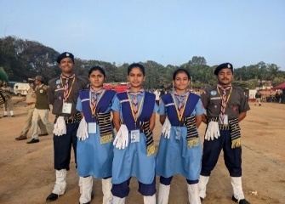

74th Republic Day held at Manekshaw Parade Ground on January 26 2023,5 Students participated in this event.
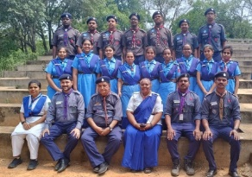
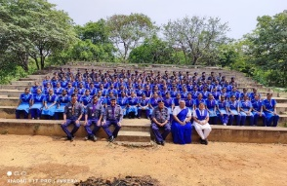
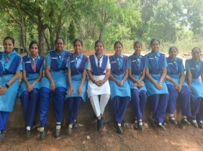
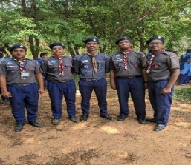

A number of 7 Rovers and 9 Rangers have secured Nipun Examination in the year 2023.
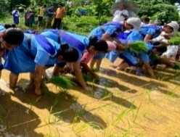
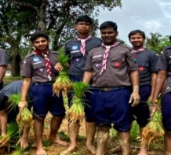
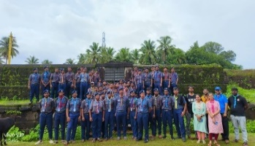
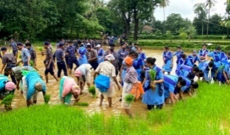
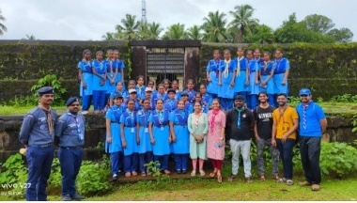
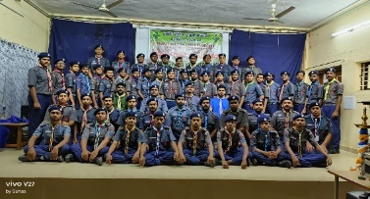
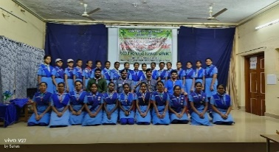

Scouting Walks Towards Farming (15-07-22 and 16-07-22) held at MPM college, Karkala.

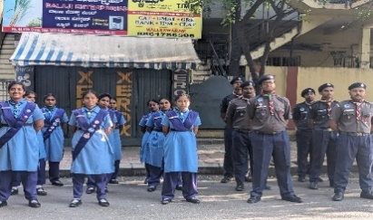
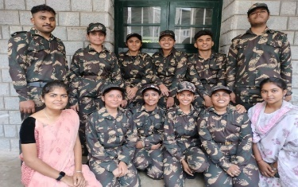
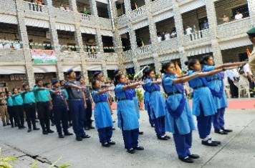
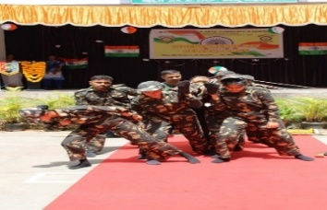
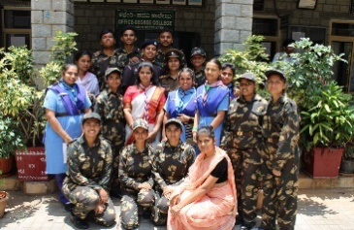
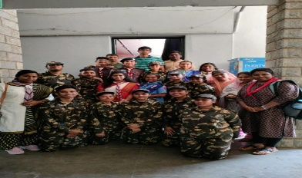

76th Independence Day Celebrations in our college.
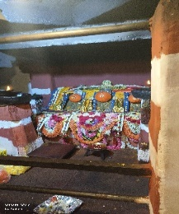
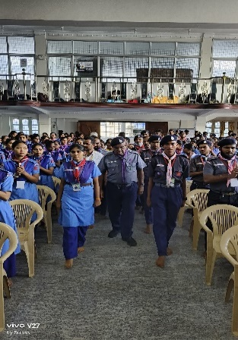
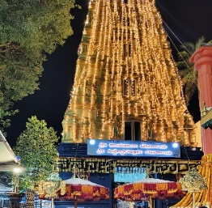
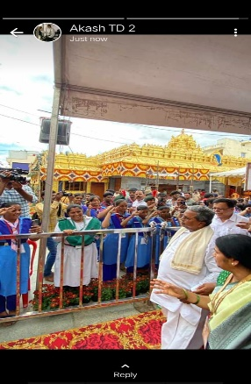
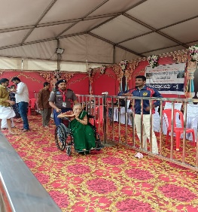
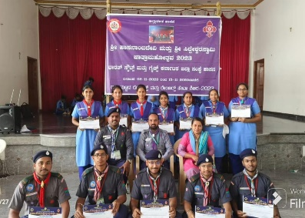
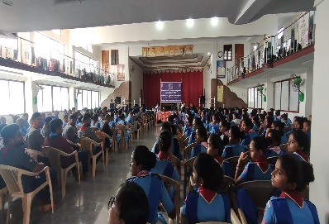

A Historical Temple Hasanamba, Hassan – a devotional service held from
05th November 2023 – 09th November 2023.

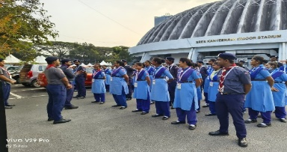
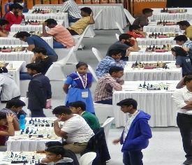
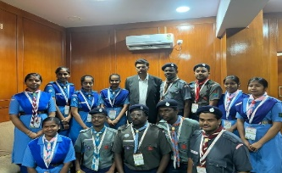
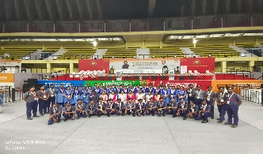
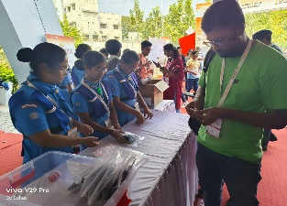
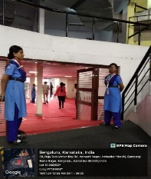
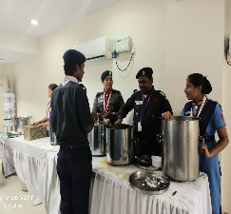

1st Bangalore International Chess Grandmaster Tournament 2024 - A Historic event.

UPCOMING EVENTS.
- Republic day
- Founder’s Day
- Trekking Camp.
- Nipun Examination.
- Environmental Day.
- Swachata Program.

6.SOCIAL MEDIA LINKS.
INSTAGRAM : https://www.instagram.com/rovers_and_rangers_of_mes?igsh=MXY0d296ZGk1bXZiNw==
FACEBOOK : https://www.facebook.com/rangersnrovers.mes

