Youth/Indian Red Cross
Year 2020
Two days online workshop on “Personal Excellence Program “ on 01/07/2020 and 02/07/2020
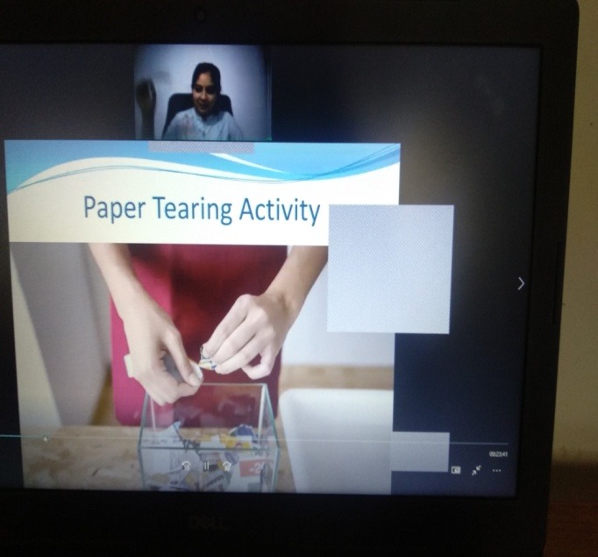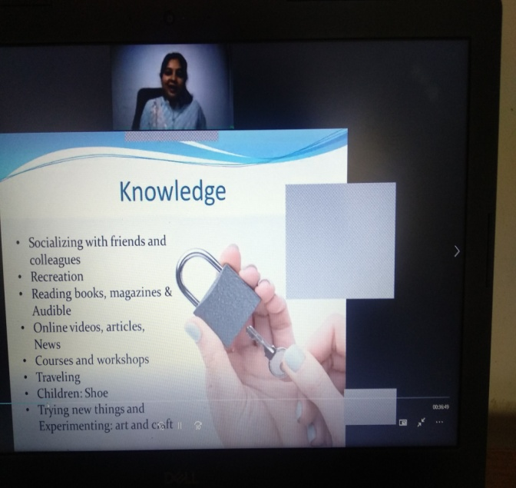

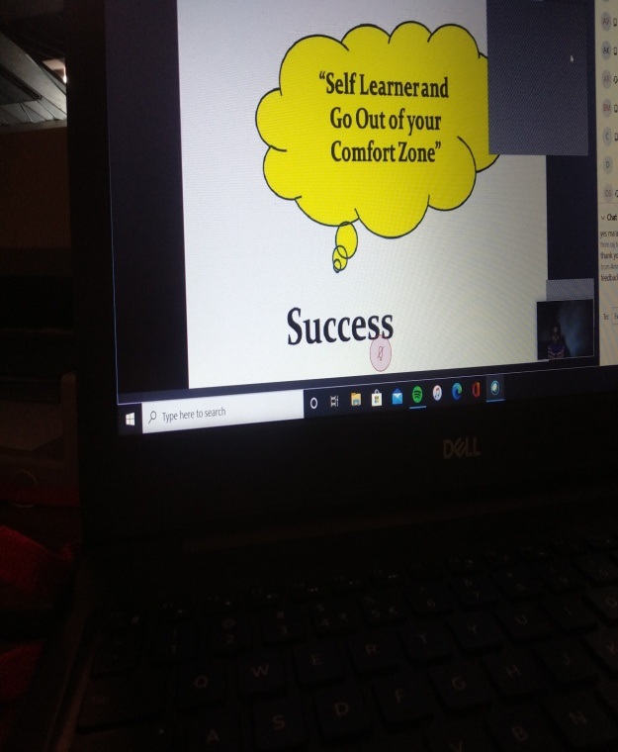

Year 2019
- Talk On “A Compass for Success in Life and Career” on 15/02/2019
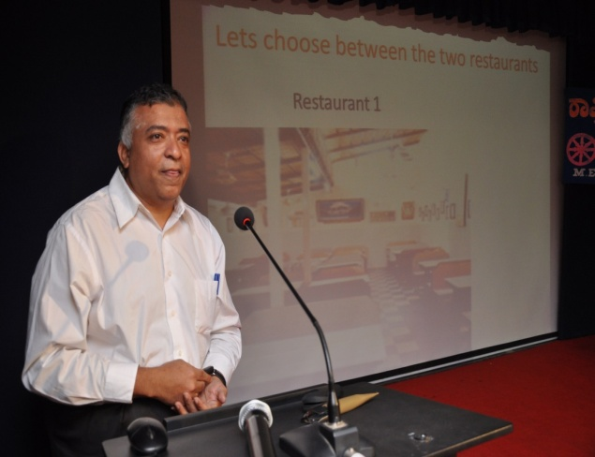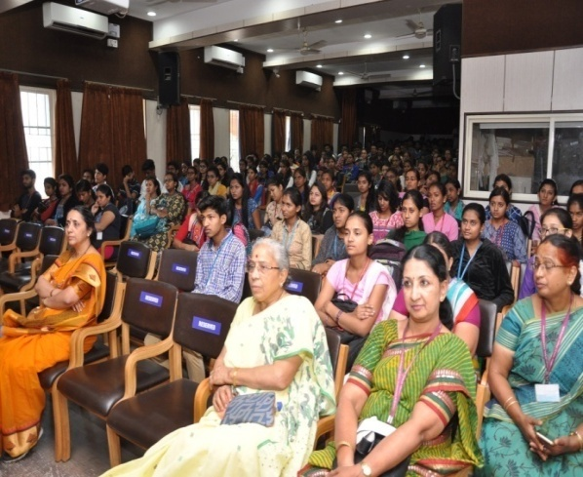
- BLOOD DONATION CAMP on 11/04/2019
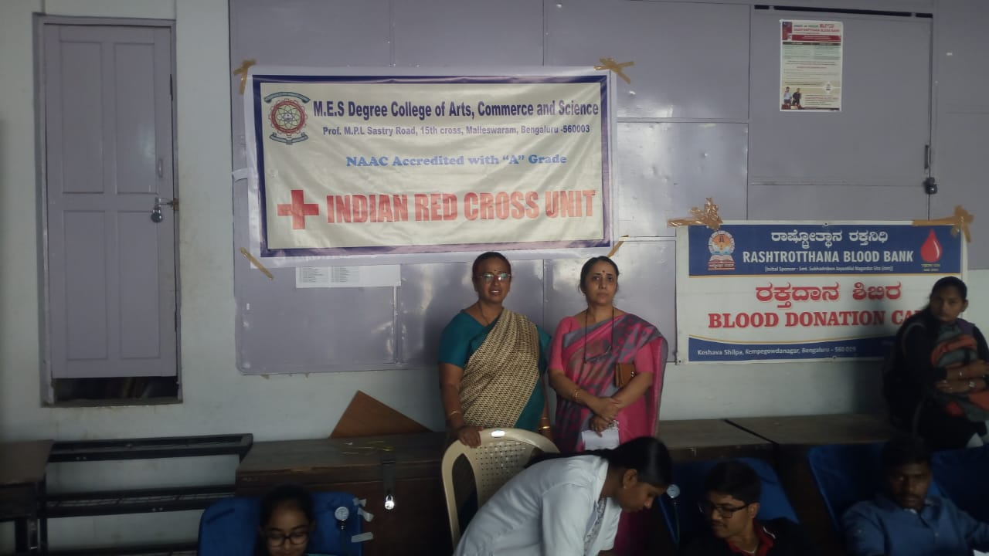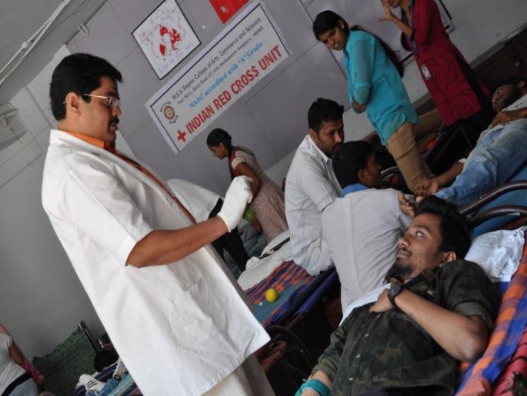
- Festival of Democracy on 08/04/2019
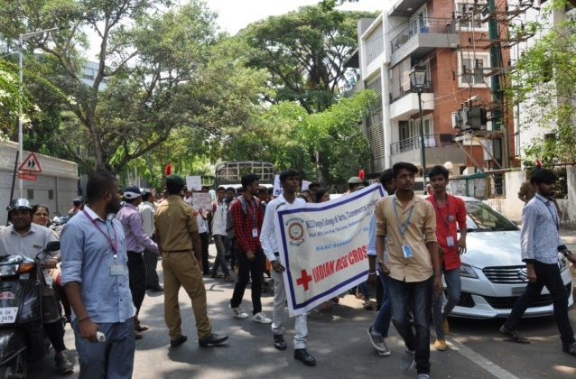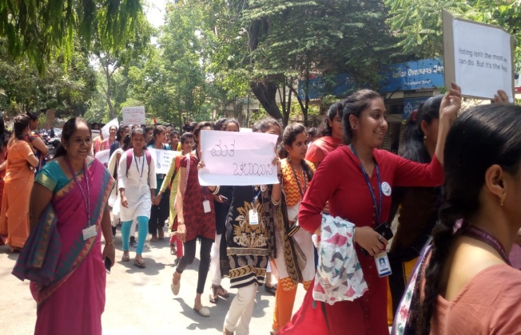
- Workshop on personality development and interview skills on 28/07/2019 and 04/08/2019.
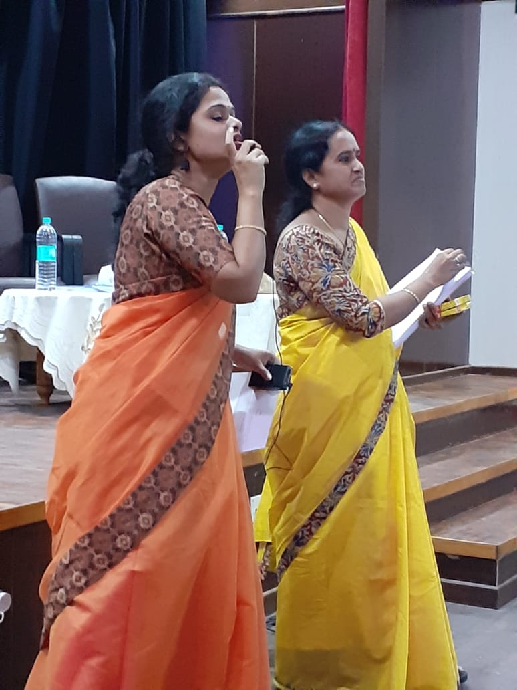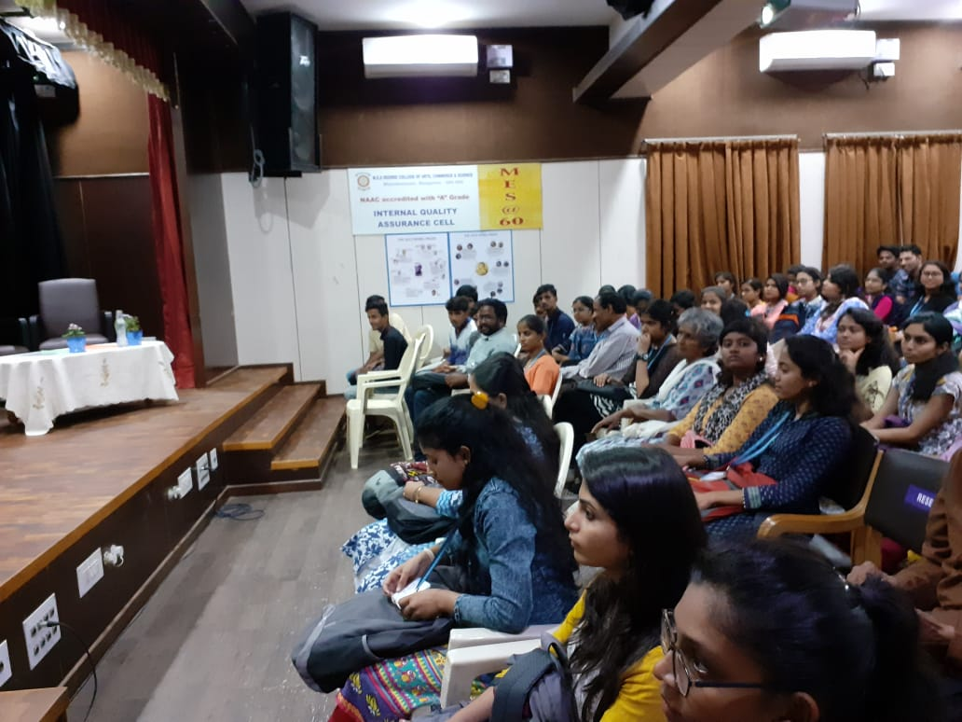
- Voluntary Blood Donation camp on 20/08/2019.

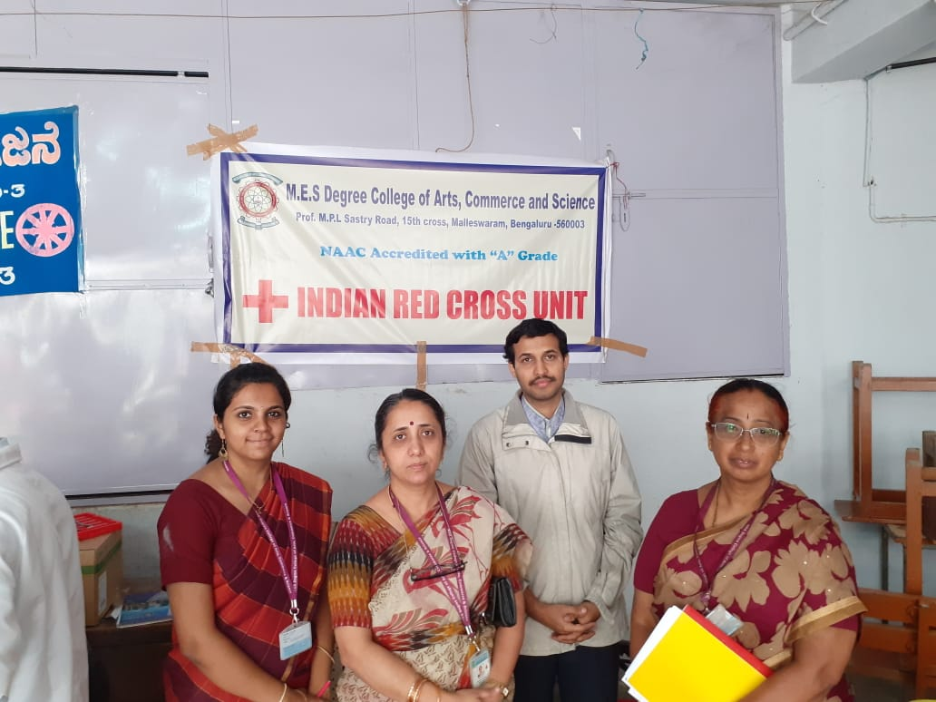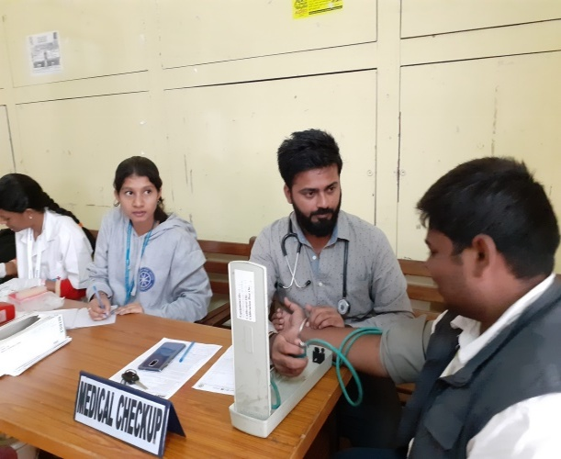
Gandhi Jayanthi Celebration 02/10/2019.
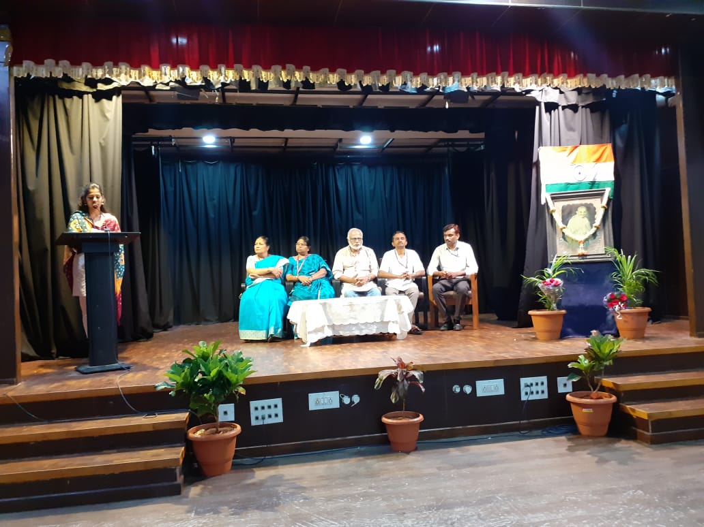
Year 2018
- Talk On “FIRST AID-THE LIFE SAVIOUR” on 17/02/2018.
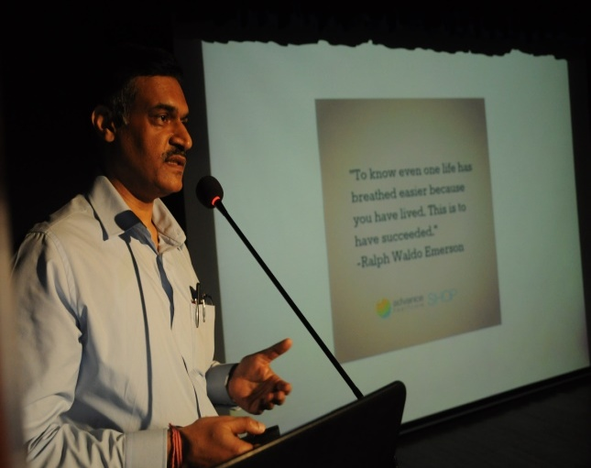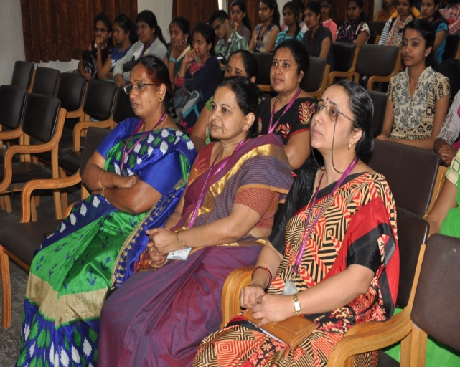
- BLOOD DONATION CAMP on 21/02/2018
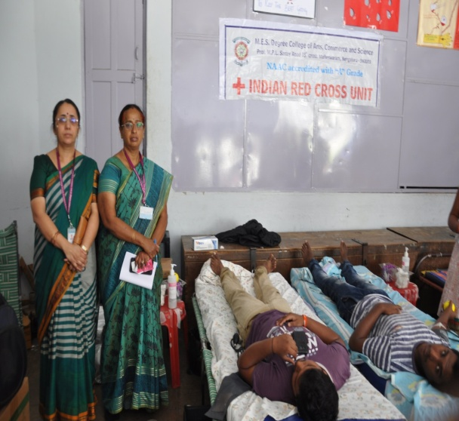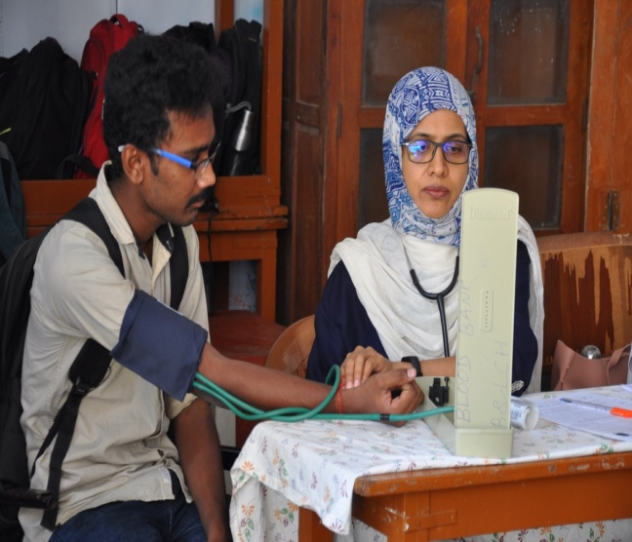
- Talk on “HUMOUR-THE ART OF LIVING” on 10/08/2018
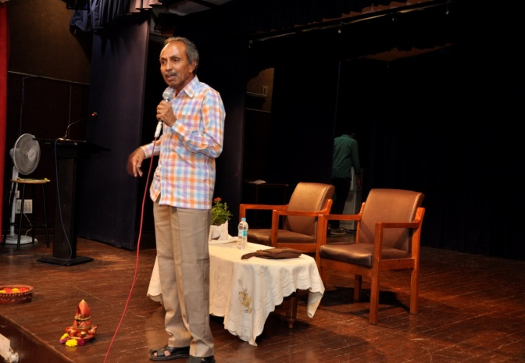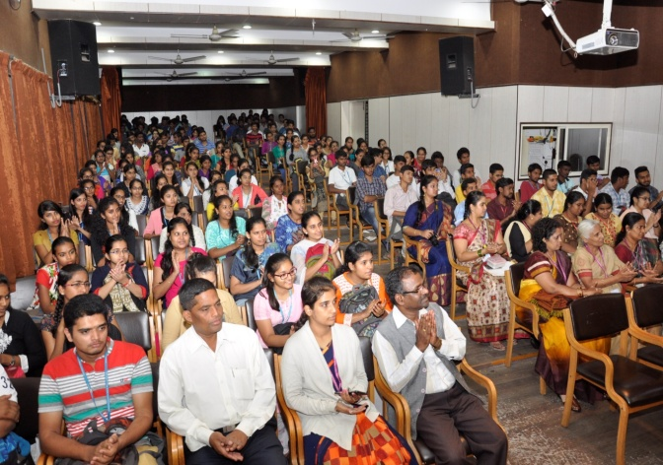

- TWO DAY TRAINING PROGRAM ON COMPETENCY SKILLS on 05/08/2018 and 12/08/2018.
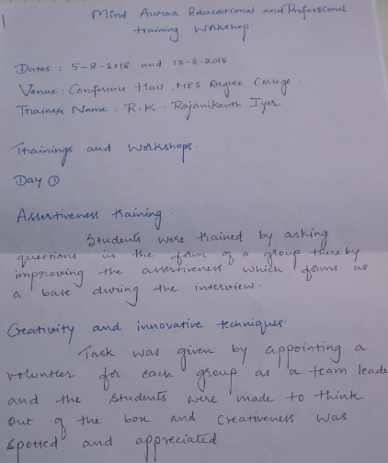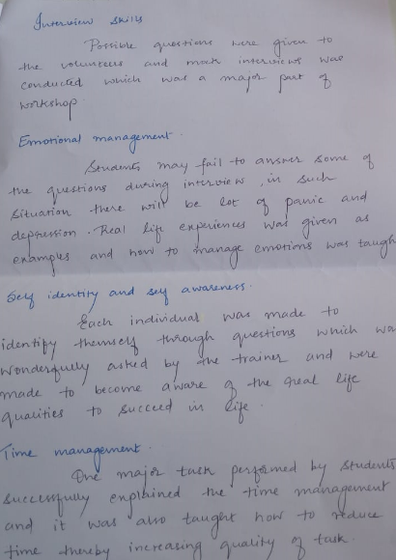
- SEED GANESHA MAKING WORKSHOP on 02/09/2018
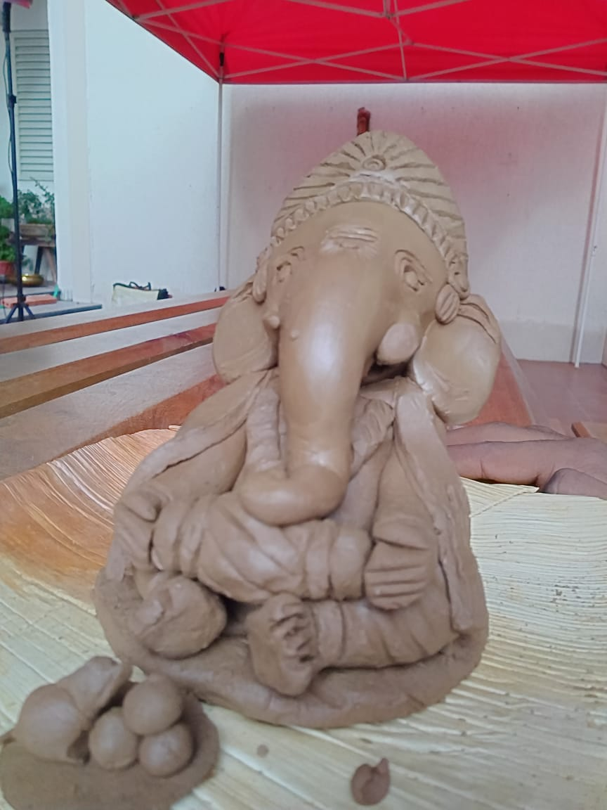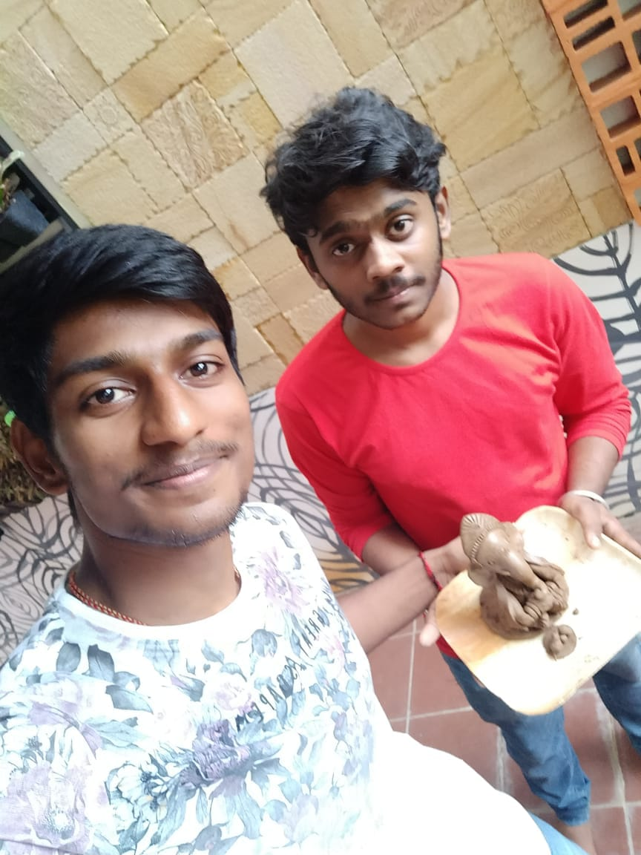

Year 2017
Medical Health check up for the children of Belaku Shishu Nivasa on 25/06/2017.
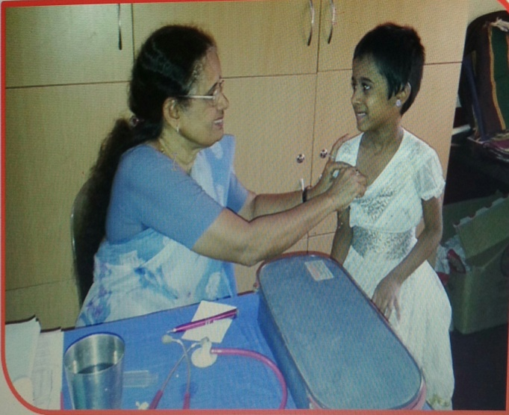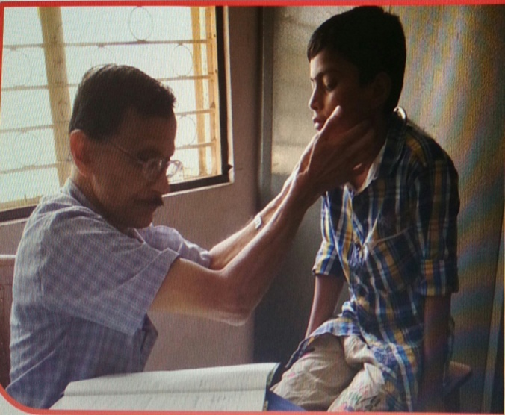
Lecture on- “Cancer awareness and cure” on 10/10/2017.
